MIBC

Juan Henao

October 16, 2025

Abstract

Text of abstract

# No noise

## Number of nodes

### Single-omics

library(tidyverse)  
library(data.table)  
library(reshape)  
library(ggplot2)  
library(dplyr)  
library(viridis)  
  
#general setup  
dir <- "/workspaces/phd_dissertation/kimono/analysis/data/derived_data/"  
  
#load library  
setwd(dir)  
  
dat_raw <- fread("221116_all_project_info.csv")  
  
#dat_raw <- cbind(dat_raw[,c(1,2,3,16,18)],nodes=dat_raw$V6+dat_raw$V8+dat_raw$V10)  
#dat_raw <- dat_raw[dat_raw$iteration == 1,]  
  
dat_raw$method <- gsub(pattern = "_moran|_mos|_mor|_so|_sor",replacement = "",x = dat_raw$method)  
  
dat <- dat_raw[tolower(dat_raw$method) %in% c("galasso_false","galasso_true","knnkimono","salasso_false","salasso_true","cocolasso","hmlasso"),]  
  
  
#ggplot(dat, aes(x=clustering, y=n_genes+n_methylation+n_cnv, color=as.factor(method)) )+  
# geom_point(alpha=0.5) + facet_grid(experiment~noise)  
  
#ggplot(dat, aes(y=clustering, x=missingness, color=as.factor(method)) )+  
# geom_point(alpha=0.5) + facet_grid(experiment~noise)  
  
#ggplot(dat, aes(x=missingness, y=clustering,fill=as.factor(method)))+  
# scale_y_continuous(trans='sqrt') + geom_boxplot() + facet_grid(experiment~noise)  
  
  
dat$method <- as.factor(dat$method)   
dat <- dat %>% mutate(method = fct_relevel(method, "knnkimono", "galasso_false" ,"galasso_true" , "salasso_false" , "salasso_true" ,"cocolasso", "hmlasso" ))  
dat$experiment <- as.factor(dat$experiment)  
dat <- dat %>% mutate(experiment = fct_relevel(experiment, "so", "moran" ,"mos" , "sor" , "mor"))  
  
palette_OkabeIto <- c( "#CC79A7", "#D55E00", "#E69F00","#0072B2", "#56B4E9", "#009E73", "#F0E442")  
  
dat <- aggregate(dat[, -c(1:8)], list('noise'=dat$noise,  
 'missingness'=dat$missingness,  
 'method'=dat$method,  
 'experiment'=dat$experiment), function(x){mean(x,na.rm=TRUE)})  
  
dat_raw$method <- as.factor(dat_raw$method)   
dat_raw <- dat_raw %>% mutate(method = fct_relevel(method, "knnkimono", "galasso_false" ,"galasso_true" , "salasso_false" , "salasso_true" ,"cocolasso", "hmlasso" ))  
dat_raw$experiment <- as.factor(dat_raw$experiment)  
dat_raw <- dat_raw %>% mutate(experiment = fct_relevel(experiment, "so", "moran" ,"mos" , "sor" , "mor"))  
  
dat_raw <- dat_raw[ dat_raw$noise==0 & dat_raw$experiment %in% 'so' & !dat_raw$method %in% "bdcoco_lasso",]  
dat <- dat[ dat$noise==0 & dat$experiment %in% 'so' & !dat$method %in% "bdcoco_lasso",]  
  
dat_raw$adaptive <- grepl(pattern = "true",x = dat_raw$method)  
dat$adaptive <- grepl(pattern = "true",x = dat$method)  
  
p <- ggplot(dat_raw,   
 aes(y= (n_cnv+n_genes+n_methylation), x=missingness,color=as.factor(method)))+  
   
 geom_line(aes( group = interaction(method, iteration),linetype=adaptive),alpha = 0.2)+  
 facet_grid(noise~experiment, scales="free")+  
 scale_color_manual(values = palette_OkabeIto)+  
 scale_fill_manual(values = palette_OkabeIto)+   
 theme_light() +  
 theme(legend.position="bottom",  
 axis.text.x = element_text(size = 8),  
 axis.text.y = element_text(size = 8),  
 strip.background = element_blank(),   
 plot.margin = unit(c(-0.5, -0.5, 0, 0), "cm")  
 ) +  
 ylab("#Nodes")   
  
to.plot1 <- p + geom_line(data = dat,   
 aes(y= (n_cnv+n_genes+n_methylation), x=missingness, color=as.factor(method),linetype=adaptive)) +   
 theme(strip.background = element_blank(), panel.grid.minor = element_blank(),  
 legend.position = "none",  
 axis.title.x=element_blank(),  
 #axis.text.x=element_blank(),  
 #axis.ticks.x=element_blank(),  
 axis.title.y=element_blank(),  
 #axis.text.y=element_blank(),  
 #axis.ticks.y=element_blank(),   
 plot.margin = unit(c(-0.5, -0.5, 0, 0), "cm")  
 )  
  
to.plot1

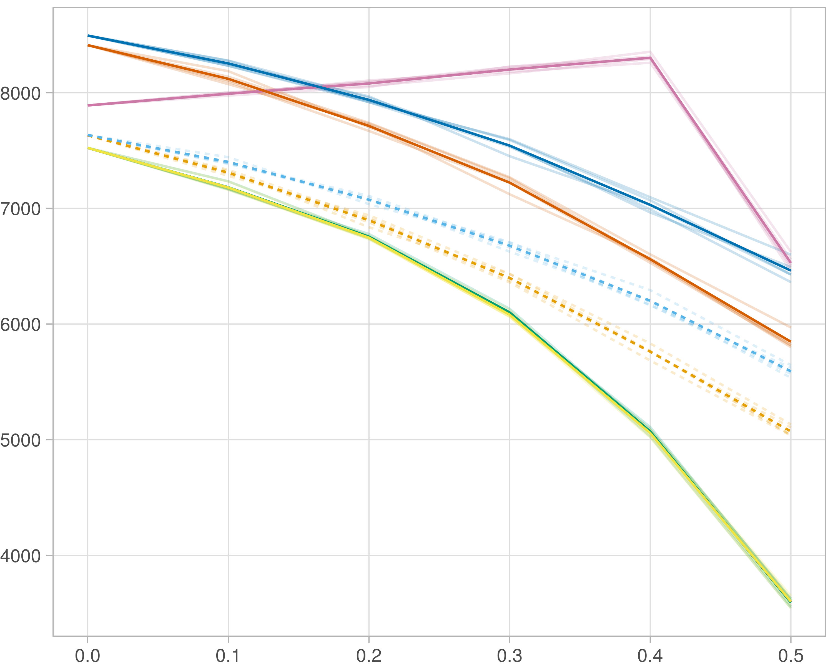

### Multi-omics

#general setup  
dir <- "/workspaces/phd_dissertation/kimono/analysis/data/derived_data/"  
  
#load library  
setwd(dir)  
  
dat_raw <- fread("221116_all_project_info.csv")  
  
#dat_raw <- cbind(dat_raw[,c(1,2,3,16,18)],nodes=dat_raw$V6+dat_raw$V8+dat_raw$V10)  
#dat_raw <- dat_raw[dat_raw$iteration == 1,]  
  
dat_raw$method <- gsub(pattern = "_moran|_mos|_mor|_so|_sor",replacement = "",x = dat_raw$method)  
  
dat <- dat_raw[tolower(dat_raw$method) %in% c("galasso_false","galasso_true","knnkimono","salasso_false","salasso_true","cocolasso","hmlasso"),]  
  
  
#ggplot(dat, aes(x=clustering, y=n_genes+n_methylation+n_cnv, color=as.factor(method)) )+  
# geom_point(alpha=0.5) + facet_grid(experiment~noise)  
  
#ggplot(dat, aes(y=clustering, x=missingness, color=as.factor(method)) )+  
# geom_point(alpha=0.5) + facet_grid(experiment~noise)  
  
#ggplot(dat, aes(x=missingness, y=clustering,fill=as.factor(method)))+  
# scale_y_continuous(trans='sqrt') + geom_boxplot() + facet_grid(experiment~noise)  
  
  
dat$method <- as.factor(dat$method)   
dat <- dat %>% mutate(method = fct_relevel(method, "knnkimono", "galasso_false" ,"galasso_true" , "salasso_false" , "salasso_true" ,"cocolasso", "hmlasso" ))  
dat$experiment <- as.factor(dat$experiment)  
dat <- dat %>% mutate(experiment = fct_relevel(experiment, "so", "moran" ,"mos" , "sor" , "mor"))  
  
palette_OkabeIto <- c( "#CC79A7", "#D55E00", "#E69F00","#0072B2", "#56B4E9", "#009E73", "#F0E442")  
  
dat <- aggregate(dat[, -c(1:8)], list('noise'=dat$noise,  
 'missingness'=dat$missingness,  
 'method'=dat$method,  
 'experiment'=dat$experiment), function(x){mean(x,na.rm=TRUE)})  
  
dat_raw$method <- as.factor(dat_raw$method)   
dat_raw <- dat_raw %>% mutate(method = fct_relevel(method, "knnkimono", "galasso_false" ,"galasso_true" , "salasso_false" , "salasso_true" ,"cocolasso", "hmlasso" ))  
dat_raw$experiment <- as.factor(dat_raw$experiment)  
dat_raw <- dat_raw %>% mutate(experiment = fct_relevel(experiment, "so", "moran" ,"mos" , "sor" , "mor"))  
  
dat_raw <- dat_raw[ dat_raw$noise==0 & dat_raw$experiment %in% 'moran' & !dat_raw$method %in% "bdcoco_lasso",]  
dat <- dat[ dat$noise==0 & dat$experiment %in% 'moran' & !dat$method %in% "bdcoco_lasso",]  
  
dat_raw$adaptive <- grepl(pattern = "true",x = dat_raw$method)  
dat$adaptive <- grepl(pattern = "true",x = dat$method)  
  
p <- ggplot(dat_raw,   
 aes(y= (n_cnv+n_genes+n_methylation), x=missingness,color=as.factor(method)))+  
   
 geom_line(aes( group = interaction(method, iteration),linetype=adaptive),alpha = 0.2)+  
 facet_grid(noise~experiment, scales="free")+  
 scale_color_manual(values = palette_OkabeIto)+  
 scale_fill_manual(values = palette_OkabeIto)+   
 theme_light() +  
 theme(legend.position="bottom",  
 axis.text.x = element_text(size = 8),  
 axis.text.y = element_text(size = 8),  
 strip.background = element_blank(),   
 plot.margin = unit(c(-0.5, -0.5, 0, 0), "cm")  
 ) +  
 ylab("#Nodes")   
  
to.plot1 <- p + geom_line(data = dat,   
 aes(y= (n_cnv+n_genes+n_methylation), x=missingness, color=as.factor(method),linetype=adaptive)) +   
 theme(strip.background = element_blank(), panel.grid.minor = element_blank(),  
 legend.position = "none",  
 axis.title.x=element_blank(),  
 #axis.text.x=element_blank(),  
 #axis.ticks.x=element_blank(),  
 axis.title.y=element_blank(),  
 #axis.text.y=element_blank(),  
 #axis.ticks.y=element_blank(),   
 plot.margin = unit(c(-0.5, -0.5, 0, 0), "cm")  
 )  
  
to.plot1

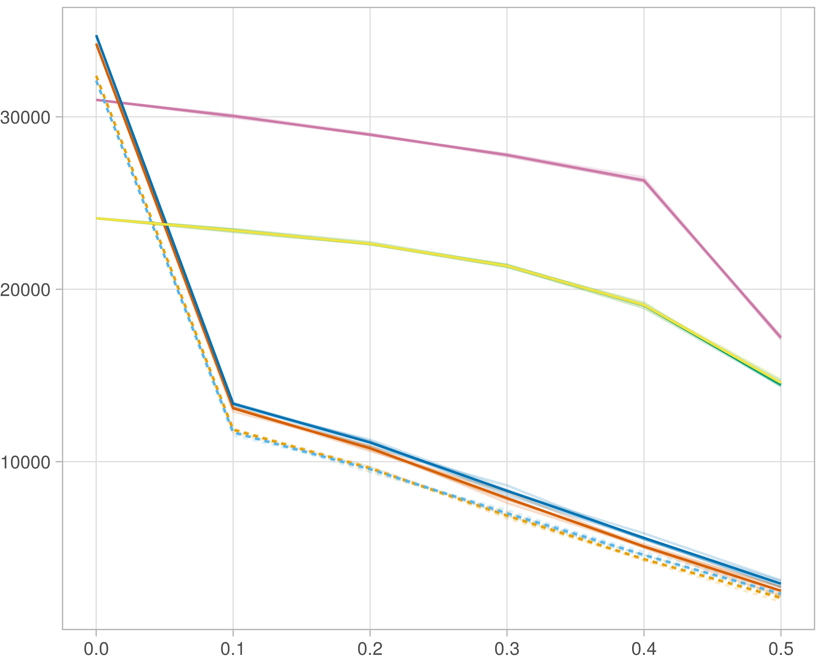

### Block-wise

#general setup  
dir <- "/workspaces/phd_dissertation/kimono/analysis/data/derived_data/"  
  
#load library  
setwd(dir)  
  
dat_raw <- fread("221116_all_project_info.csv")  
  
#dat_raw <- cbind(dat_raw[,c(1,2,3,16,18)],nodes=dat_raw$V6+dat_raw$V8+dat_raw$V10)  
#dat_raw <- dat_raw[dat_raw$iteration == 1,]  
  
dat_raw$method <- gsub(pattern = "_moran|_mos|_mor|_so|_sor",replacement = "",x = dat_raw$method)  
  
dat <- dat_raw[tolower(dat_raw$method) %in% c("galasso_false","galasso_true","knnkimono","salasso_false","salasso_true","cocolasso","hmlasso"),]  
  
  
#ggplot(dat, aes(x=clustering, y=n_genes+n_methylation+n_cnv, color=as.factor(method)) )+  
# geom_point(alpha=0.5) + facet_grid(experiment~noise)  
  
#ggplot(dat, aes(y=clustering, x=missingness, color=as.factor(method)) )+  
# geom_point(alpha=0.5) + facet_grid(experiment~noise)  
  
#ggplot(dat, aes(x=missingness, y=clustering,fill=as.factor(method)))+  
# scale_y_continuous(trans='sqrt') + geom_boxplot() + facet_grid(experiment~noise)  
  
  
dat$method <- as.factor(dat$method)   
dat <- dat %>% mutate(method = fct_relevel(method, "knnkimono", "galasso_false" ,"galasso_true" , "salasso_false" , "salasso_true" ,"cocolasso", "hmlasso" ))  
dat$experiment <- as.factor(dat$experiment)  
dat <- dat %>% mutate(experiment = fct_relevel(experiment, "so", "moran" ,"mos" , "sor" , "mor"))  
  
palette_OkabeIto <- c( "#CC79A7", "#D55E00", "#E69F00","#0072B2", "#56B4E9", "#009E73", "#F0E442")  
  
dat <- aggregate(dat[, -c(1:8)], list('noise'=dat$noise,  
 'missingness'=dat$missingness,  
 'method'=dat$method,  
 'experiment'=dat$experiment), function(x){mean(x,na.rm=TRUE)})  
  
dat_raw$method <- as.factor(dat_raw$method)   
dat_raw <- dat_raw %>% mutate(method = fct_relevel(method, "knnkimono", "galasso_false" ,"galasso_true" , "salasso_false" , "salasso_true" ,"cocolasso", "hmlasso" ))  
dat_raw$experiment <- as.factor(dat_raw$experiment)  
dat_raw <- dat_raw %>% mutate(experiment = fct_relevel(experiment, "so", "moran" ,"mos" , "sor" , "mor"))  
  
dat_raw <- dat_raw[ dat_raw$noise==0 & dat_raw$experiment %in% 'mos' & !dat_raw$method %in% "bdcoco_lasso",]  
dat <- dat[ dat$noise==0 & dat$experiment %in% 'mos' & !dat$method %in% "bdcoco_lasso",]  
  
dat_raw$adaptive <- grepl(pattern = "true",x = dat_raw$method)  
dat$adaptive <- grepl(pattern = "true",x = dat$method)  
  
p <- ggplot(dat_raw,   
 aes(y= (n_cnv+n_genes+n_methylation), x=missingness,color=as.factor(method)))+  
   
 geom_line(aes( group = interaction(method, iteration),linetype=adaptive),alpha = 0.2)+  
 facet_grid(noise~experiment, scales="free")+  
 scale_color_manual(values = palette_OkabeIto)+  
 scale_fill_manual(values = palette_OkabeIto)+   
 theme_light() +  
 theme(legend.position="bottom",  
 axis.text.x = element_text(size = 8),  
 axis.text.y = element_text(size = 8),  
 strip.background = element_blank(),   
 plot.margin = unit(c(-0.5, -0.5, 0, 0), "cm")  
 ) +  
 ylab("#Nodes")   
  
to.plot1 <- p + geom_line(data = dat,   
 aes(y= (n_cnv+n_genes+n_methylation), x=missingness, color=as.factor(method),linetype=adaptive)) +   
 theme(strip.background = element_blank(), panel.grid.minor = element_blank(),  
 legend.position = "none",  
 axis.title.x=element_blank(),  
 #axis.text.x=element_blank(),  
 #axis.ticks.x=element_blank(),  
 axis.title.y=element_blank(),  
 #axis.text.y=element_blank(),  
 #axis.ticks.y=element_blank(),   
 plot.margin = unit(c(-0.5, -0.5, 0, 0), "cm")  
 )  
  
to.plot1

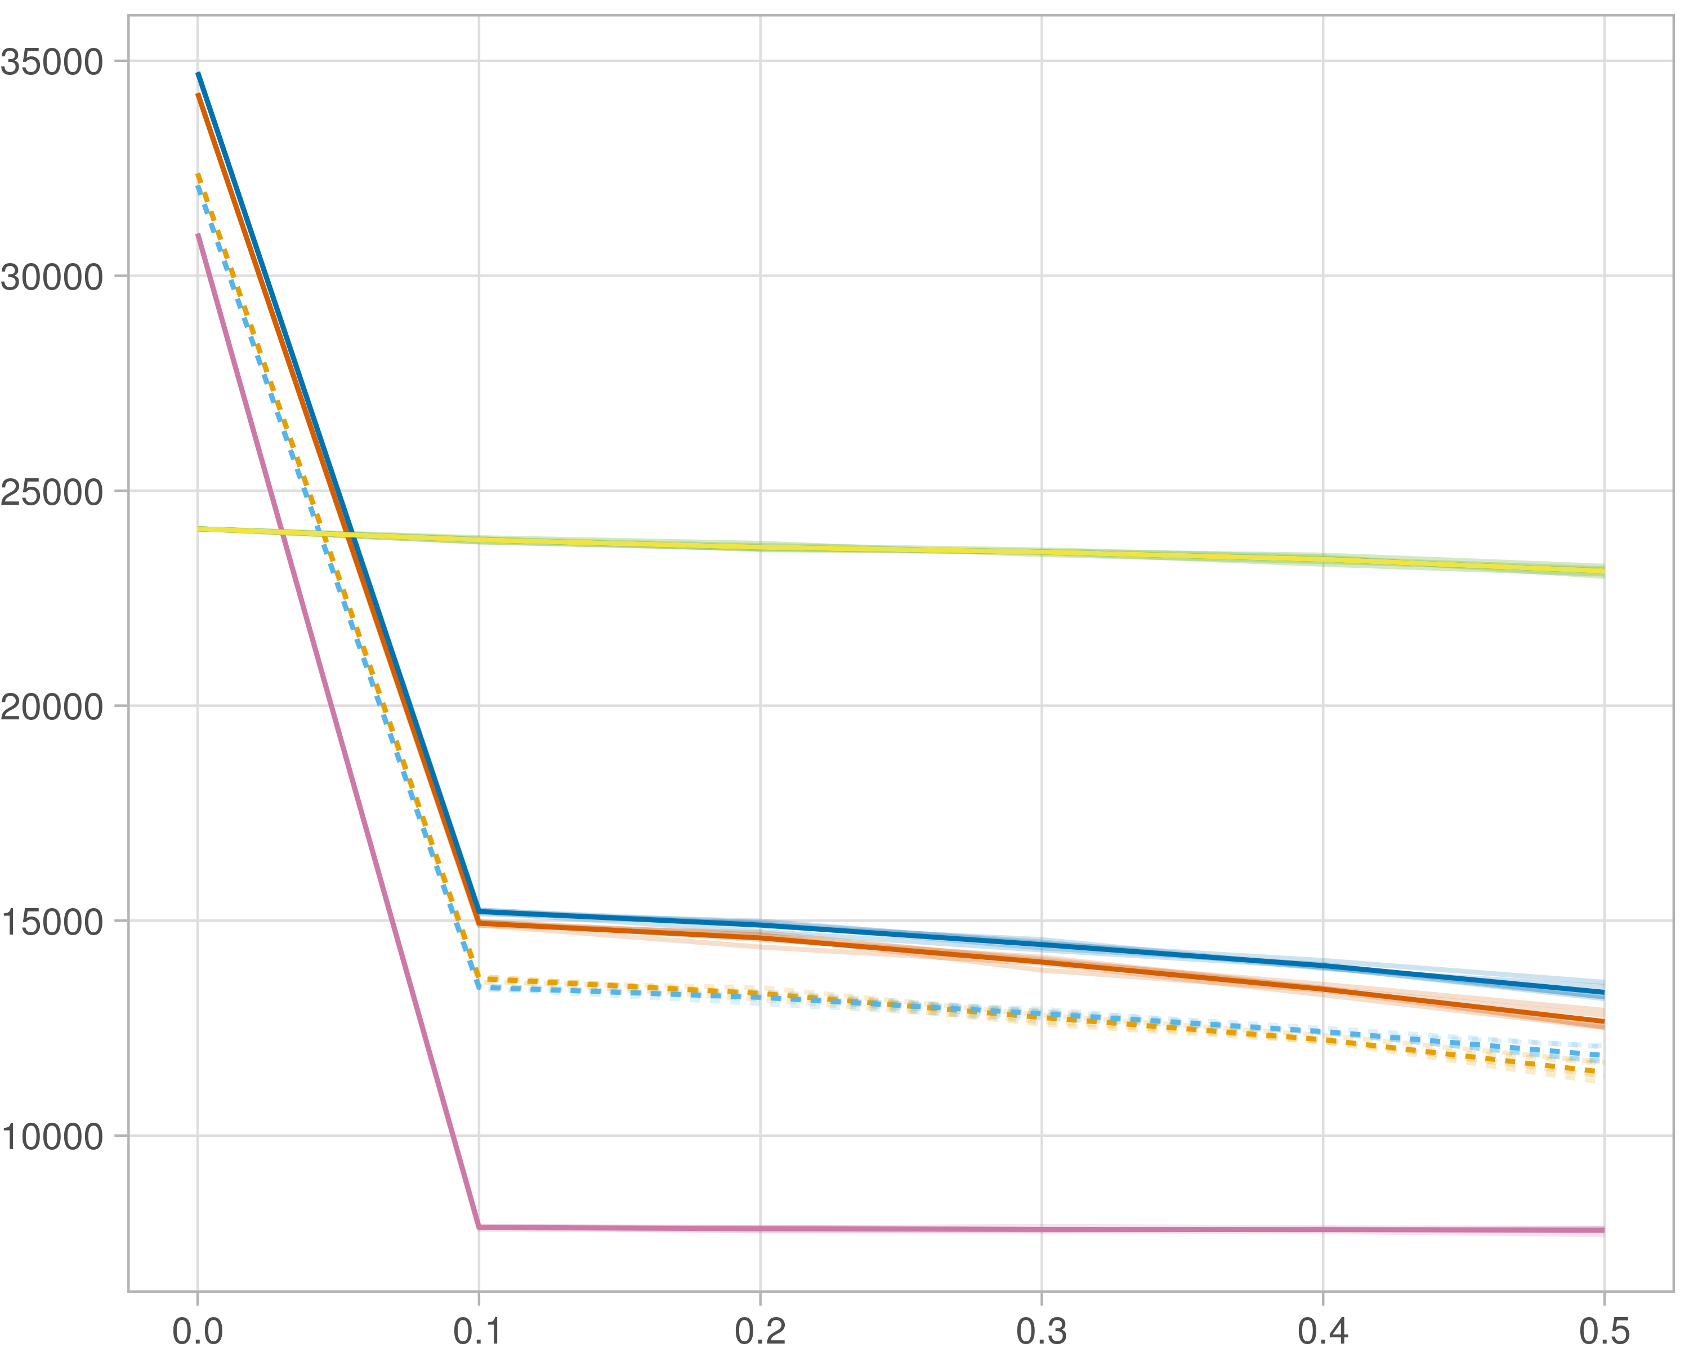

## Transitivity

### Single-omics

#general setup  
dir <- "/workspaces/phd_dissertation/kimono/analysis/data/derived_data/"  
  
#load library  
setwd(dir)  
  
dat_raw <- fread("221116_all_project_info.csv")  
  
#dat_raw <- cbind(dat_raw[,c(1,2,3,16,18)],nodes=dat_raw$V6+dat_raw$V8+dat_raw$V10)  
#dat_raw <- dat_raw[dat_raw$iteration == 1,]  
  
dat_raw$method <- gsub(pattern = "_moran|_mos|_mor|_so|_sor",replacement = "",x = dat_raw$method)  
  
dat <- dat_raw[tolower(dat_raw$method) %in% c("galasso_false","galasso_true","knnkimono","salasso_false","salasso_true","cocolasso","hmlasso"),]  
  
  
#ggplot(dat, aes(x=clustering, y=n_genes+n_methylation+n_cnv, color=as.factor(method)) )+  
# geom_point(alpha=0.5) + facet_grid(experiment~noise)  
  
#ggplot(dat, aes(y=clustering, x=missingness, color=as.factor(method)) )+  
# geom_point(alpha=0.5) + facet_grid(experiment~noise)  
  
#ggplot(dat, aes(x=missingness, y=clustering,fill=as.factor(method)))+  
# scale_y_continuous(trans='sqrt') + geom_boxplot() + facet_grid(experiment~noise)  
  
  
dat$method <- as.factor(dat$method)   
dat <- dat %>% mutate(method = fct_relevel(method, "knnkimono", "galasso_false" ,"galasso_true" , "salasso_false" , "salasso_true" ,"cocolasso", "hmlasso" ))  
dat$experiment <- as.factor(dat$experiment)  
dat <- dat %>% mutate(experiment = fct_relevel(experiment, "so", "moran" ,"mos" , "sor" , "mor"))  
  
palette_OkabeIto <- c( "#CC79A7", "#D55E00", "#E69F00","#0072B2", "#56B4E9", "#009E73", "#F0E442")  
  
dat <- aggregate(dat[, -c(1:8)], list('noise'=dat$noise,  
 'missingness'=dat$missingness,  
 'method'=dat$method,  
 'experiment'=dat$experiment), function(x){mean(x,na.rm=TRUE)})  
  
dat_raw$method <- as.factor(dat_raw$method)   
dat_raw <- dat_raw %>% mutate(method = fct_relevel(method, "knnkimono", "galasso_false" ,"galasso_true" , "salasso_false" , "salasso_true" ,"cocolasso", "hmlasso" ))  
dat_raw$experiment <- as.factor(dat_raw$experiment)  
dat_raw <- dat_raw %>% mutate(experiment = fct_relevel(experiment, "so", "moran" ,"mos" , "sor" , "mor"))  
  
dat_raw <- dat_raw[ dat_raw$noise==0 & dat_raw$experiment %in% 'so' & !dat_raw$method %in% "bdcoco_lasso",]  
dat <- dat[ dat$noise==0 & dat$experiment %in% 'so' & !dat$method %in% "bdcoco_lasso",]  
  
dat_raw$adaptive <- grepl(pattern = "true",x = dat_raw$method)  
dat$adaptive <- grepl(pattern = "true",x = dat$method)  
  
p <- ggplot(dat_raw,   
 aes(y= (clustering), x=missingness,color=as.factor(method)))+  
   
 geom_line(aes( group = interaction(method, iteration),linetype=adaptive),alpha = 0.2)+  
 facet_grid(noise~experiment, scales="free")+  
 scale_color_manual(values = palette_OkabeIto)+  
 scale_fill_manual(values = palette_OkabeIto)+   
 theme_light() +  
 theme(legend.position="bottom",  
 axis.text.x = element_text(size = 8),  
 axis.text.y = element_text(size = 8),  
 strip.background = element_blank(),   
 plot.margin = unit(c(-0.5, -0.5, 0, 0), "cm")  
 ) +  
 ylab("#Nodes")   
  
to.plot2 <- p + geom_line(data = dat,   
 aes(y= (clustering), x=missingness, color=as.factor(method),linetype=adaptive)) +   
 theme(strip.background = element_blank(), panel.grid.minor = element_blank(),  
 legend.position = "none",  
 axis.title.x=element_blank(),  
 #axis.text.x=element_blank(),  
 #axis.ticks.x=element_blank(),  
 axis.title.y=element_blank(),  
 #axis.text.y=element_blank(),  
 #axis.ticks.y=element_blank(),   
 plot.margin = unit(c(-0.5, -0.5, 0, 0), "cm")  
 )  
  
to.plot2

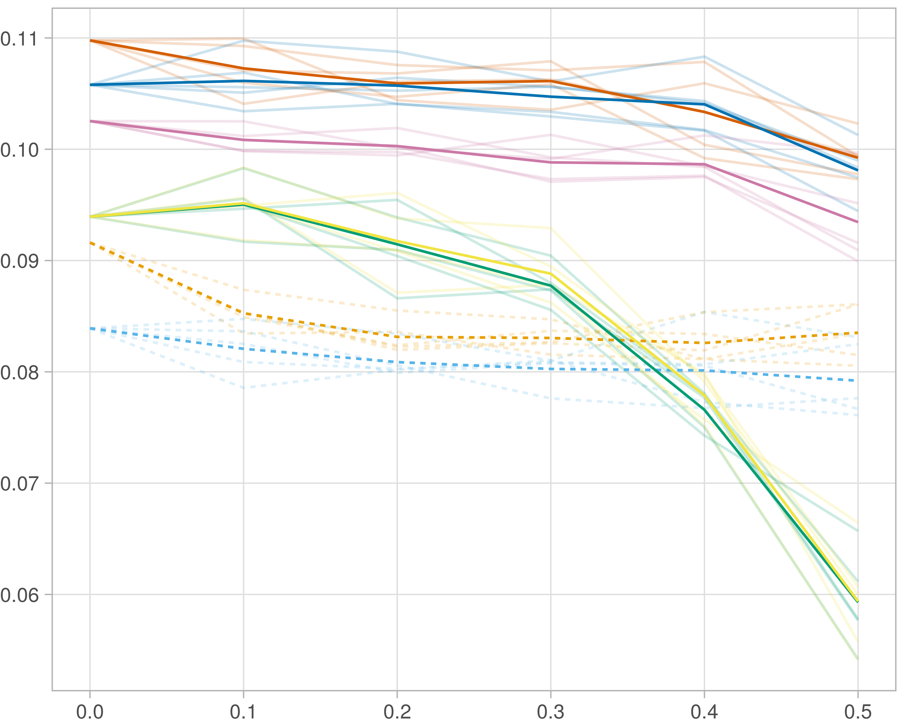

### Multi-omics

#general setup  
dir <- "/workspaces/phd_dissertation/kimono/analysis/data/derived_data/"  
  
#load library  
setwd(dir)  
  
dat_raw <- fread("221116_all_project_info.csv")  
  
#dat_raw <- cbind(dat_raw[,c(1,2,3,16,18)],nodes=dat_raw$V6+dat_raw$V8+dat_raw$V10)  
#dat_raw <- dat_raw[dat_raw$iteration == 1,]  
  
dat_raw$method <- gsub(pattern = "_moran|_mos|_mor|_so|_sor",replacement = "",x = dat_raw$method)  
  
dat <- dat_raw[tolower(dat_raw$method) %in% c("galasso_false","galasso_true","knnkimono","salasso_false","salasso_true","cocolasso","hmlasso"),]  
  
  
#ggplot(dat, aes(x=clustering, y=n_genes+n_methylation+n_cnv, color=as.factor(method)) )+  
# geom_point(alpha=0.5) + facet_grid(experiment~noise)  
  
#ggplot(dat, aes(y=clustering, x=missingness, color=as.factor(method)) )+  
# geom_point(alpha=0.5) + facet_grid(experiment~noise)  
  
#ggplot(dat, aes(x=missingness, y=clustering,fill=as.factor(method)))+  
# scale_y_continuous(trans='sqrt') + geom_boxplot() + facet_grid(experiment~noise)  
  
  
dat$method <- as.factor(dat$method)   
dat <- dat %>% mutate(method = fct_relevel(method, "knnkimono", "galasso_false" ,"galasso_true" , "salasso_false" , "salasso_true" ,"cocolasso", "hmlasso" ))  
dat$experiment <- as.factor(dat$experiment)  
dat <- dat %>% mutate(experiment = fct_relevel(experiment, "so", "moran" ,"mos" , "sor" , "mor"))  
  
palette_OkabeIto <- c( "#CC79A7", "#D55E00", "#E69F00","#0072B2", "#56B4E9", "#009E73", "#F0E442")  
  
dat <- aggregate(dat[, -c(1:8)], list('noise'=dat$noise,  
 'missingness'=dat$missingness,  
 'method'=dat$method,  
 'experiment'=dat$experiment), function(x){mean(x,na.rm=TRUE)})  
  
dat_raw$method <- as.factor(dat_raw$method)   
dat_raw <- dat_raw %>% mutate(method = fct_relevel(method, "knnkimono", "galasso_false" ,"galasso_true" , "salasso_false" , "salasso_true" ,"cocolasso", "hmlasso" ))  
dat_raw$experiment <- as.factor(dat_raw$experiment)  
dat_raw <- dat_raw %>% mutate(experiment = fct_relevel(experiment, "so", "moran" ,"mos" , "sor" , "mor"))  
  
dat_raw <- dat_raw[ dat_raw$noise==0 & dat_raw$experiment %in% 'moran' & !dat_raw$method %in% "bdcoco_lasso",]  
dat <- dat[ dat$noise==0 & dat$experiment %in% 'moran' & !dat$method %in% "bdcoco_lasso",]  
  
dat_raw$adaptive <- grepl(pattern = "true",x = dat_raw$method)  
dat$adaptive <- grepl(pattern = "true",x = dat$method)  
  
p <- ggplot(dat_raw,   
 aes(y= (clustering), x=missingness,color=as.factor(method)))+  
   
 geom_line(aes( group = interaction(method, iteration),linetype=adaptive),alpha = 0.2)+  
 facet_grid(noise~experiment, scales="free")+  
 scale_color_manual(values = palette_OkabeIto)+  
 scale_fill_manual(values = palette_OkabeIto)+   
 theme_light() +  
 theme(legend.position="bottom",  
 axis.text.x = element_text(size = 8),  
 axis.text.y = element_text(size = 8),  
 strip.background = element_blank(),   
 plot.margin = unit(c(-0.5, -0.5, 0, 0), "cm")  
 ) +  
 ylab("#Nodes")   
  
to.plot2 <- p + geom_line(data = dat,   
 aes(y= (clustering), x=missingness, color=as.factor(method),linetype=adaptive)) +   
 theme(strip.background = element_blank(), panel.grid.minor = element_blank(),  
 legend.position = "none",  
 axis.title.x=element_blank(),  
 #axis.text.x=element_blank(),  
 #axis.ticks.x=element_blank(),  
 axis.title.y=element_blank(),  
 #axis.text.y=element_blank(),  
 #axis.ticks.y=element_blank(),   
 plot.margin = unit(c(-0.5, -0.5, 0, 0), "cm")  
 )  
  
to.plot2

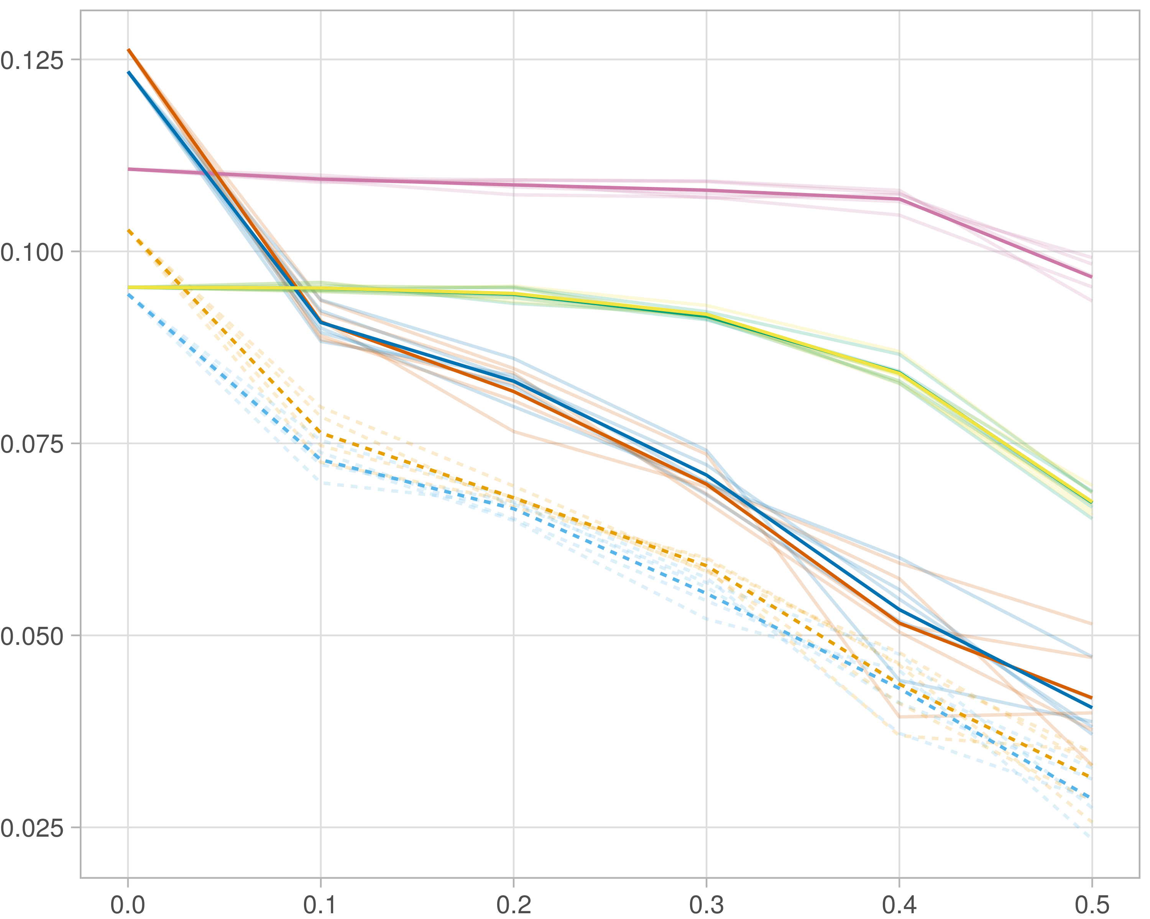

### Block-wise

#general setup  
dir <- "/workspaces/phd_dissertation/kimono/analysis/data/derived_data/"  
  
#load library  
setwd(dir)  
  
dat_raw <- fread("221116_all_project_info.csv")  
  
#dat_raw <- cbind(dat_raw[,c(1,2,3,16,18)],nodes=dat_raw$V6+dat_raw$V8+dat_raw$V10)  
#dat_raw <- dat_raw[dat_raw$iteration == 1,]  
  
dat_raw$method <- gsub(pattern = "_moran|_mos|_mor|_so|_sor",replacement = "",x = dat_raw$method)  
  
dat <- dat_raw[tolower(dat_raw$method) %in% c("galasso_false","galasso_true","knnkimono","salasso_false","salasso_true","cocolasso","hmlasso"),]  
  
  
#ggplot(dat, aes(x=clustering, y=n_genes+n_methylation+n_cnv, color=as.factor(method)) )+  
# geom_point(alpha=0.5) + facet_grid(experiment~noise)  
  
#ggplot(dat, aes(y=clustering, x=missingness, color=as.factor(method)) )+  
# geom_point(alpha=0.5) + facet_grid(experiment~noise)  
  
#ggplot(dat, aes(x=missingness, y=clustering,fill=as.factor(method)))+  
# scale_y_continuous(trans='sqrt') + geom_boxplot() + facet_grid(experiment~noise)  
  
  
dat$method <- as.factor(dat$method)   
dat <- dat %>% mutate(method = fct_relevel(method, "knnkimono", "galasso_false" ,"galasso_true" , "salasso_false" , "salasso_true" ,"cocolasso", "hmlasso" ))  
dat$experiment <- as.factor(dat$experiment)  
dat <- dat %>% mutate(experiment = fct_relevel(experiment, "so", "moran" ,"mos" , "sor" , "mor"))  
  
palette_OkabeIto <- c( "#CC79A7", "#D55E00", "#E69F00","#0072B2", "#56B4E9", "#009E73", "#F0E442")  
  
dat <- aggregate(dat[, -c(1:8)], list('noise'=dat$noise,  
 'missingness'=dat$missingness,  
 'method'=dat$method,  
 'experiment'=dat$experiment), function(x){mean(x,na.rm=TRUE)})  
  
dat_raw$method <- as.factor(dat_raw$method)   
dat_raw <- dat_raw %>% mutate(method = fct_relevel(method, "knnkimono", "galasso_false" ,"galasso_true" , "salasso_false" , "salasso_true" ,"cocolasso", "hmlasso" ))  
dat_raw$experiment <- as.factor(dat_raw$experiment)  
dat_raw <- dat_raw %>% mutate(experiment = fct_relevel(experiment, "so", "moran" ,"mos" , "sor" , "mor"))  
  
dat_raw <- dat_raw[ dat_raw$noise==0 & dat_raw$experiment %in% 'mos' & !dat_raw$method %in% "bdcoco_lasso",]  
dat <- dat[ dat$noise==0 & dat$experiment %in% 'mos' & !dat$method %in% "bdcoco_lasso",]  
  
dat_raw$adaptive <- grepl(pattern = "true",x = dat_raw$method)  
dat$adaptive <- grepl(pattern = "true",x = dat$method)  
  
p <- ggplot(dat_raw,   
 aes(y= (clustering), x=missingness,color=as.factor(method)))+  
   
 geom_line(aes( group = interaction(method, iteration),linetype=adaptive),alpha = 0.2)+  
 facet_grid(noise~experiment, scales="free")+  
 scale_color_manual(values = palette_OkabeIto)+  
 scale_fill_manual(values = palette_OkabeIto)+   
 theme_light() +  
 theme(legend.position="bottom",  
 axis.text.x = element_text(size = 8),  
 axis.text.y = element_text(size = 8),  
 strip.background = element_blank(),   
 plot.margin = unit(c(-0.5, -0.5, 0, 0), "cm")  
 ) +  
 ylab("#Nodes")   
  
to.plot2 <- p + geom_line(data = dat,   
 aes(y= (clustering), x=missingness, color=as.factor(method),linetype=adaptive)) +   
 theme(strip.background = element_blank(), panel.grid.minor = element_blank(),  
 legend.position = "none",  
 axis.title.x=element_blank(),  
 #axis.text.x=element_blank(),  
 #axis.ticks.x=element_blank(),  
 axis.title.y=element_blank(),  
 #axis.text.y=element_blank(),  
 #axis.ticks.y=element_blank(),   
 plot.margin = unit(c(-0.5, -0.5, 0, 0), "cm")  
 )  
  
to.plot2

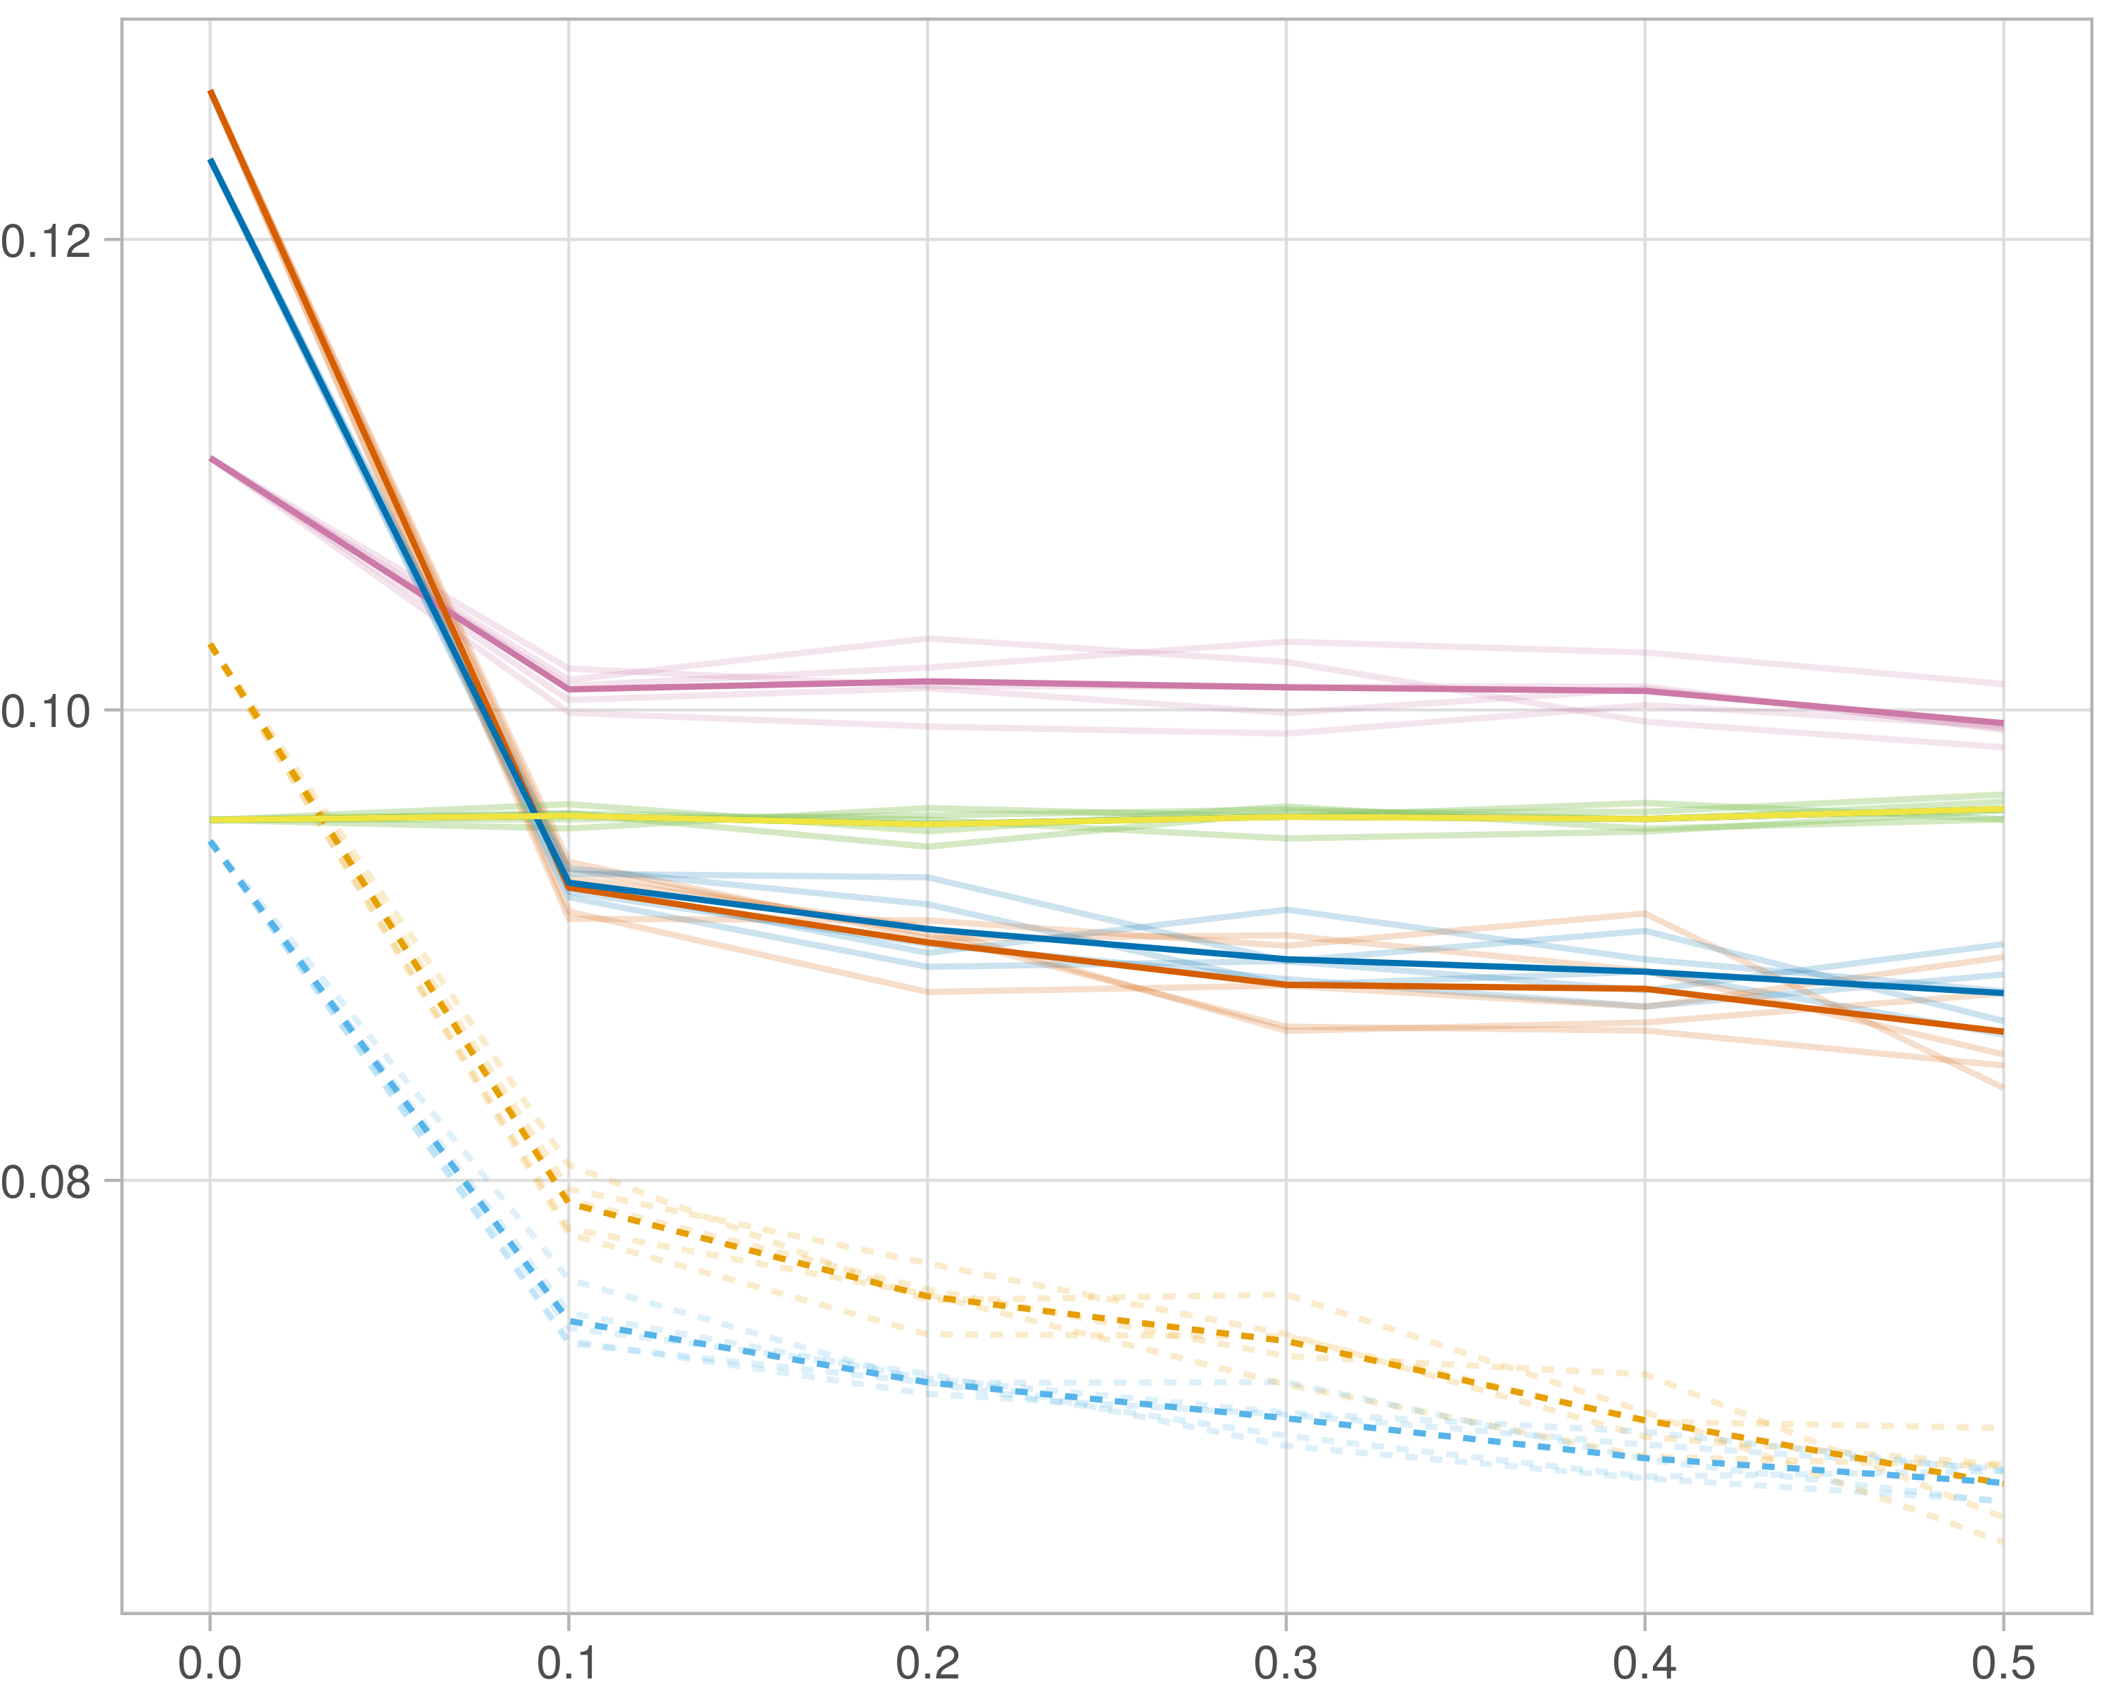

## Median R-squared

### Single-omics

#general setup  
dir <- "/workspaces/phd_dissertation/kimono/analysis/data/derived_data/"  
  
#load library  
setwd(dir)  
  
dat_raw <- fread("221116_all_project_info.csv")  
  
#dat_raw <- cbind(dat_raw[,c(1,2,3,16,18)],nodes=dat_raw$V6+dat_raw$V8+dat_raw$V10)  
#dat_raw <- dat_raw[dat_raw$iteration == 1,]  
  
dat_raw$method <- gsub(pattern = "_moran|_mos|_mor|_so|_sor",replacement = "",x = dat_raw$method)  
  
dat <- dat_raw[tolower(dat_raw$method) %in% c("galasso_false","galasso_true","knnkimono","salasso_false","salasso_true","cocolasso","hmlasso"),]  
  
  
#ggplot(dat, aes(x=clustering, y=n_genes+n_methylation+n_cnv, color=as.factor(method)) )+  
# geom_point(alpha=0.5) + facet_grid(experiment~noise)  
  
#ggplot(dat, aes(y=clustering, x=missingness, color=as.factor(method)) )+  
# geom_point(alpha=0.5) + facet_grid(experiment~noise)  
  
#ggplot(dat, aes(x=missingness, y=clustering,fill=as.factor(method)))+  
# scale_y_continuous(trans='sqrt') + geom_boxplot() + facet_grid(experiment~noise)  
  
  
dat$method <- as.factor(dat$method)   
dat <- dat %>% mutate(method = fct_relevel(method, "knnkimono", "galasso_false" ,"galasso_true" , "salasso_false" , "salasso_true" ,"cocolasso", "hmlasso" ))  
dat$experiment <- as.factor(dat$experiment)  
dat <- dat %>% mutate(experiment = fct_relevel(experiment, "so", "moran" ,"mos" , "sor" , "mor"))  
  
palette_OkabeIto <- c( "#CC79A7", "#D55E00", "#E69F00","#0072B2", "#56B4E9", "#009E73", "#F0E442")  
  
dat <- aggregate(dat[, -c(1:8)], list('noise'=dat$noise,  
 'missingness'=dat$missingness,  
 'method'=dat$method,  
 'experiment'=dat$experiment), function(x){mean(x,na.rm=TRUE)})  
  
dat_raw$method <- as.factor(dat_raw$method)   
dat_raw <- dat_raw %>% mutate(method = fct_relevel(method, "knnkimono", "galasso_false" ,"galasso_true" , "salasso_false" , "salasso_true" ,"cocolasso", "hmlasso" ))  
dat_raw$experiment <- as.factor(dat_raw$experiment)  
dat_raw <- dat_raw %>% mutate(experiment = fct_relevel(experiment, "so", "moran" ,"mos" , "sor" , "mor"))  
  
dat_raw <- dat_raw[ dat_raw$noise==0 & dat_raw$experiment %in% 'so' & !dat_raw$method %in% "bdcoco_lasso",]  
dat <- dat[ dat$noise==0 & dat$experiment %in% 'so' & !dat$method %in% "bdcoco_lasso",]  
  
dat_raw$adaptive <- grepl(pattern = "true",x = dat_raw$method)  
dat$adaptive <- grepl(pattern = "true",x = dat$method)  
  
p <- ggplot(dat_raw,   
 aes(y= (median_r2), x=missingness,color=as.factor(method)))+  
   
 geom_line(aes( group = interaction(method, iteration),linetype=adaptive),alpha = 0.2)+  
 facet_grid(noise~experiment, scales="free")+  
 scale_color_manual(values = palette_OkabeIto)+  
 scale_fill_manual(values = palette_OkabeIto)+   
 theme_light() +  
 theme(legend.position="bottom",  
 axis.text.x = element_text(size = 8),  
 axis.text.y = element_text(size = 8),  
 strip.background = element_blank(),   
 plot.margin = unit(c(-0.5, -0.5, 0, 0), "cm")  
 ) +  
 ylab("#Nodes")   
  
to.plot3 <- p + geom_line(data = dat,   
 aes(y= (median_r2), x=missingness, color=as.factor(method),linetype=adaptive)) +   
 theme(strip.background = element_blank(), panel.grid.minor = element_blank(),  
 legend.position = "none",  
 axis.title.x=element_blank(),  
 #axis.text.x=element_blank(),  
 #axis.ticks.x=element_blank(),  
 axis.title.y=element_blank(),  
 #axis.text.y=element_blank(),  
 #axis.ticks.y=element_blank(),   
 plot.margin = unit(c(-0.5, -0.5, 0, 0), "cm")  
 )  
  
to.plot3

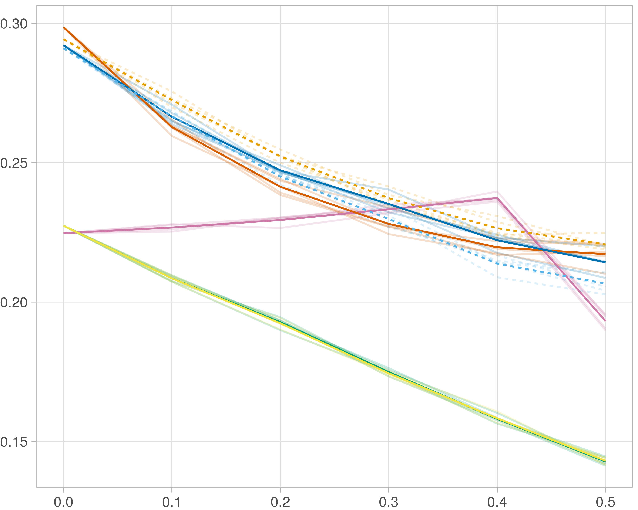

### Multi_omics

#general setup  
dir <- "/workspaces/phd_dissertation/kimono/analysis/data/derived_data/"  
  
#load library  
setwd(dir)  
  
dat_raw <- fread("221116_all_project_info.csv")  
  
#dat_raw <- cbind(dat_raw[,c(1,2,3,16,18)],nodes=dat_raw$V6+dat_raw$V8+dat_raw$V10)  
#dat_raw <- dat_raw[dat_raw$iteration == 1,]  
  
dat_raw$method <- gsub(pattern = "_moran|_mos|_mor|_so|_sor",replacement = "",x = dat_raw$method)  
  
dat <- dat_raw[tolower(dat_raw$method) %in% c("galasso_false","galasso_true","knnkimono","salasso_false","salasso_true","cocolasso","hmlasso"),]  
  
  
#ggplot(dat, aes(x=clustering, y=n_genes+n_methylation+n_cnv, color=as.factor(method)) )+  
# geom_point(alpha=0.5) + facet_grid(experiment~noise)  
  
#ggplot(dat, aes(y=clustering, x=missingness, color=as.factor(method)) )+  
# geom_point(alpha=0.5) + facet_grid(experiment~noise)  
  
#ggplot(dat, aes(x=missingness, y=clustering,fill=as.factor(method)))+  
# scale_y_continuous(trans='sqrt') + geom_boxplot() + facet_grid(experiment~noise)  
  
  
dat$method <- as.factor(dat$method)   
dat <- dat %>% mutate(method = fct_relevel(method, "knnkimono", "galasso_false" ,"galasso_true" , "salasso_false" , "salasso_true" ,"cocolasso", "hmlasso" ))  
dat$experiment <- as.factor(dat$experiment)  
dat <- dat %>% mutate(experiment = fct_relevel(experiment, "so", "moran" ,"mos" , "sor" , "mor"))  
  
palette_OkabeIto <- c( "#CC79A7", "#D55E00", "#E69F00","#0072B2", "#56B4E9", "#009E73", "#F0E442")  
  
dat <- aggregate(dat[, -c(1:8)], list('noise'=dat$noise,  
 'missingness'=dat$missingness,  
 'method'=dat$method,  
 'experiment'=dat$experiment), function(x){mean(x,na.rm=TRUE)})  
  
dat_raw$method <- as.factor(dat_raw$method)   
dat_raw <- dat_raw %>% mutate(method = fct_relevel(method, "knnkimono", "galasso_false" ,"galasso_true" , "salasso_false" , "salasso_true" ,"cocolasso", "hmlasso" ))  
dat_raw$experiment <- as.factor(dat_raw$experiment)  
dat_raw <- dat_raw %>% mutate(experiment = fct_relevel(experiment, "so", "moran" ,"mos" , "sor" , "mor"))  
  
dat_raw <- dat_raw[ dat_raw$noise==0 & dat_raw$experiment %in% 'moran' & !dat_raw$method %in% "bdcoco_lasso",]  
dat <- dat[ dat$noise==0 & dat$experiment %in% 'moran' & !dat$method %in% "bdcoco_lasso",]  
  
dat_raw$adaptive <- grepl(pattern = "true",x = dat_raw$method)  
dat$adaptive <- grepl(pattern = "true",x = dat$method)  
  
p <- ggplot(dat_raw,   
 aes(y= (median_r2), x=missingness,color=as.factor(method)))+  
   
 geom_line(aes( group = interaction(method, iteration),linetype=adaptive),alpha = 0.2)+  
 facet_grid(noise~experiment, scales="free")+  
 scale_color_manual(values = palette_OkabeIto)+  
 scale_fill_manual(values = palette_OkabeIto)+   
 theme_light() +  
 theme(legend.position="bottom",  
 axis.text.x = element_text(size = 8),  
 axis.text.y = element_text(size = 8),  
 strip.background = element_blank(),   
 plot.margin = unit(c(-0.5, -0.5, 0, 0), "cm")  
 ) +  
 ylab("#Nodes")   
  
to.plot3 <- p + geom_line(data = dat,   
 aes(y= (median_r2), x=missingness, color=as.factor(method),linetype=adaptive)) +   
 theme(strip.background = element_blank(), panel.grid.minor = element_blank(),  
 legend.position = "none",  
 axis.title.x=element_blank(),  
 #axis.text.x=element_blank(),  
 #axis.ticks.x=element_blank(),  
 axis.title.y=element_blank(),  
 #axis.text.y=element_blank(),  
 #axis.ticks.y=element_blank(),   
 plot.margin = unit(c(-0.5, -0.5, 0, 0), "cm")  
 )  
  
to.plot3

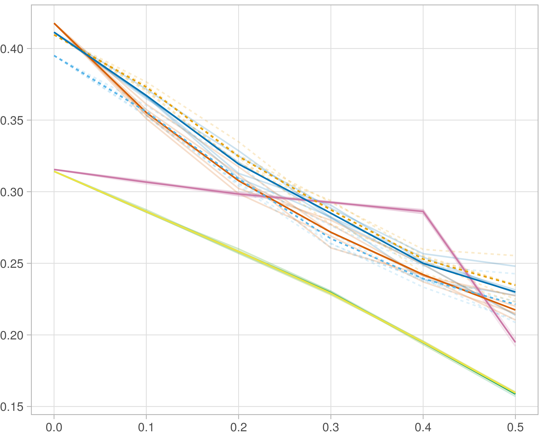

### Block-wise

#general setup  
dir <- "/workspaces/phd_dissertation/kimono/analysis/data/derived_data/"  
  
#load library  
setwd(dir)  
  
dat_raw <- fread("221116_all_project_info.csv")  
  
#dat_raw <- cbind(dat_raw[,c(1,2,3,16,18)],nodes=dat_raw$V6+dat_raw$V8+dat_raw$V10)  
#dat_raw <- dat_raw[dat_raw$iteration == 1,]  
  
dat_raw$method <- gsub(pattern = "_moran|_mos|_mor|_so|_sor",replacement = "",x = dat_raw$method)  
  
dat <- dat_raw[tolower(dat_raw$method) %in% c("galasso_false","galasso_true","knnkimono","salasso_false","salasso_true","cocolasso","hmlasso"),]  
  
  
#ggplot(dat, aes(x=clustering, y=n_genes+n_methylation+n_cnv, color=as.factor(method)) )+  
# geom_point(alpha=0.5) + facet_grid(experiment~noise)  
  
#ggplot(dat, aes(y=clustering, x=missingness, color=as.factor(method)) )+  
# geom_point(alpha=0.5) + facet_grid(experiment~noise)  
  
#ggplot(dat, aes(x=missingness, y=clustering,fill=as.factor(method)))+  
# scale_y_continuous(trans='sqrt') + geom_boxplot() + facet_grid(experiment~noise)  
  
  
dat$method <- as.factor(dat$method)   
dat <- dat %>% mutate(method = fct_relevel(method, "knnkimono", "galasso_false" ,"galasso_true" , "salasso_false" , "salasso_true" ,"cocolasso", "hmlasso" ))  
dat$experiment <- as.factor(dat$experiment)  
dat <- dat %>% mutate(experiment = fct_relevel(experiment, "so", "moran" ,"mos" , "sor" , "mor"))  
  
palette_OkabeIto <- c( "#CC79A7", "#D55E00", "#E69F00","#0072B2", "#56B4E9", "#009E73", "#F0E442")  
  
dat <- aggregate(dat[, -c(1:8)], list('noise'=dat$noise,  
 'missingness'=dat$missingness,  
 'method'=dat$method,  
 'experiment'=dat$experiment), function(x){mean(x,na.rm=TRUE)})  
  
dat_raw$method <- as.factor(dat_raw$method)   
dat_raw <- dat_raw %>% mutate(method = fct_relevel(method, "knnkimono", "galasso_false" ,"galasso_true" , "salasso_false" , "salasso_true" ,"cocolasso", "hmlasso" ))  
dat_raw$experiment <- as.factor(dat_raw$experiment)  
dat_raw <- dat_raw %>% mutate(experiment = fct_relevel(experiment, "so", "moran" ,"mos" , "sor" , "mor"))  
  
dat_raw <- dat_raw[ dat_raw$noise==0 & dat_raw$experiment %in% 'mos' & !dat_raw$method %in% "bdcoco_lasso",]  
dat <- dat[ dat$noise==0 & dat$experiment %in% 'mos' & !dat$method %in% "bdcoco_lasso",]  
  
dat_raw$adaptive <- grepl(pattern = "true",x = dat_raw$method)  
dat$adaptive <- grepl(pattern = "true",x = dat$method)  
  
p <- ggplot(dat_raw,   
 aes(y= (median_r2), x=missingness,color=as.factor(method)))+  
   
 geom_line(aes( group = interaction(method, iteration),linetype=adaptive),alpha = 0.2)+  
 facet_grid(noise~experiment, scales="free")+  
 scale_color_manual(values = palette_OkabeIto)+  
 scale_fill_manual(values = palette_OkabeIto)+   
 theme_light() +  
 theme(legend.position="bottom",  
 axis.text.x = element_text(size = 8),  
 axis.text.y = element_text(size = 8),  
 strip.background = element_blank(),   
 plot.margin = unit(c(-0.5, -0.5, 0, 0), "cm")  
 ) +  
 ylab("#Nodes")   
  
to.plot3 <- p + geom_line(data = dat,   
 aes(y= (median_r2), x=missingness, color=as.factor(method),linetype=adaptive)) +   
 theme(strip.background = element_blank(), panel.grid.minor = element_blank(),  
 legend.position = "none",  
 axis.title.x=element_blank(),  
 #axis.text.x=element_blank(),  
 #axis.ticks.x=element_blank(),  
 axis.title.y=element_blank(),  
 #axis.text.y=element_blank(),  
 #axis.ticks.y=element_blank(),   
 plot.margin = unit(c(-0.5, -0.5, 0, 0), "cm")  
 )  
  
to.plot3

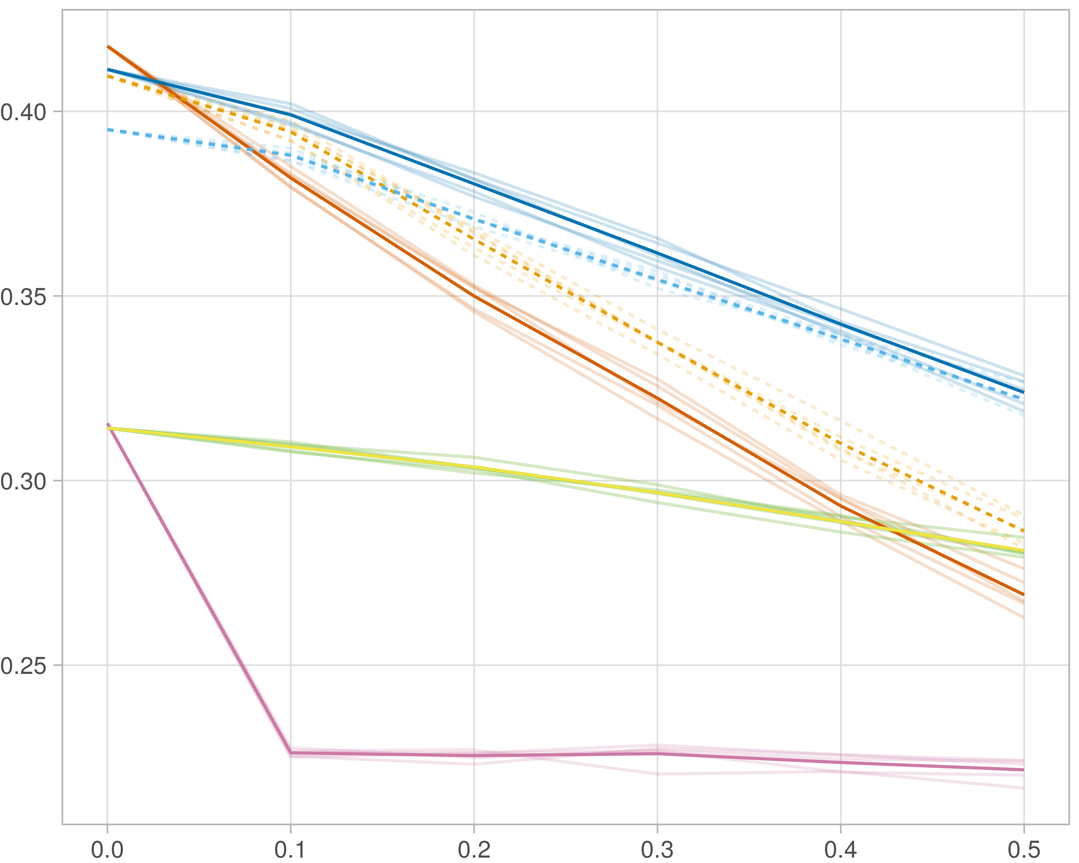

## F1-score (reference)

### Single-omics

#general setup  
dir <- "/workspaces/phd_dissertation/kimono/analysis/data/derived_data/"  
  
#load library  
setwd(dir)  
  
dat_raw <- fread("221116_all_project_info.csv")  
  
#dat_raw <- cbind(dat_raw[,c(1,2,3,16,18)],nodes=dat_raw$V6+dat_raw$V8+dat_raw$V10)  
#dat_raw <- dat_raw[dat_raw$iteration == 1,]  
  
dat_raw$method <- gsub(pattern = "_moran|_mos|_mor|_so|_sor",replacement = "",x = dat_raw$method)  
  
dat <- dat_raw[tolower(dat_raw$method) %in% c("galasso_false","galasso_true","knnkimono","salasso_false","salasso_true","cocolasso","hmlasso"),]  
  
  
#ggplot(dat, aes(x=clustering, y=n_genes+n_methylation+n_cnv, color=as.factor(method)) )+  
# geom_point(alpha=0.5) + facet_grid(experiment~noise)  
  
#ggplot(dat, aes(y=clustering, x=missingness, color=as.factor(method)) )+  
# geom_point(alpha=0.5) + facet_grid(experiment~noise)  
  
#ggplot(dat, aes(x=missingness, y=clustering,fill=as.factor(method)))+  
# scale_y_continuous(trans='sqrt') + geom_boxplot() + facet_grid(experiment~noise)  
  
  
dat$method <- as.factor(dat$method)   
dat <- dat %>% mutate(method = fct_relevel(method, "knnkimono", "galasso_false" ,"galasso_true" , "salasso_false" , "salasso_true" ,"cocolasso", "hmlasso" ))  
dat$experiment <- as.factor(dat$experiment)  
dat <- dat %>% mutate(experiment = fct_relevel(experiment, "so", "moran" ,"mos" , "sor" , "mor"))  
  
palette_OkabeIto <- c( "#CC79A7", "#D55E00", "#E69F00","#0072B2", "#56B4E9", "#009E73", "#F0E442")  
  
dat <- aggregate(dat[, -c(1:8)], list('noise'=dat$noise,  
 'missingness'=dat$missingness,  
 'method'=dat$method,  
 'experiment'=dat$experiment), function(x){mean(x,na.rm=TRUE)})  
  
dat_raw$method <- as.factor(dat_raw$method)   
dat_raw <- dat_raw %>% mutate(method = fct_relevel(method, "knnkimono", "galasso_false" ,"galasso_true" , "salasso_false" , "salasso_true" ,"cocolasso", "hmlasso" ))  
dat_raw$experiment <- as.factor(dat_raw$experiment)  
dat_raw <- dat_raw %>% mutate(experiment = fct_relevel(experiment, "so", "moran" ,"mos" , "sor" , "mor"))  
  
dat_raw <- dat_raw[ dat_raw$noise==0 & dat_raw$experiment %in% 'so' & !dat_raw$method %in% "bdcoco_lasso",]  
dat <- dat[ dat$noise==0 & dat$experiment %in% 'so' & !dat$method %in% "bdcoco_lasso",]  
  
dat_raw$adaptive <- grepl(pattern = "true",x = dat_raw$method)  
dat$adaptive <- grepl(pattern = "true",x = dat$method)  
  
p <- ggplot(dat_raw,   
 aes(y= (f1_score_reference), x=missingness,color=as.factor(method)))+  
   
 geom_line(aes( group = interaction(method, iteration),linetype=adaptive),alpha = 0.2)+  
 facet_grid(noise~experiment, scales="free")+  
 scale_color_manual(values = palette_OkabeIto)+  
 scale_fill_manual(values = palette_OkabeIto)+   
 theme_light() +  
 theme(legend.position="bottom",  
 axis.text.x = element_text(size = 8),  
 axis.text.y = element_text(size = 8),  
 strip.background = element_blank(),   
 plot.margin = unit(c(-0.5, -0.5, 0, 0), "cm")  
 ) +  
 ylab("#Nodes")   
  
to.plot4 <- p + geom_line(data = dat,   
 aes(y= (f1_score_reference), x=missingness, color=as.factor(method),linetype=adaptive)) +   
 theme(strip.background = element_blank(), panel.grid.minor = element_blank(),  
 legend.position = "none",  
 axis.title.x=element_blank(),  
 #axis.text.x=element_blank(),  
 #axis.ticks.x=element_blank(),  
 axis.title.y=element_blank(),  
 #axis.text.y=element_blank(),  
 #axis.ticks.y=element_blank(),   
 plot.margin = unit(c(-0.5, -0.5, 0, 0), "cm")  
 )  
  
to.plot4

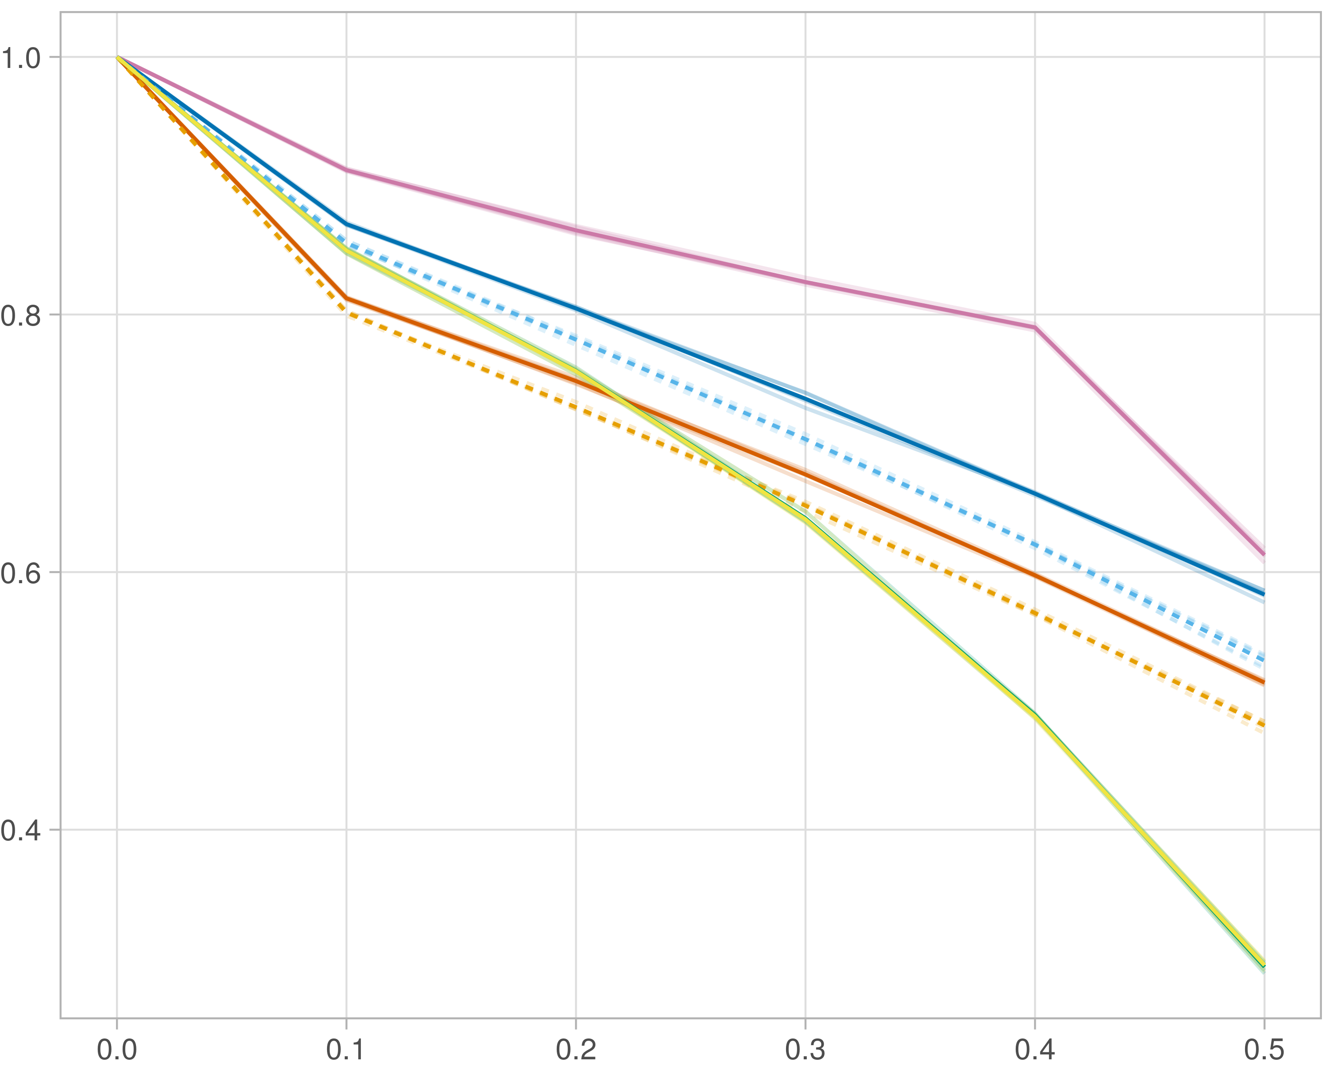

### Multi-omics

#general setup  
dir <- "/workspaces/phd_dissertation/kimono/analysis/data/derived_data/"  
  
#load library  
setwd(dir)  
  
dat_raw <- fread("221116_all_project_info.csv")  
  
#dat_raw <- cbind(dat_raw[,c(1,2,3,16,18)],nodes=dat_raw$V6+dat_raw$V8+dat_raw$V10)  
#dat_raw <- dat_raw[dat_raw$iteration == 1,]  
  
dat_raw$method <- gsub(pattern = "_moran|_mos|_mor|_so|_sor",replacement = "",x = dat_raw$method)  
  
dat <- dat_raw[tolower(dat_raw$method) %in% c("galasso_false","galasso_true","knnkimono","salasso_false","salasso_true","cocolasso","hmlasso"),]  
  
  
#ggplot(dat, aes(x=clustering, y=n_genes+n_methylation+n_cnv, color=as.factor(method)) )+  
# geom_point(alpha=0.5) + facet_grid(experiment~noise)  
  
#ggplot(dat, aes(y=clustering, x=missingness, color=as.factor(method)) )+  
# geom_point(alpha=0.5) + facet_grid(experiment~noise)  
  
#ggplot(dat, aes(x=missingness, y=clustering,fill=as.factor(method)))+  
# scale_y_continuous(trans='sqrt') + geom_boxplot() + facet_grid(experiment~noise)  
  
  
dat$method <- as.factor(dat$method)   
dat <- dat %>% mutate(method = fct_relevel(method, "knnkimono", "galasso_false" ,"galasso_true" , "salasso_false" , "salasso_true" ,"cocolasso", "hmlasso" ))  
dat$experiment <- as.factor(dat$experiment)  
dat <- dat %>% mutate(experiment = fct_relevel(experiment, "so", "moran" ,"mos" , "sor" , "mor"))  
  
palette_OkabeIto <- c( "#CC79A7", "#D55E00", "#E69F00","#0072B2", "#56B4E9", "#009E73", "#F0E442")  
  
dat <- aggregate(dat[, -c(1:8)], list('noise'=dat$noise,  
 'missingness'=dat$missingness,  
 'method'=dat$method,  
 'experiment'=dat$experiment), function(x){mean(x,na.rm=TRUE)})  
  
dat_raw$method <- as.factor(dat_raw$method)   
dat_raw <- dat_raw %>% mutate(method = fct_relevel(method, "knnkimono", "galasso_false" ,"galasso_true" , "salasso_false" , "salasso_true" ,"cocolasso", "hmlasso" ))  
dat_raw$experiment <- as.factor(dat_raw$experiment)  
dat_raw <- dat_raw %>% mutate(experiment = fct_relevel(experiment, "so", "moran" ,"mos" , "sor" , "mor"))  
  
dat_raw <- dat_raw[ dat_raw$noise==0 & dat_raw$experiment %in% 'moran' & !dat_raw$method %in% "bdcoco_lasso",]  
dat <- dat[ dat$noise==0 & dat$experiment %in% 'moran' & !dat$method %in% "bdcoco_lasso",]  
  
dat_raw$adaptive <- grepl(pattern = "true",x = dat_raw$method)  
dat$adaptive <- grepl(pattern = "true",x = dat$method)  
  
p <- ggplot(dat_raw,   
 aes(y= (f1_score_reference), x=missingness,color=as.factor(method)))+  
   
 geom_line(aes( group = interaction(method, iteration),linetype=adaptive),alpha = 0.2)+  
 facet_grid(noise~experiment, scales="free")+  
 scale_color_manual(values = palette_OkabeIto)+  
 scale_fill_manual(values = palette_OkabeIto)+   
 theme_light() +  
 theme(legend.position="bottom",  
 axis.text.x = element_text(size = 8),  
 axis.text.y = element_text(size = 8),  
 strip.background = element_blank(),   
 plot.margin = unit(c(-0.5, -0.5, 0, 0), "cm")  
 ) +  
 ylab("#Nodes")   
  
to.plot4 <- p + geom_line(data = dat,   
 aes(y= (f1_score_reference), x=missingness, color=as.factor(method),linetype=adaptive)) +   
 theme(strip.background = element_blank(), panel.grid.minor = element_blank(),  
 legend.position = "none",  
 axis.title.x=element_blank(),  
 #axis.text.x=element_blank(),  
 #axis.ticks.x=element_blank(),  
 axis.title.y=element_blank(),  
 #axis.text.y=element_blank(),  
 #axis.ticks.y=element_blank(),   
 plot.margin = unit(c(-0.5, -0.5, 0, 0), "cm")  
 )  
  
to.plot4

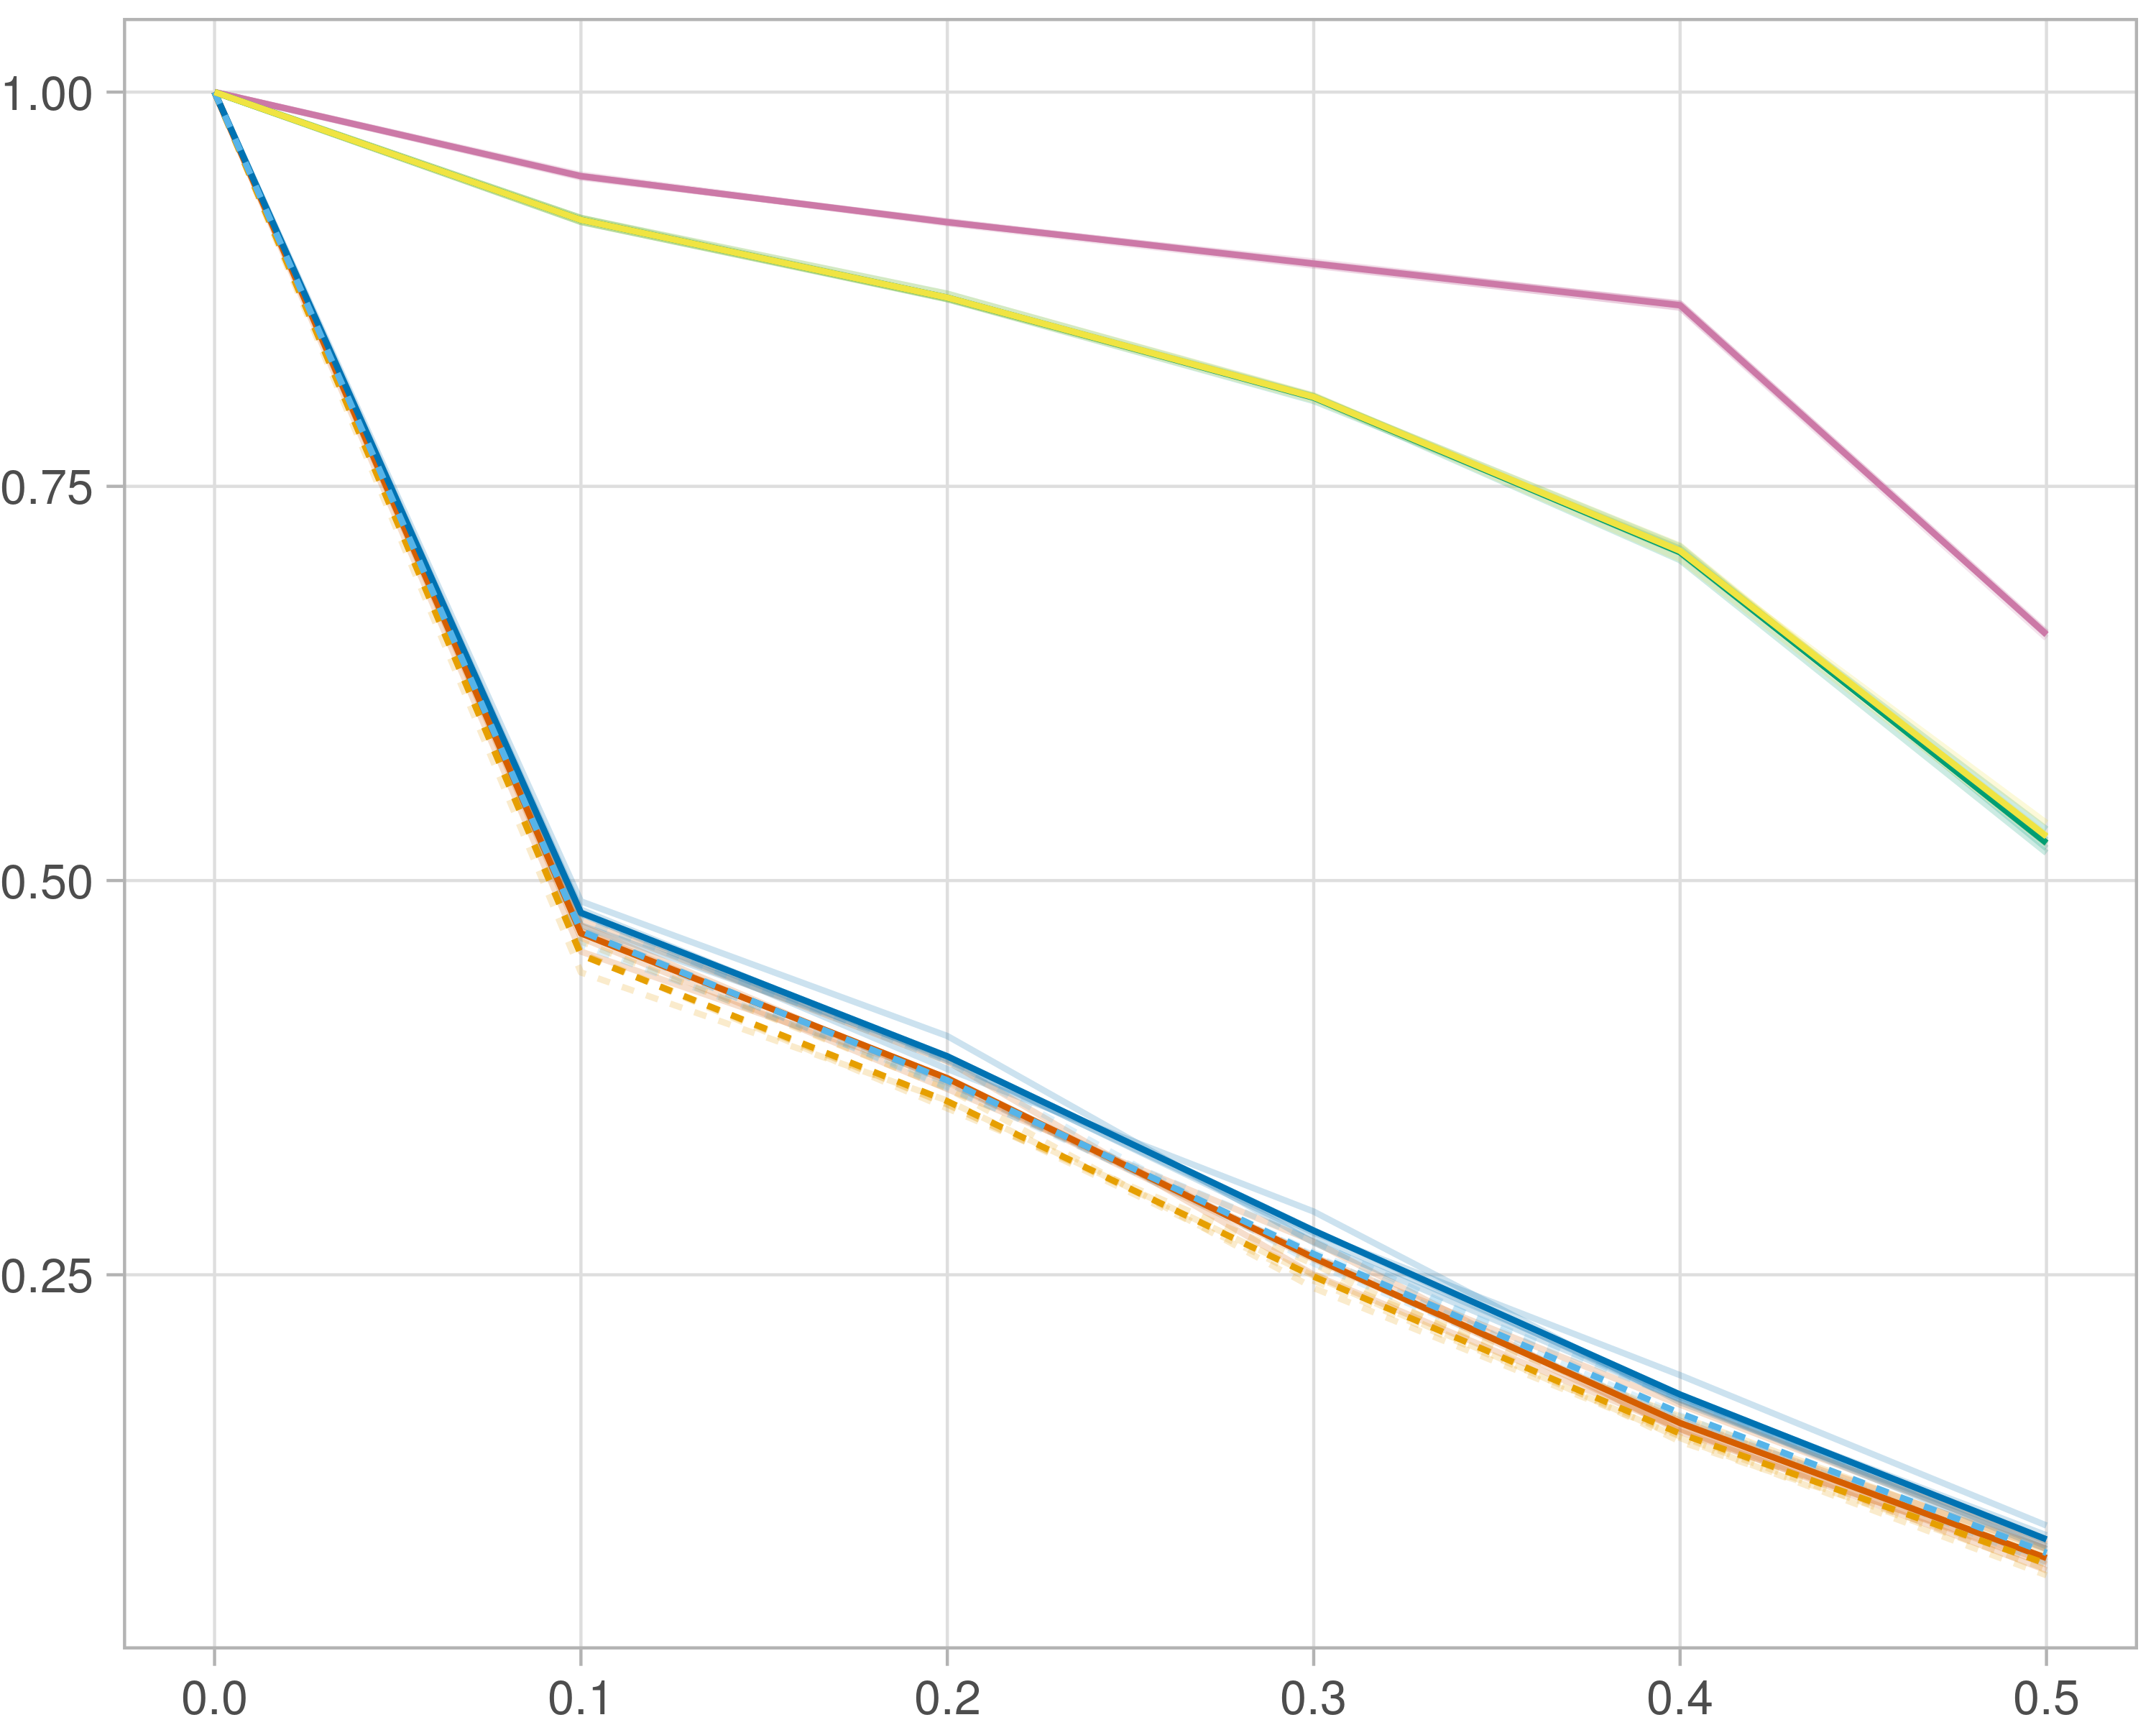

### Block-wise

#general setup  
dir <- "/workspaces/phd_dissertation/kimono/analysis/data/derived_data/"  
  
#load library  
setwd(dir)  
  
dat_raw <- fread("221116_all_project_info.csv")  
  
#dat_raw <- cbind(dat_raw[,c(1,2,3,16,18)],nodes=dat_raw$V6+dat_raw$V8+dat_raw$V10)  
#dat_raw <- dat_raw[dat_raw$iteration == 1,]  
  
dat_raw$method <- gsub(pattern = "_moran|_mos|_mor|_so|_sor",replacement = "",x = dat_raw$method)  
  
dat <- dat_raw[tolower(dat_raw$method) %in% c("galasso_false","galasso_true","knnkimono","salasso_false","salasso_true","cocolasso","hmlasso"),]  
  
  
#ggplot(dat, aes(x=clustering, y=n_genes+n_methylation+n_cnv, color=as.factor(method)) )+  
# geom_point(alpha=0.5) + facet_grid(experiment~noise)  
  
#ggplot(dat, aes(y=clustering, x=missingness, color=as.factor(method)) )+  
# geom_point(alpha=0.5) + facet_grid(experiment~noise)  
  
#ggplot(dat, aes(x=missingness, y=clustering,fill=as.factor(method)))+  
# scale_y_continuous(trans='sqrt') + geom_boxplot() + facet_grid(experiment~noise)  
  
  
dat$method <- as.factor(dat$method)   
dat <- dat %>% mutate(method = fct_relevel(method, "knnkimono", "galasso_false" ,"galasso_true" , "salasso_false" , "salasso_true" ,"cocolasso", "hmlasso" ))  
dat$experiment <- as.factor(dat$experiment)  
dat <- dat %>% mutate(experiment = fct_relevel(experiment, "so", "moran" ,"mos" , "sor" , "mor"))  
  
palette_OkabeIto <- c( "#CC79A7", "#D55E00", "#E69F00","#0072B2", "#56B4E9", "#009E73", "#F0E442")  
  
dat <- aggregate(dat[, -c(1:8)], list('noise'=dat$noise,  
 'missingness'=dat$missingness,  
 'method'=dat$method,  
 'experiment'=dat$experiment), function(x){mean(x,na.rm=TRUE)})  
  
dat_raw$method <- as.factor(dat_raw$method)   
dat_raw <- dat_raw %>% mutate(method = fct_relevel(method, "knnkimono", "galasso_false" ,"galasso_true" , "salasso_false" , "salasso_true" ,"cocolasso", "hmlasso" ))  
dat_raw$experiment <- as.factor(dat_raw$experiment)  
dat_raw <- dat_raw %>% mutate(experiment = fct_relevel(experiment, "so", "moran" ,"mos" , "sor" , "mor"))  
  
dat_raw <- dat_raw[ dat_raw$noise==0 & dat_raw$experiment %in% 'mos' & !dat_raw$method %in% "bdcoco_lasso",]  
dat <- dat[ dat$noise==0 & dat$experiment %in% 'mos' & !dat$method %in% "bdcoco_lasso",]  
  
dat_raw$adaptive <- grepl(pattern = "true",x = dat_raw$method)  
dat$adaptive <- grepl(pattern = "true",x = dat$method)  
  
p <- ggplot(dat_raw,   
 aes(y= (f1_score_reference), x=missingness,color=as.factor(method)))+  
   
 geom_line(aes( group = interaction(method, iteration),linetype=adaptive),alpha = 0.2)+  
 facet_grid(noise~experiment, scales="free")+  
 scale_color_manual(values = palette_OkabeIto)+  
 scale_fill_manual(values = palette_OkabeIto)+   
 theme_light() +  
 theme(legend.position="bottom",  
 axis.text.x = element_text(size = 8),  
 axis.text.y = element_text(size = 8),  
 strip.background = element_blank(),   
 plot.margin = unit(c(-0.5, -0.5, 0, 0), "cm")  
 ) +  
 ylab("#Nodes")   
  
to.plot4 <- p + geom_line(data = dat,   
 aes(y= (f1_score_reference), x=missingness, color=as.factor(method),linetype=adaptive)) +   
 theme(strip.background = element_blank(), panel.grid.minor = element_blank(),  
 legend.position = "none",  
 axis.title.x=element_blank(),  
 #axis.text.x=element_blank(),  
 #axis.ticks.x=element_blank(),  
 axis.title.y=element_blank(),  
 #axis.text.y=element_blank(),  
 #axis.ticks.y=element_blank(),   
 plot.margin = unit(c(-0.5, -0.5, 0, 0), "cm")  
 )  
  
to.plot4

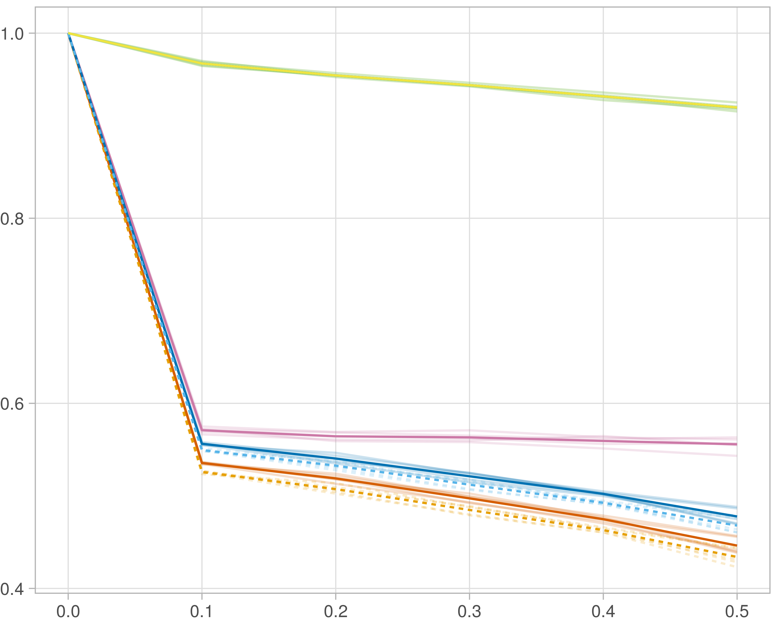

## F1-score (stability selection)

### Single-omics

#general setup  
dir <- "/workspaces/phd_dissertation/kimono/analysis/data/derived_data/"  
  
#load library  
setwd(dir)  
  
dat_raw <- fread("221116_all_project_info.csv")  
  
#dat_raw <- cbind(dat_raw[,c(1,2,3,16,18)],nodes=dat_raw$V6+dat_raw$V8+dat_raw$V10)  
#dat_raw <- dat_raw[dat_raw$iteration == 1,]  
  
dat_raw$method <- gsub(pattern = "_moran|_mos|_mor|_so|_sor",replacement = "",x = dat_raw$method)  
  
dat <- dat_raw[tolower(dat_raw$method) %in% c("galasso_false","galasso_true","knnkimono","salasso_false","salasso_true","cocolasso","hmlasso"),]  
  
  
#ggplot(dat, aes(x=clustering, y=n_genes+n_methylation+n_cnv, color=as.factor(method)) )+  
# geom_point(alpha=0.5) + facet_grid(experiment~noise)  
  
#ggplot(dat, aes(y=clustering, x=missingness, color=as.factor(method)) )+  
# geom_point(alpha=0.5) + facet_grid(experiment~noise)  
  
#ggplot(dat, aes(x=missingness, y=clustering,fill=as.factor(method)))+  
# scale_y_continuous(trans='sqrt') + geom_boxplot() + facet_grid(experiment~noise)  
  
  
dat$method <- as.factor(dat$method)   
dat <- dat %>% mutate(method = fct_relevel(method, "knnkimono", "galasso_false" ,"galasso_true" , "salasso_false" , "salasso_true" ,"cocolasso", "hmlasso" ))  
dat$experiment <- as.factor(dat$experiment)  
dat <- dat %>% mutate(experiment = fct_relevel(experiment, "so", "moran" ,"mos" , "sor" , "mor"))  
  
palette_OkabeIto <- c( "#CC79A7", "#D55E00", "#E69F00","#0072B2", "#56B4E9", "#009E73", "#F0E442")  
  
dat <- aggregate(dat[, -c(1:8)], list('noise'=dat$noise,  
 'missingness'=dat$missingness,  
 'method'=dat$method,  
 'experiment'=dat$experiment), function(x){mean(x,na.rm=TRUE)})  
  
dat_raw$method <- as.factor(dat_raw$method)   
dat_raw <- dat_raw %>% mutate(method = fct_relevel(method, "knnkimono", "galasso_false" ,"galasso_true" , "salasso_false" , "salasso_true" ,"cocolasso", "hmlasso" ))  
dat_raw$experiment <- as.factor(dat_raw$experiment)  
dat_raw <- dat_raw %>% mutate(experiment = fct_relevel(experiment, "so", "moran" ,"mos" , "sor" , "mor"))  
  
dat_raw <- dat_raw[ dat_raw$noise==0 & dat_raw$experiment %in% 'so' & !dat_raw$method %in% "bdcoco_lasso",]  
dat <- dat[ dat$noise==0 & dat$experiment %in% 'so' & !dat$method %in% "bdcoco_lasso",]  
  
dat_raw$adaptive <- grepl(pattern = "true",x = dat_raw$method)  
dat$adaptive <- grepl(pattern = "true",x = dat$method)  
  
p <- ggplot(dat_raw,   
 aes(y= (f1_score_stability), x=missingness,color=as.factor(method)))+  
   
 geom_line(aes( group = interaction(method, iteration),linetype=adaptive),alpha = 0.2)+  
 facet_grid(noise~experiment, scales="free")+  
 scale_color_manual(values = palette_OkabeIto)+  
 scale_fill_manual(values = palette_OkabeIto)+   
 theme_light() +  
 theme(legend.position="bottom",  
 axis.text.x = element_text(size = 8),  
 axis.text.y = element_text(size = 8),  
 strip.background = element_blank(),   
 plot.margin = unit(c(-0.5, -0.5, 0, 0), "cm")  
 ) +  
 ylab("#Nodes")   
  
to.plot5 <- p + geom_line(data = dat,   
 aes(y= (f1_score_stability), x=missingness, color=as.factor(method),linetype=adaptive)) +   
 theme(strip.background = element_blank(), panel.grid.minor = element_blank(),  
 legend.position = "none",  
 axis.title.x=element_blank(),  
 #axis.text.x=element_blank(),  
 #axis.ticks.x=element_blank(),  
 axis.title.y=element_blank(),  
 #axis.text.y=element_blank(),  
 #axis.ticks.y=element_blank(),   
 plot.margin = unit(c(-0.5, -0.5, 0, 0), "cm")  
 )  
  
to.plot5

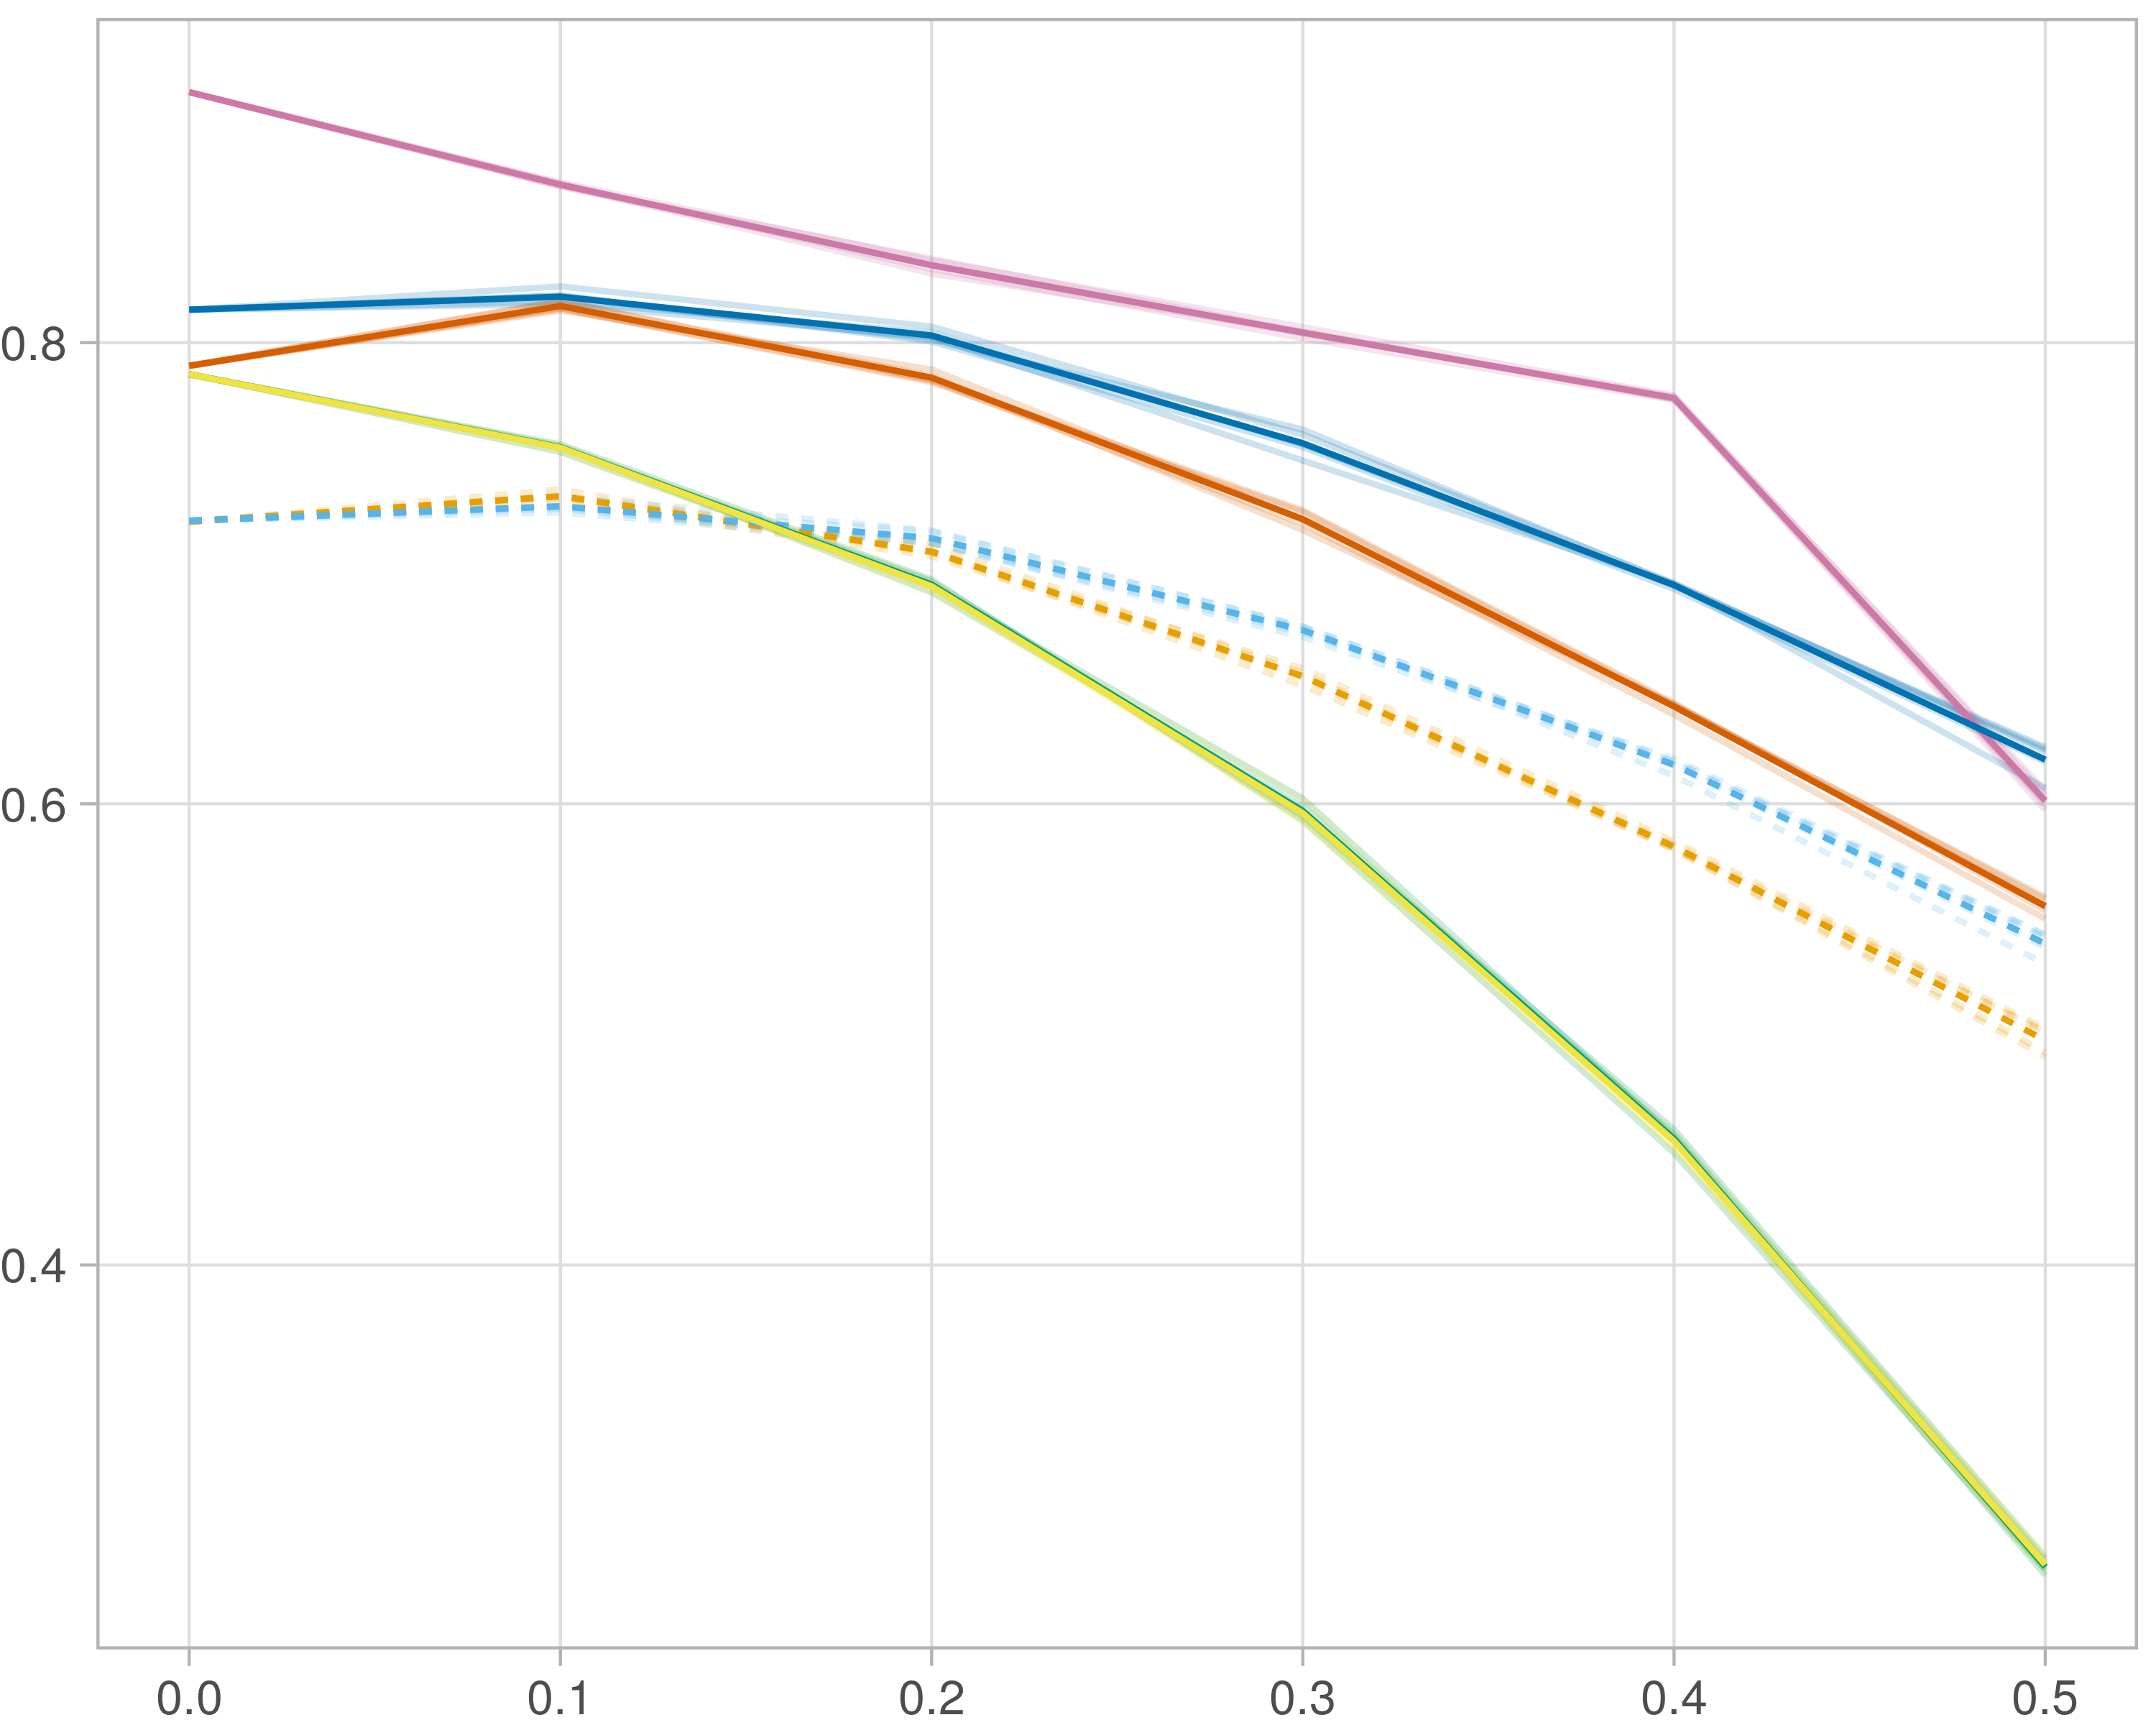

### Multi-omics

#general setup  
dir <- "/workspaces/phd_dissertation/kimono/analysis/data/derived_data/"  
  
#load library  
setwd(dir)  
  
dat_raw <- fread("221116_all_project_info.csv")  
  
#dat_raw <- cbind(dat_raw[,c(1,2,3,16,18)],nodes=dat_raw$V6+dat_raw$V8+dat_raw$V10)  
#dat_raw <- dat_raw[dat_raw$iteration == 1,]  
  
dat_raw$method <- gsub(pattern = "_moran|_mos|_mor|_so|_sor",replacement = "",x = dat_raw$method)  
  
dat <- dat_raw[tolower(dat_raw$method) %in% c("galasso_false","galasso_true","knnkimono","salasso_false","salasso_true","cocolasso","hmlasso"),]  
  
  
#ggplot(dat, aes(x=clustering, y=n_genes+n_methylation+n_cnv, color=as.factor(method)) )+  
# geom_point(alpha=0.5) + facet_grid(experiment~noise)  
  
#ggplot(dat, aes(y=clustering, x=missingness, color=as.factor(method)) )+  
# geom_point(alpha=0.5) + facet_grid(experiment~noise)  
  
#ggplot(dat, aes(x=missingness, y=clustering,fill=as.factor(method)))+  
# scale_y_continuous(trans='sqrt') + geom_boxplot() + facet_grid(experiment~noise)  
  
  
dat$method <- as.factor(dat$method)   
dat <- dat %>% mutate(method = fct_relevel(method, "knnkimono", "galasso_false" ,"galasso_true" , "salasso_false" , "salasso_true" ,"cocolasso", "hmlasso" ))  
dat$experiment <- as.factor(dat$experiment)  
dat <- dat %>% mutate(experiment = fct_relevel(experiment, "so", "moran" ,"mos" , "sor" , "mor"))  
  
palette_OkabeIto <- c( "#CC79A7", "#D55E00", "#E69F00","#0072B2", "#56B4E9", "#009E73", "#F0E442")  
  
dat <- aggregate(dat[, -c(1:8)], list('noise'=dat$noise,  
 'missingness'=dat$missingness,  
 'method'=dat$method,  
 'experiment'=dat$experiment), function(x){mean(x,na.rm=TRUE)})  
  
dat_raw$method <- as.factor(dat_raw$method)   
dat_raw <- dat_raw %>% mutate(method = fct_relevel(method, "knnkimono", "galasso_false" ,"galasso_true" , "salasso_false" , "salasso_true" ,"cocolasso", "hmlasso" ))  
dat_raw$experiment <- as.factor(dat_raw$experiment)  
dat_raw <- dat_raw %>% mutate(experiment = fct_relevel(experiment, "so", "moran" ,"mos" , "sor" , "mor"))  
  
dat_raw <- dat_raw[ dat_raw$noise==0 & dat_raw$experiment %in% 'moran' & !dat_raw$method %in% "bdcoco_lasso",]  
dat <- dat[ dat$noise==0 & dat$experiment %in% 'moran' & !dat$method %in% "bdcoco_lasso",]  
  
dat_raw$adaptive <- grepl(pattern = "true",x = dat_raw$method)  
dat$adaptive <- grepl(pattern = "true",x = dat$method)  
  
p <- ggplot(dat_raw,   
 aes(y= (f1_score_stability), x=missingness,color=as.factor(method)))+  
   
 geom_line(aes( group = interaction(method, iteration),linetype=adaptive),alpha = 0.2)+  
 facet_grid(noise~experiment, scales="free")+  
 scale_color_manual(values = palette_OkabeIto)+  
 scale_fill_manual(values = palette_OkabeIto)+   
 theme_light() +  
 theme(legend.position="bottom",  
 axis.text.x = element_text(size = 8),  
 axis.text.y = element_text(size = 8),  
 strip.background = element_blank(),   
 plot.margin = unit(c(-0.5, -0.5, 0, 0), "cm")  
 ) +  
 ylab("#Nodes")   
  
to.plot5 <- p + geom_line(data = dat,   
 aes(y= (f1_score_stability), x=missingness, color=as.factor(method),linetype=adaptive)) +   
 theme(strip.background = element_blank(), panel.grid.minor = element_blank(),  
 legend.position = "none",  
 axis.title.x=element_blank(),  
 #axis.text.x=element_blank(),  
 #axis.ticks.x=element_blank(),  
 axis.title.y=element_blank(),  
 #axis.text.y=element_blank(),  
 #axis.ticks.y=element_blank(),   
 plot.margin = unit(c(-0.5, -0.5, 0, 0), "cm")  
 )  
  
to.plot5

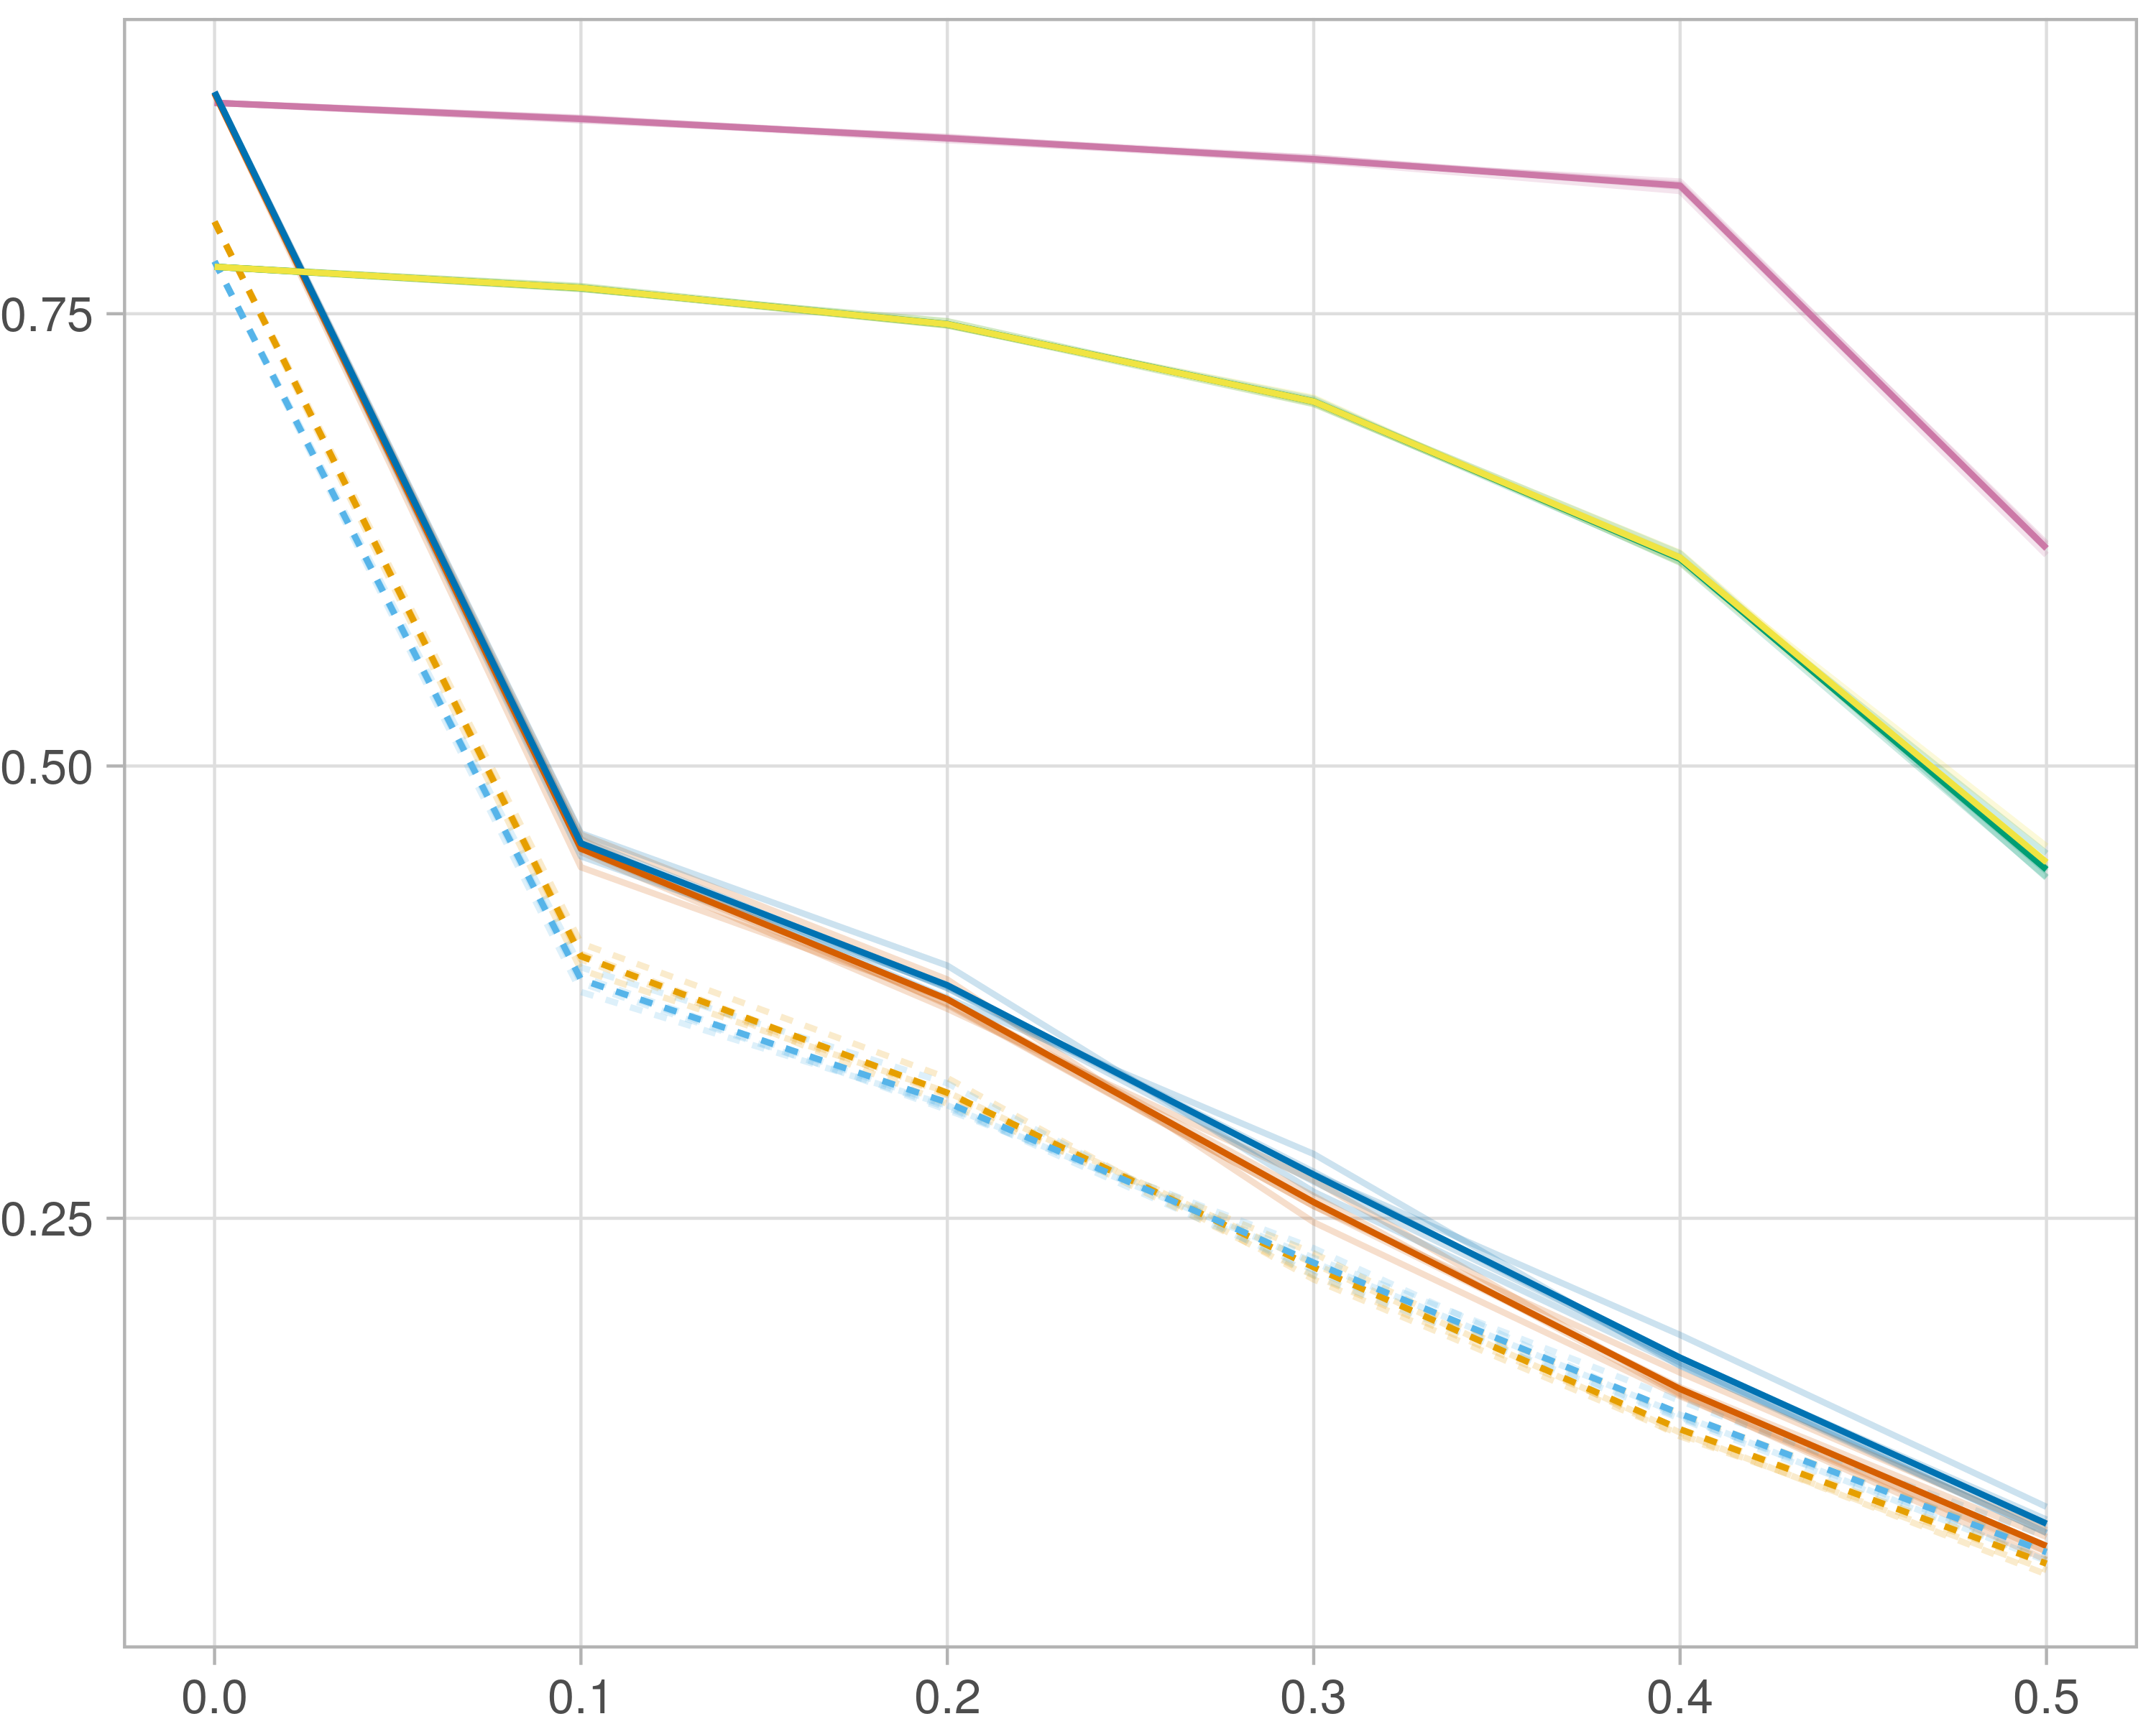

### Block-wise

#general setup  
dir <- "/workspaces/phd_dissertation/kimono/analysis/data/derived_data/"  
  
#load library  
setwd(dir)  
  
dat_raw <- fread("221116_all_project_info.csv")  
  
#dat_raw <- cbind(dat_raw[,c(1,2,3,16,18)],nodes=dat_raw$V6+dat_raw$V8+dat_raw$V10)  
#dat_raw <- dat_raw[dat_raw$iteration == 1,]  
  
dat_raw$method <- gsub(pattern = "_moran|_mos|_mor|_so|_sor",replacement = "",x = dat_raw$method)  
  
dat <- dat_raw[tolower(dat_raw$method) %in% c("galasso_false","galasso_true","knnkimono","salasso_false","salasso_true","cocolasso","hmlasso"),]  
  
  
#ggplot(dat, aes(x=clustering, y=n_genes+n_methylation+n_cnv, color=as.factor(method)) )+  
# geom_point(alpha=0.5) + facet_grid(experiment~noise)  
  
#ggplot(dat, aes(y=clustering, x=missingness, color=as.factor(method)) )+  
# geom_point(alpha=0.5) + facet_grid(experiment~noise)  
  
#ggplot(dat, aes(x=missingness, y=clustering,fill=as.factor(method)))+  
# scale_y_continuous(trans='sqrt') + geom_boxplot() + facet_grid(experiment~noise)  
  
  
dat$method <- as.factor(dat$method)   
dat <- dat %>% mutate(method = fct_relevel(method, "knnkimono", "galasso_false" ,"galasso_true" , "salasso_false" , "salasso_true" ,"cocolasso", "hmlasso" ))  
dat$experiment <- as.factor(dat$experiment)  
dat <- dat %>% mutate(experiment = fct_relevel(experiment, "so", "moran" ,"mos" , "sor" , "mor"))  
  
palette_OkabeIto <- c( "#CC79A7", "#D55E00", "#E69F00","#0072B2", "#56B4E9", "#009E73", "#F0E442")  
  
dat <- aggregate(dat[, -c(1:8)], list('noise'=dat$noise,  
 'missingness'=dat$missingness,  
 'method'=dat$method,  
 'experiment'=dat$experiment), function(x){mean(x,na.rm=TRUE)})  
  
dat_raw$method <- as.factor(dat_raw$method)   
dat_raw <- dat_raw %>% mutate(method = fct_relevel(method, "knnkimono", "galasso_false" ,"galasso_true" , "salasso_false" , "salasso_true" ,"cocolasso", "hmlasso" ))  
dat_raw$experiment <- as.factor(dat_raw$experiment)  
dat_raw <- dat_raw %>% mutate(experiment = fct_relevel(experiment, "so", "moran" ,"mos" , "sor" , "mor"))  
  
dat_raw <- dat_raw[ dat_raw$noise==0 & dat_raw$experiment %in% 'mos' & !dat_raw$method %in% "bdcoco_lasso",]  
dat <- dat[ dat$noise==0 & dat$experiment %in% 'mos' & !dat$method %in% "bdcoco_lasso",]  
  
dat_raw$adaptive <- grepl(pattern = "true",x = dat_raw$method)  
dat$adaptive <- grepl(pattern = "true",x = dat$method)  
  
p <- ggplot(dat_raw,   
 aes(y= (f1_score_stability), x=missingness,color=as.factor(method)))+  
   
 geom_line(aes( group = interaction(method, iteration),linetype=adaptive),alpha = 0.2)+  
 facet_grid(noise~experiment, scales="free")+  
 scale_color_manual(values = palette_OkabeIto)+  
 scale_fill_manual(values = palette_OkabeIto)+   
 theme_light() +  
 theme(legend.position="bottom",  
 axis.text.x = element_text(size = 8),  
 axis.text.y = element_text(size = 8),  
 strip.background = element_blank(),   
 plot.margin = unit(c(-0.5, -0.5, 0, 0), "cm")  
 ) +  
 ylab("#Nodes")   
  
to.plot5 <- p + geom_line(data = dat,   
 aes(y= (f1_score_stability), x=missingness, color=as.factor(method),linetype=adaptive)) +   
 theme(strip.background = element_blank(), panel.grid.minor = element_blank(),  
 legend.position = "none",  
 axis.title.x=element_blank(),  
 #axis.text.x=element_blank(),  
 #axis.ticks.x=element_blank(),  
 axis.title.y=element_blank(),  
 #axis.text.y=element_blank(),  
 #axis.ticks.y=element_blank(),   
 plot.margin = unit(c(-0.5, -0.5, 0, 0), "cm")  
 )  
  
to.plot5

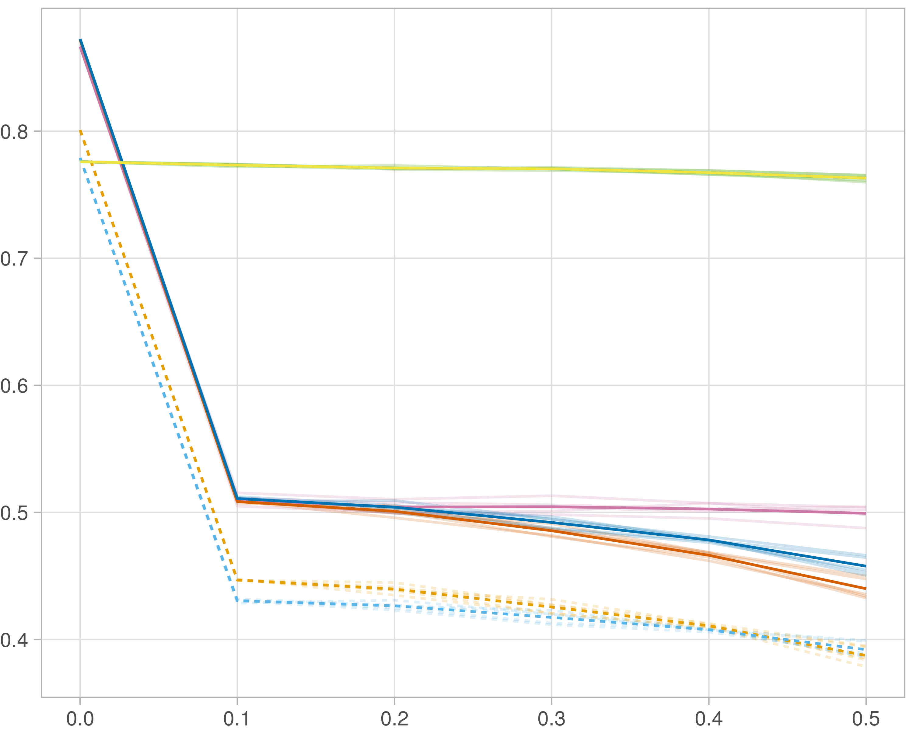

# Noise

## Number of nodes

### Single-omics

library(tidyverse)  
library(data.table)  
library(reshape)  
library(ggplot2)  
library(dplyr)  
library(viridis)  
  
#general setup  
dir <- "/workspaces/phd_dissertation/kimono/analysis/data/derived_data/"  
  
#load library  
setwd(dir)  
  
dat_raw <- fread("221116_all_project_info.csv")  
  
#dat_raw <- cbind(dat_raw[,c(1,2,3,16,18)],nodes=dat_raw$V6+dat_raw$V8+dat_raw$V10)  
#dat_raw <- dat_raw[dat_raw$iteration == 1,]  
  
dat_raw$method <- gsub(pattern = "_moran|_mos|_mor|_so|_sor",replacement = "",x = dat_raw$method)  
  
dat <- dat_raw[tolower(dat_raw$method) %in% c("galasso_false","galasso_true","knnkimono","salasso_false","salasso_true","cocolasso","hmlasso"),]  
  
  
#ggplot(dat, aes(x=clustering, y=n_genes+n_methylation+n_cnv, color=as.factor(method)) )+  
# geom_point(alpha=0.5) + facet_grid(experiment~noise)  
  
#ggplot(dat, aes(y=clustering, x=missingness, color=as.factor(method)) )+  
# geom_point(alpha=0.5) + facet_grid(experiment~noise)  
  
#ggplot(dat, aes(x=missingness, y=clustering,fill=as.factor(method)))+  
# scale_y_continuous(trans='sqrt') + geom_boxplot() + facet_grid(experiment~noise)  
  
  
dat$method <- as.factor(dat$method)   
dat <- dat %>% mutate(method = fct_relevel(method, "knnkimono", "galasso_false" ,"galasso_true" , "salasso_false" , "salasso_true" ,"cocolasso", "hmlasso" ))  
dat$experiment <- as.factor(dat$experiment)  
dat <- dat %>% mutate(experiment = fct_relevel(experiment, "so", "moran" ,"mos" , "sor" , "mor"))  
  
palette_OkabeIto <- c( "#CC79A7", "#D55E00", "#E69F00","#0072B2", "#56B4E9", "#009E73", "#F0E442")  
  
dat <- aggregate(dat[, -c(1:8)], list('noise'=dat$noise,  
 'missingness'=dat$missingness,  
 'method'=dat$method,  
 'experiment'=dat$experiment), function(x){mean(x,na.rm=TRUE)})  
  
dat_raw$method <- as.factor(dat_raw$method)   
dat_raw <- dat_raw %>% mutate(method = fct_relevel(method, "knnkimono", "galasso_false" ,"galasso_true" , "salasso_false" , "salasso_true" ,"cocolasso", "hmlasso" ))  
dat_raw$experiment <- as.factor(dat_raw$experiment)  
dat_raw <- dat_raw %>% mutate(experiment = fct_relevel(experiment, "so", "moran" ,"mos" , "sor" , "mor"))  
  
dat_raw <- dat_raw[ dat_raw$noise==1.5 & dat_raw$experiment %in% 'so' & !dat_raw$method %in% "bdcoco_lasso",]  
dat <- dat[ dat$noise==1.5 & dat$experiment %in% 'so' & !dat$method %in% "bdcoco_lasso",]  
  
dat_raw$adaptive <- grepl(pattern = "true",x = dat_raw$method)  
dat$adaptive <- grepl(pattern = "true",x = dat$method)  
  
p <- ggplot(dat_raw,   
 aes(y= (n_cnv+n_genes+n_methylation), x=missingness,color=as.factor(method)))+  
   
 geom_line(aes( group = interaction(method, iteration),linetype=adaptive),alpha = 0.2)+  
 facet_grid(noise~experiment, scales="free")+  
 scale_color_manual(values = palette_OkabeIto)+  
 scale_fill_manual(values = palette_OkabeIto)+   
 theme_light() +  
 theme(legend.position="bottom",  
 axis.text.x = element_text(size = 8),  
 axis.text.y = element_text(size = 8),  
 strip.background = element_blank(),   
 plot.margin = unit(c(-0.5, -0.5, 0, 0), "cm")  
 ) +  
 ylab("#Nodes")   
  
to.plot1 <- p + geom_line(data = dat,   
 aes(y= (n_cnv+n_genes+n_methylation), x=missingness, color=as.factor(method),linetype=adaptive)) +   
 theme(strip.background = element_blank(), panel.grid.minor = element_blank(),  
 legend.position = "none",  
 axis.title.x=element_blank(),  
 #axis.text.x=element_blank(),  
 #axis.ticks.x=element_blank(),  
 axis.title.y=element_blank(),  
 #axis.text.y=element_blank(),  
 #axis.ticks.y=element_blank(),   
 plot.margin = unit(c(-0.5, -0.5, 0, 0), "cm")  
 )  
  
to.plot1

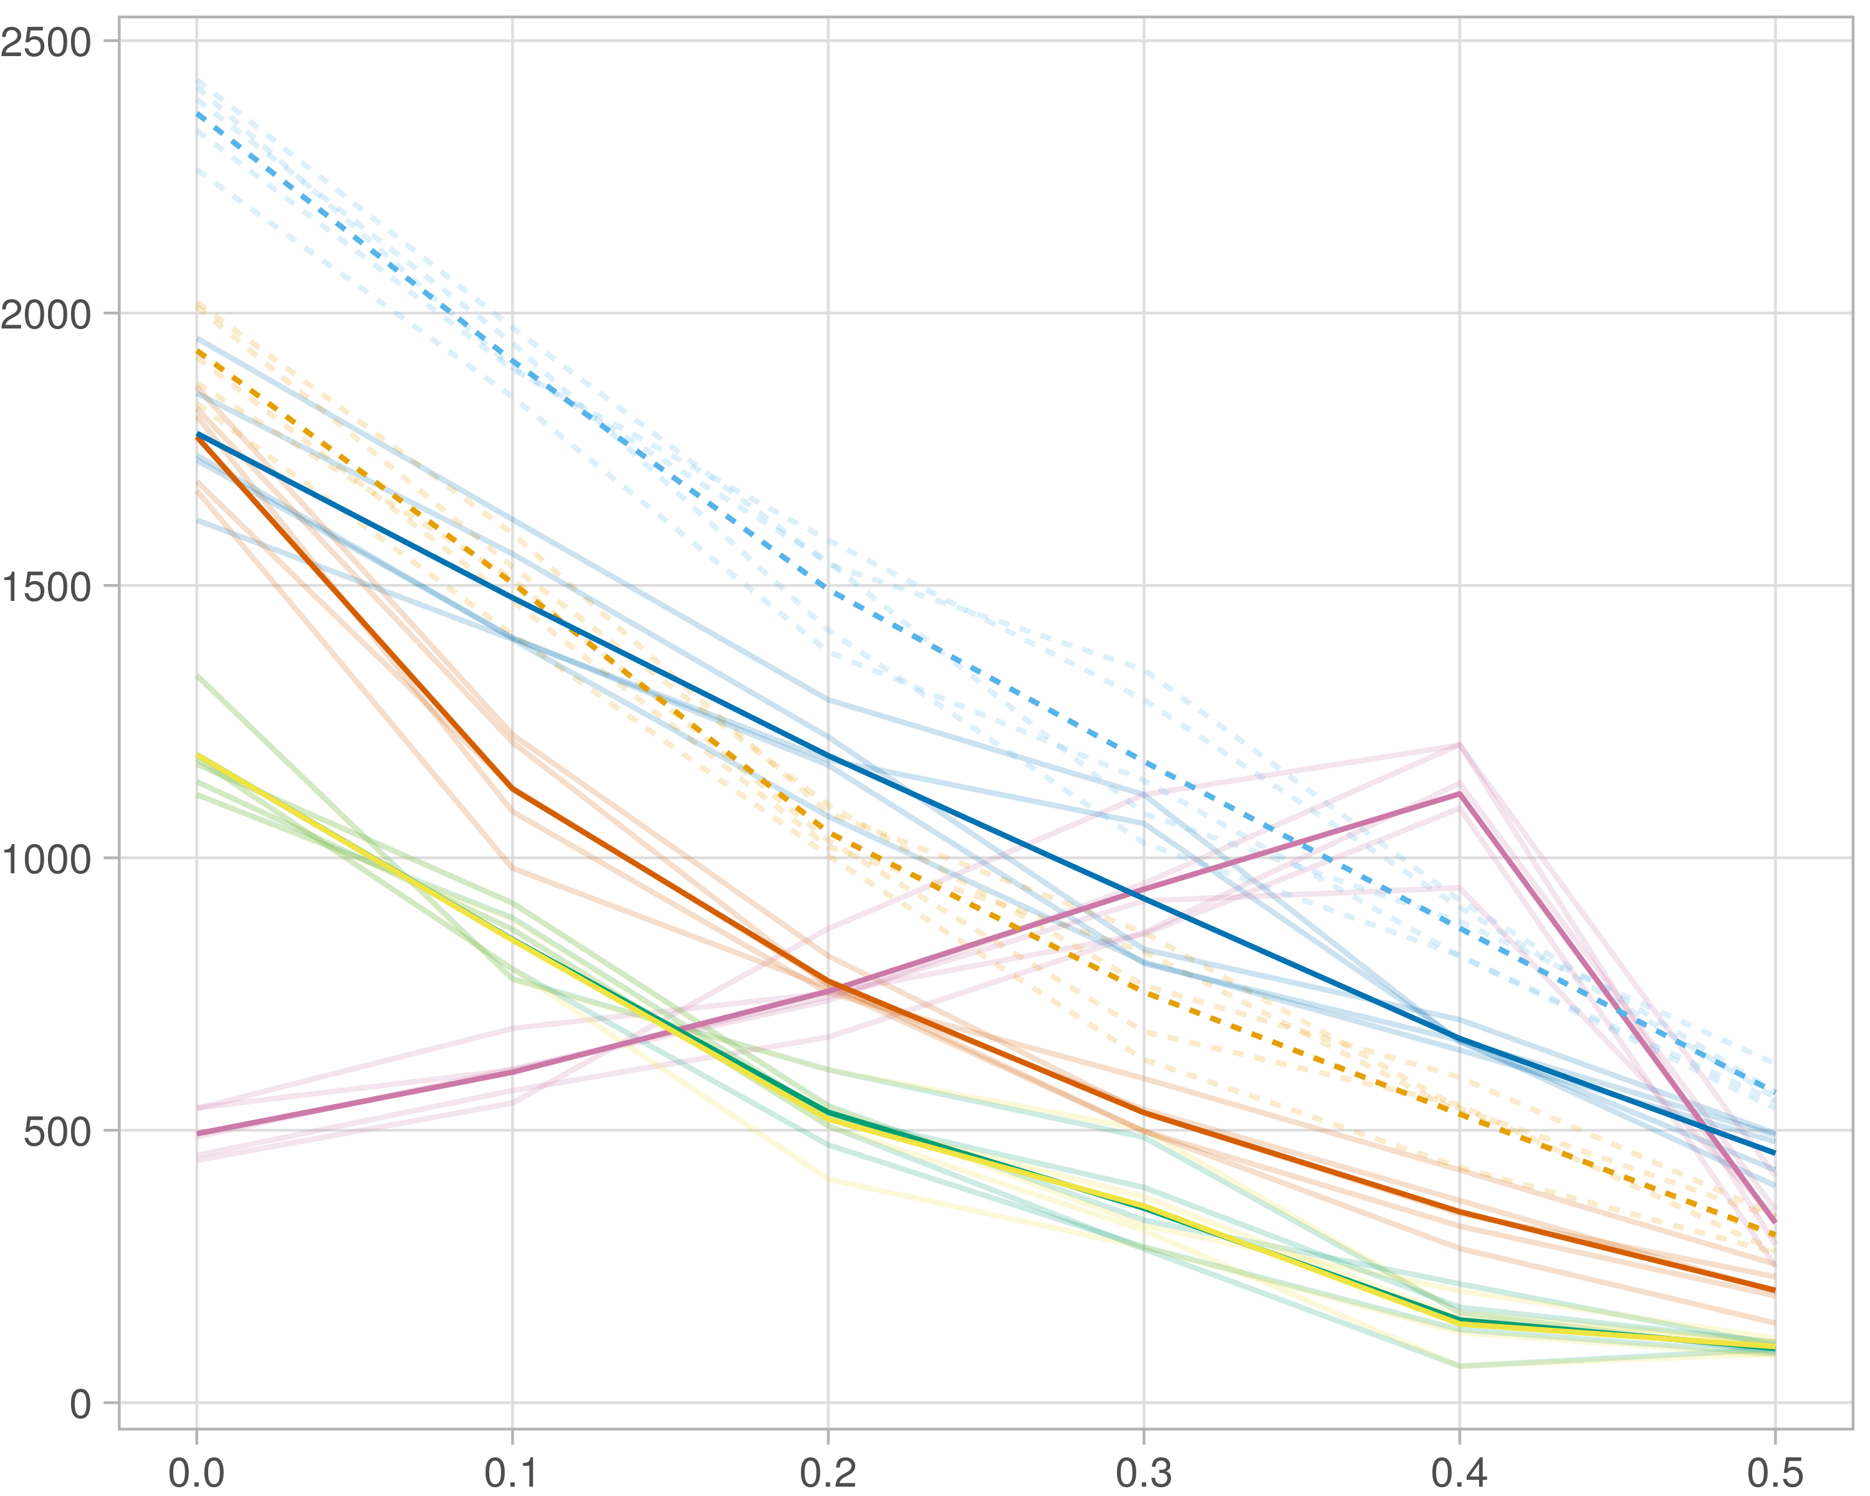

### Multi-omics

#general setup  
dir <- "/workspaces/phd_dissertation/kimono/analysis/data/derived_data/"  
  
#load library  
setwd(dir)  
  
dat_raw <- fread("221116_all_project_info.csv")  
  
#dat_raw <- cbind(dat_raw[,c(1,2,3,16,18)],nodes=dat_raw$V6+dat_raw$V8+dat_raw$V10)  
#dat_raw <- dat_raw[dat_raw$iteration == 1,]  
  
dat_raw$method <- gsub(pattern = "_moran|_mos|_mor|_so|_sor",replacement = "",x = dat_raw$method)  
  
dat <- dat_raw[tolower(dat_raw$method) %in% c("galasso_false","galasso_true","knnkimono","salasso_false","salasso_true","cocolasso","hmlasso"),]  
  
  
#ggplot(dat, aes(x=clustering, y=n_genes+n_methylation+n_cnv, color=as.factor(method)) )+  
# geom_point(alpha=0.5) + facet_grid(experiment~noise)  
  
#ggplot(dat, aes(y=clustering, x=missingness, color=as.factor(method)) )+  
# geom_point(alpha=0.5) + facet_grid(experiment~noise)  
  
#ggplot(dat, aes(x=missingness, y=clustering,fill=as.factor(method)))+  
# scale_y_continuous(trans='sqrt') + geom_boxplot() + facet_grid(experiment~noise)  
  
  
dat$method <- as.factor(dat$method)   
dat <- dat %>% mutate(method = fct_relevel(method, "knnkimono", "galasso_false" ,"galasso_true" , "salasso_false" , "salasso_true" ,"cocolasso", "hmlasso" ))  
dat$experiment <- as.factor(dat$experiment)  
dat <- dat %>% mutate(experiment = fct_relevel(experiment, "so", "moran" ,"mos" , "sor" , "mor"))  
  
palette_OkabeIto <- c( "#CC79A7", "#D55E00", "#E69F00","#0072B2", "#56B4E9", "#009E73", "#F0E442")  
  
dat <- aggregate(dat[, -c(1:8)], list('noise'=dat$noise,  
 'missingness'=dat$missingness,  
 'method'=dat$method,  
 'experiment'=dat$experiment), function(x){mean(x,na.rm=TRUE)})  
  
dat_raw$method <- as.factor(dat_raw$method)   
dat_raw <- dat_raw %>% mutate(method = fct_relevel(method, "knnkimono", "galasso_false" ,"galasso_true" , "salasso_false" , "salasso_true" ,"cocolasso", "hmlasso" ))  
dat_raw$experiment <- as.factor(dat_raw$experiment)  
dat_raw <- dat_raw %>% mutate(experiment = fct_relevel(experiment, "so", "moran" ,"mos" , "sor" , "mor"))  
  
dat_raw <- dat_raw[ dat_raw$noise==1.5 & dat_raw$experiment %in% 'moran' & !dat_raw$method %in% "bdcoco_lasso",]  
dat <- dat[ dat$noise==1.5 & dat$experiment %in% 'moran' & !dat$method %in% "bdcoco_lasso",]  
  
dat_raw$adaptive <- grepl(pattern = "true",x = dat_raw$method)  
dat$adaptive <- grepl(pattern = "true",x = dat$method)  
  
p <- ggplot(dat_raw,   
 aes(y= (n_cnv+n_genes+n_methylation), x=missingness,color=as.factor(method)))+  
   
 geom_line(aes( group = interaction(method, iteration),linetype=adaptive),alpha = 0.2)+  
 facet_grid(noise~experiment, scales="free")+  
 scale_color_manual(values = palette_OkabeIto)+  
 scale_fill_manual(values = palette_OkabeIto)+   
 theme_light() +  
 theme(legend.position="bottom",  
 axis.text.x = element_text(size = 8),  
 axis.text.y = element_text(size = 8),  
 strip.background = element_blank(),   
 plot.margin = unit(c(-0.5, -0.5, 0, 0), "cm")  
 ) +  
 ylab("#Nodes")   
  
to.plot1 <- p + geom_line(data = dat,   
 aes(y= (n_cnv+n_genes+n_methylation), x=missingness, color=as.factor(method),linetype=adaptive)) +   
 theme(strip.background = element_blank(), panel.grid.minor = element_blank(),  
 legend.position = "none",  
 axis.title.x=element_blank(),  
 #axis.text.x=element_blank(),  
 #axis.ticks.x=element_blank(),  
 axis.title.y=element_blank(),  
 #axis.text.y=element_blank(),  
 #axis.ticks.y=element_blank(),   
 plot.margin = unit(c(-0.5, -0.5, 0, 0), "cm")  
 )  
  
to.plot1

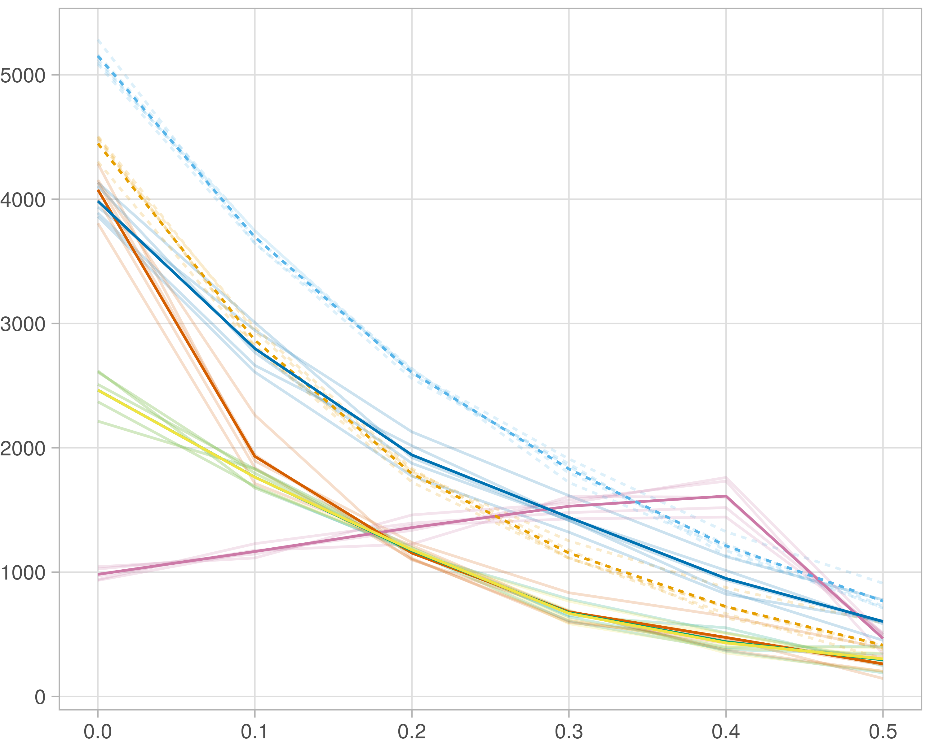

### Block-wise

#general setup  
dir <- "/workspaces/phd_dissertation/kimono/analysis/data/derived_data/"  
  
#load library  
setwd(dir)  
  
dat_raw <- fread("221116_all_project_info.csv")  
  
#dat_raw <- cbind(dat_raw[,c(1,2,3,16,18)],nodes=dat_raw$V6+dat_raw$V8+dat_raw$V10)  
#dat_raw <- dat_raw[dat_raw$iteration == 1,]  
  
dat_raw$method <- gsub(pattern = "_moran|_mos|_mor|_so|_sor",replacement = "",x = dat_raw$method)  
  
dat <- dat_raw[tolower(dat_raw$method) %in% c("galasso_false","galasso_true","knnkimono","salasso_false","salasso_true","cocolasso","hmlasso"),]  
  
  
#ggplot(dat, aes(x=clustering, y=n_genes+n_methylation+n_cnv, color=as.factor(method)) )+  
# geom_point(alpha=0.5) + facet_grid(experiment~noise)  
  
#ggplot(dat, aes(y=clustering, x=missingness, color=as.factor(method)) )+  
# geom_point(alpha=0.5) + facet_grid(experiment~noise)  
  
#ggplot(dat, aes(x=missingness, y=clustering,fill=as.factor(method)))+  
# scale_y_continuous(trans='sqrt') + geom_boxplot() + facet_grid(experiment~noise)  
  
  
dat$method <- as.factor(dat$method)   
dat <- dat %>% mutate(method = fct_relevel(method, "knnkimono", "galasso_false" ,"galasso_true" , "salasso_false" , "salasso_true" ,"cocolasso", "hmlasso" ))  
dat$experiment <- as.factor(dat$experiment)  
dat <- dat %>% mutate(experiment = fct_relevel(experiment, "so", "moran" ,"mos" , "sor" , "mor"))  
  
palette_OkabeIto <- c( "#CC79A7", "#D55E00", "#E69F00","#0072B2", "#56B4E9", "#009E73", "#F0E442")  
  
dat <- aggregate(dat[, -c(1:8)], list('noise'=dat$noise,  
 'missingness'=dat$missingness,  
 'method'=dat$method,  
 'experiment'=dat$experiment), function(x){mean(x,na.rm=TRUE)})  
  
dat_raw$method <- as.factor(dat_raw$method)   
dat_raw <- dat_raw %>% mutate(method = fct_relevel(method, "knnkimono", "galasso_false" ,"galasso_true" , "salasso_false" , "salasso_true" ,"cocolasso", "hmlasso" ))  
dat_raw$experiment <- as.factor(dat_raw$experiment)  
dat_raw <- dat_raw %>% mutate(experiment = fct_relevel(experiment, "so", "moran" ,"mos" , "sor" , "mor"))  
  
dat_raw <- dat_raw[ dat_raw$noise==1.5 & dat_raw$experiment %in% 'mos' & !dat_raw$method %in% "bdcoco_lasso",]  
dat <- dat[ dat$noise==1.5 & dat$experiment %in% 'mos' & !dat$method %in% "bdcoco_lasso",]  
  
dat_raw$adaptive <- grepl(pattern = "true",x = dat_raw$method)  
dat$adaptive <- grepl(pattern = "true",x = dat$method)  
  
p <- ggplot(dat_raw,   
 aes(y= (n_cnv+n_genes+n_methylation), x=missingness,color=as.factor(method)))+  
   
 geom_line(aes( group = interaction(method, iteration),linetype=adaptive),alpha = 0.2)+  
 facet_grid(noise~experiment, scales="free")+  
 scale_color_manual(values = palette_OkabeIto)+  
 scale_fill_manual(values = palette_OkabeIto)+   
 theme_light() +  
 theme(legend.position="bottom",  
 axis.text.x = element_text(size = 8),  
 axis.text.y = element_text(size = 8),  
 strip.background = element_blank(),   
 plot.margin = unit(c(-0.5, -0.5, 0, 0), "cm")  
 ) +  
 ylab("#Nodes")   
  
to.plot1 <- p + geom_line(data = dat,   
 aes(y= (n_cnv+n_genes+n_methylation), x=missingness, color=as.factor(method),linetype=adaptive)) +   
 theme(strip.background = element_blank(), panel.grid.minor = element_blank(),  
 legend.position = "none",  
 axis.title.x=element_blank(),  
 #axis.text.x=element_blank(),  
 #axis.ticks.x=element_blank(),  
 axis.title.y=element_blank(),  
 #axis.text.y=element_blank(),  
 #axis.ticks.y=element_blank(),   
 plot.margin = unit(c(-0.5, -0.5, 0, 0), "cm")  
 )  
  
to.plot1

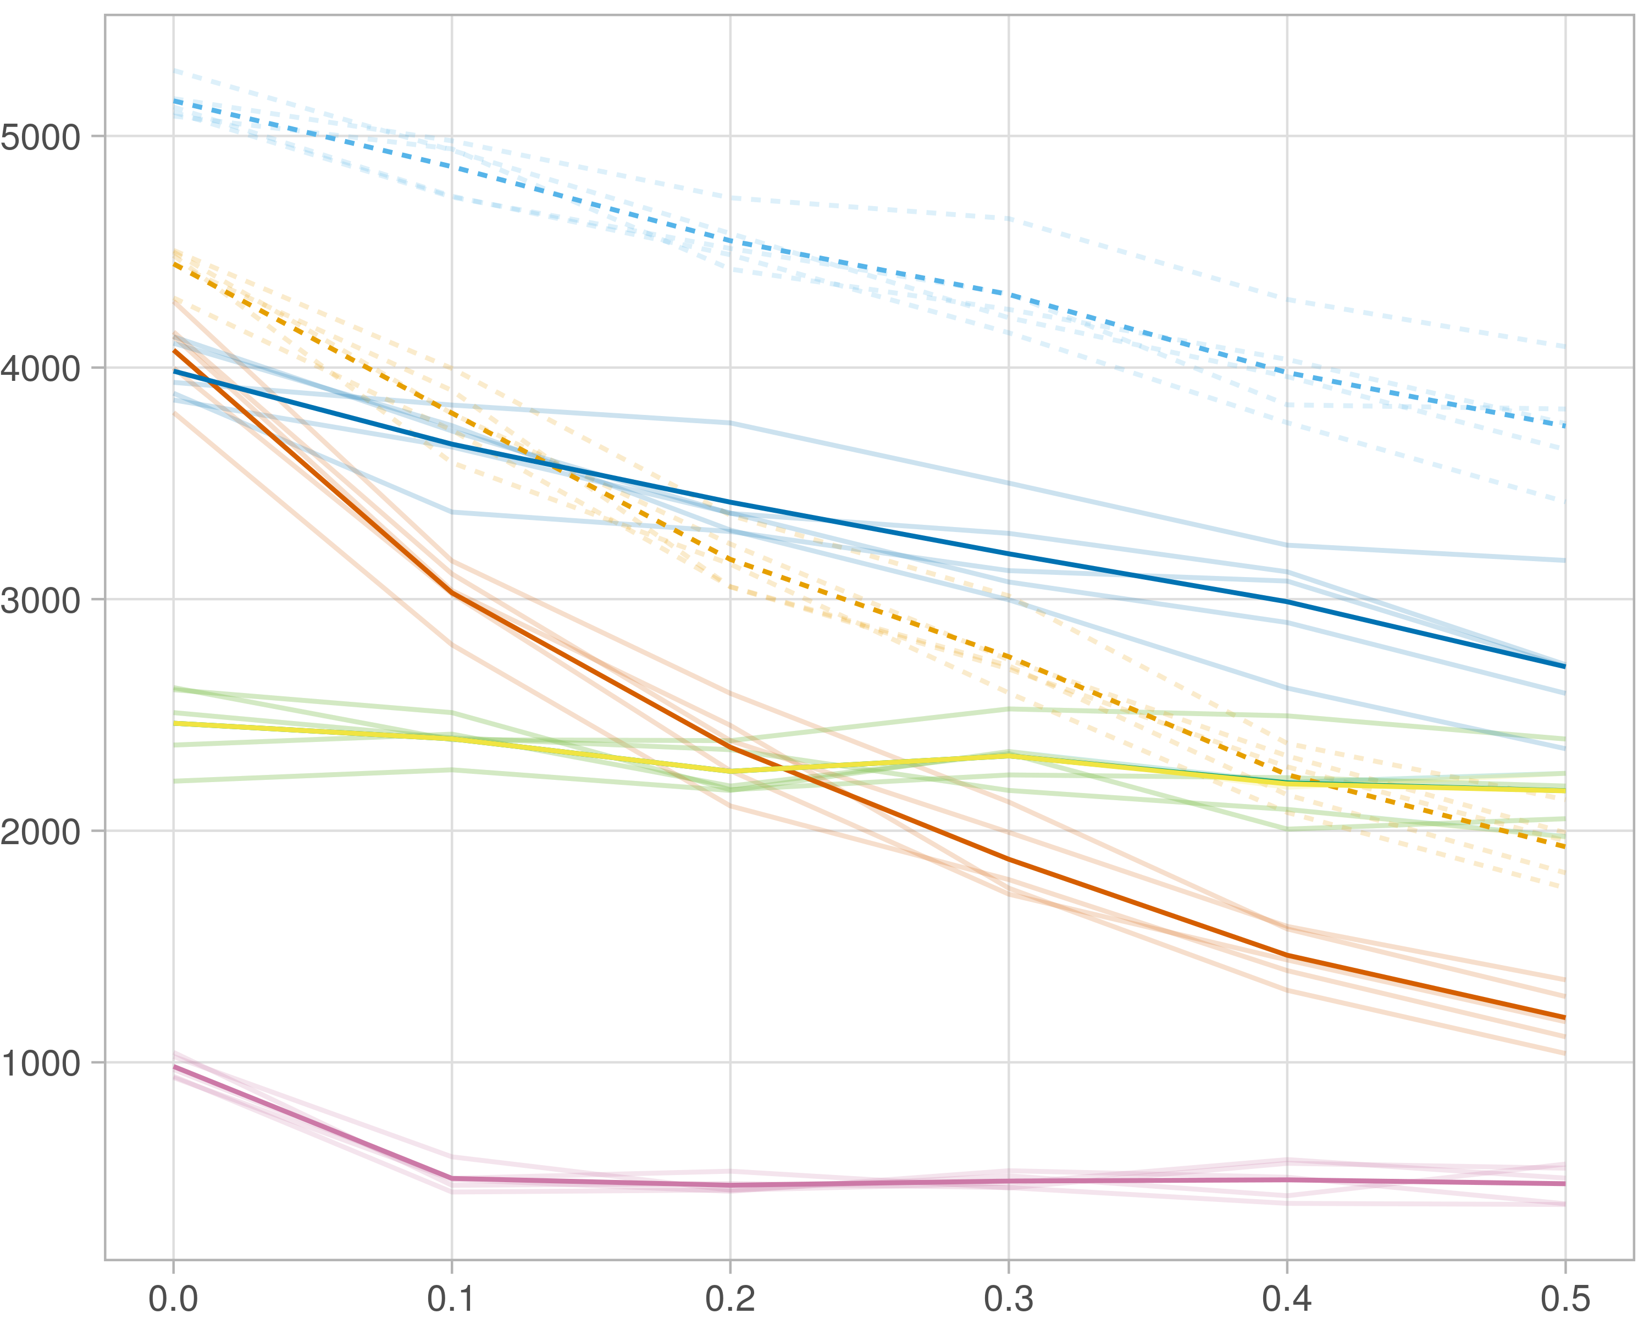

## Transitivity

### Single-omics

#general setup  
dir <- "/workspaces/phd_dissertation/kimono/analysis/data/derived_data/"  
  
#load library  
setwd(dir)  
  
dat_raw <- fread("221116_all_project_info.csv")  
  
#dat_raw <- cbind(dat_raw[,c(1,2,3,16,18)],nodes=dat_raw$V6+dat_raw$V8+dat_raw$V10)  
#dat_raw <- dat_raw[dat_raw$iteration == 1,]  
  
dat_raw$method <- gsub(pattern = "_moran|_mos|_mor|_so|_sor",replacement = "",x = dat_raw$method)  
  
dat <- dat_raw[tolower(dat_raw$method) %in% c("galasso_false","galasso_true","knnkimono","salasso_false","salasso_true","cocolasso","hmlasso"),]  
  
  
#ggplot(dat, aes(x=clustering, y=n_genes+n_methylation+n_cnv, color=as.factor(method)) )+  
# geom_point(alpha=0.5) + facet_grid(experiment~noise)  
  
#ggplot(dat, aes(y=clustering, x=missingness, color=as.factor(method)) )+  
# geom_point(alpha=0.5) + facet_grid(experiment~noise)  
  
#ggplot(dat, aes(x=missingness, y=clustering,fill=as.factor(method)))+  
# scale_y_continuous(trans='sqrt') + geom_boxplot() + facet_grid(experiment~noise)  
  
  
dat$method <- as.factor(dat$method)   
dat <- dat %>% mutate(method = fct_relevel(method, "knnkimono", "galasso_false" ,"galasso_true" , "salasso_false" , "salasso_true" ,"cocolasso", "hmlasso" ))  
dat$experiment <- as.factor(dat$experiment)  
dat <- dat %>% mutate(experiment = fct_relevel(experiment, "so", "moran" ,"mos" , "sor" , "mor"))  
  
palette_OkabeIto <- c( "#CC79A7", "#D55E00", "#E69F00","#0072B2", "#56B4E9", "#009E73", "#F0E442")  
  
dat <- aggregate(dat[, -c(1:8)], list('noise'=dat$noise,  
 'missingness'=dat$missingness,  
 'method'=dat$method,  
 'experiment'=dat$experiment), function(x){mean(x,na.rm=TRUE)})  
  
dat_raw$method <- as.factor(dat_raw$method)   
dat_raw <- dat_raw %>% mutate(method = fct_relevel(method, "knnkimono", "galasso_false" ,"galasso_true" , "salasso_false" , "salasso_true" ,"cocolasso", "hmlasso" ))  
dat_raw$experiment <- as.factor(dat_raw$experiment)  
dat_raw <- dat_raw %>% mutate(experiment = fct_relevel(experiment, "so", "moran" ,"mos" , "sor" , "mor"))  
  
dat_raw <- dat_raw[ dat_raw$noise==1.5 & dat_raw$experiment %in% 'so' & !dat_raw$method %in% "bdcoco_lasso",]  
dat <- dat[ dat$noise==1.5 & dat$experiment %in% 'so' & !dat$method %in% "bdcoco_lasso",]  
  
dat_raw$adaptive <- grepl(pattern = "true",x = dat_raw$method)  
dat$adaptive <- grepl(pattern = "true",x = dat$method)  
  
p <- ggplot(dat_raw,   
 aes(y= (clustering), x=missingness,color=as.factor(method)))+  
   
 geom_line(aes( group = interaction(method, iteration),linetype=adaptive),alpha = 0.2)+  
 facet_grid(noise~experiment, scales="free")+  
 scale_color_manual(values = palette_OkabeIto)+  
 scale_fill_manual(values = palette_OkabeIto)+   
 theme_light() +  
 theme(legend.position="bottom",  
 axis.text.x = element_text(size = 8),  
 axis.text.y = element_text(size = 8),  
 strip.background = element_blank(),   
 plot.margin = unit(c(-0.5, -0.5, 0, 0), "cm")  
 ) +  
 ylab("#Nodes")   
  
to.plot2 <- p + geom_line(data = dat,   
 aes(y= (clustering), x=missingness, color=as.factor(method),linetype=adaptive)) +   
 theme(strip.background = element_blank(), panel.grid.minor = element_blank(),  
 legend.position = "none",  
 axis.title.x=element_blank(),  
 #axis.text.x=element_blank(),  
 #axis.ticks.x=element_blank(),  
 axis.title.y=element_blank(),  
 #axis.text.y=element_blank(),  
 #axis.ticks.y=element_blank(),   
 plot.margin = unit(c(-0.5, -0.5, 0, 0), "cm")  
 )  
  
to.plot2

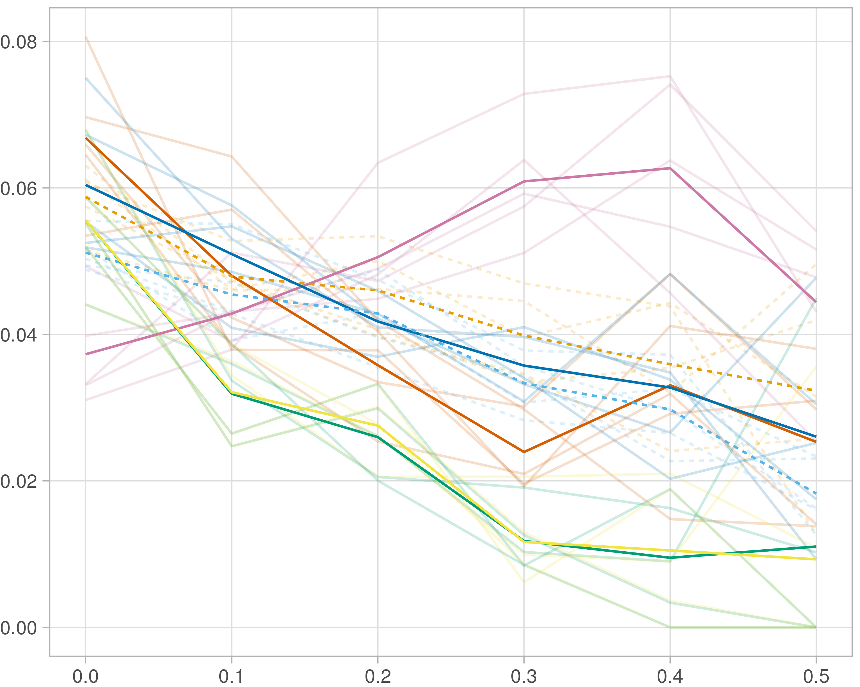

### Multi-omics

#general setup  
dir <- "/workspaces/phd_dissertation/kimono/analysis/data/derived_data/"  
  
#load library  
setwd(dir)  
  
dat_raw <- fread("221116_all_project_info.csv")  
  
#dat_raw <- cbind(dat_raw[,c(1,2,3,16,18)],nodes=dat_raw$V6+dat_raw$V8+dat_raw$V10)  
#dat_raw <- dat_raw[dat_raw$iteration == 1,]  
  
dat_raw$method <- gsub(pattern = "_moran|_mos|_mor|_so|_sor",replacement = "",x = dat_raw$method)  
  
dat <- dat_raw[tolower(dat_raw$method) %in% c("galasso_false","galasso_true","knnkimono","salasso_false","salasso_true","cocolasso","hmlasso"),]  
  
  
#ggplot(dat, aes(x=clustering, y=n_genes+n_methylation+n_cnv, color=as.factor(method)) )+  
# geom_point(alpha=0.5) + facet_grid(experiment~noise)  
  
#ggplot(dat, aes(y=clustering, x=missingness, color=as.factor(method)) )+  
# geom_point(alpha=0.5) + facet_grid(experiment~noise)  
  
#ggplot(dat, aes(x=missingness, y=clustering,fill=as.factor(method)))+  
# scale_y_continuous(trans='sqrt') + geom_boxplot() + facet_grid(experiment~noise)  
  
  
dat$method <- as.factor(dat$method)   
dat <- dat %>% mutate(method = fct_relevel(method, "knnkimono", "galasso_false" ,"galasso_true" , "salasso_false" , "salasso_true" ,"cocolasso", "hmlasso" ))  
dat$experiment <- as.factor(dat$experiment)  
dat <- dat %>% mutate(experiment = fct_relevel(experiment, "so", "moran" ,"mos" , "sor" , "mor"))  
  
palette_OkabeIto <- c( "#CC79A7", "#D55E00", "#E69F00","#0072B2", "#56B4E9", "#009E73", "#F0E442")  
  
dat <- aggregate(dat[, -c(1:8)], list('noise'=dat$noise,  
 'missingness'=dat$missingness,  
 'method'=dat$method,  
 'experiment'=dat$experiment), function(x){mean(x,na.rm=TRUE)})  
  
dat_raw$method <- as.factor(dat_raw$method)   
dat_raw <- dat_raw %>% mutate(method = fct_relevel(method, "knnkimono", "galasso_false" ,"galasso_true" , "salasso_false" , "salasso_true" ,"cocolasso", "hmlasso" ))  
dat_raw$experiment <- as.factor(dat_raw$experiment)  
dat_raw <- dat_raw %>% mutate(experiment = fct_relevel(experiment, "so", "moran" ,"mos" , "sor" , "mor"))  
  
dat_raw <- dat_raw[ dat_raw$noise==1.5 & dat_raw$experiment %in% 'moran' & !dat_raw$method %in% "bdcoco_lasso",]  
dat <- dat[ dat$noise==1.5 & dat$experiment %in% 'moran' & !dat$method %in% "bdcoco_lasso",]  
  
dat_raw$adaptive <- grepl(pattern = "true",x = dat_raw$method)  
dat$adaptive <- grepl(pattern = "true",x = dat$method)  
  
p <- ggplot(dat_raw,   
 aes(y= (clustering), x=missingness,color=as.factor(method)))+  
   
 geom_line(aes( group = interaction(method, iteration),linetype=adaptive),alpha = 0.2)+  
 facet_grid(noise~experiment, scales="free")+  
 scale_color_manual(values = palette_OkabeIto)+  
 scale_fill_manual(values = palette_OkabeIto)+   
 theme_light() +  
 theme(legend.position="bottom",  
 axis.text.x = element_text(size = 8),  
 axis.text.y = element_text(size = 8),  
 strip.background = element_blank(),   
 plot.margin = unit(c(-0.5, -0.5, 0, 0), "cm")  
 ) +  
 ylab("#Nodes")   
  
to.plot2 <- p + geom_line(data = dat,   
 aes(y= (clustering), x=missingness, color=as.factor(method),linetype=adaptive)) +   
 theme(strip.background = element_blank(), panel.grid.minor = element_blank(),  
 legend.position = "none",  
 axis.title.x=element_blank(),  
 #axis.text.x=element_blank(),  
 #axis.ticks.x=element_blank(),  
 axis.title.y=element_blank(),  
 #axis.text.y=element_blank(),  
 #axis.ticks.y=element_blank(),   
 plot.margin = unit(c(-0.5, -0.5, 0, 0), "cm")  
 )  
  
to.plot2

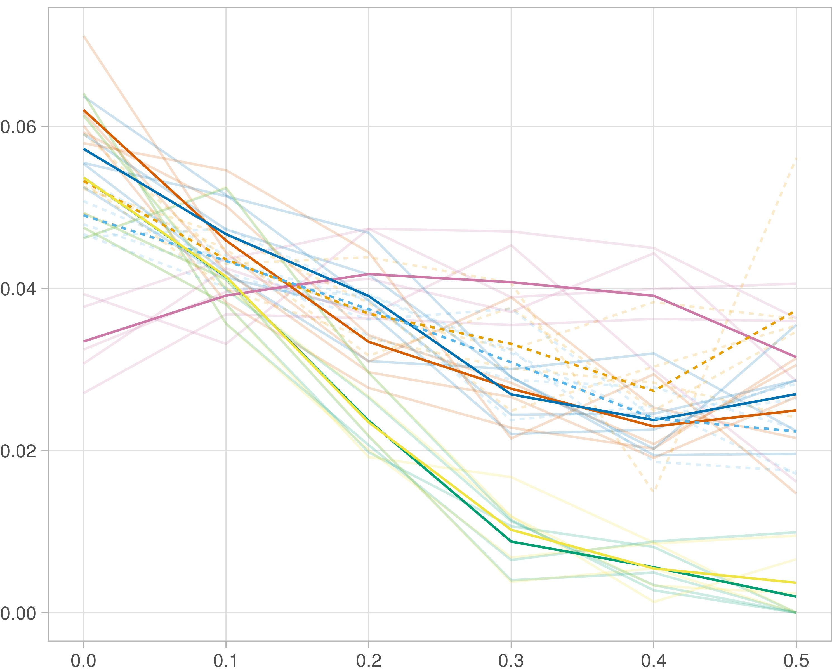

### Block-wise

#general setup  
dir <- "/workspaces/phd_dissertation/kimono/analysis/data/derived_data/"  
  
#load library  
setwd(dir)  
  
dat_raw <- fread("221116_all_project_info.csv")  
  
#dat_raw <- cbind(dat_raw[,c(1,2,3,16,18)],nodes=dat_raw$V6+dat_raw$V8+dat_raw$V10)  
#dat_raw <- dat_raw[dat_raw$iteration == 1,]  
  
dat_raw$method <- gsub(pattern = "_moran|_mos|_mor|_so|_sor",replacement = "",x = dat_raw$method)  
  
dat <- dat_raw[tolower(dat_raw$method) %in% c("galasso_false","galasso_true","knnkimono","salasso_false","salasso_true","cocolasso","hmlasso"),]  
  
  
#ggplot(dat, aes(x=clustering, y=n_genes+n_methylation+n_cnv, color=as.factor(method)) )+  
# geom_point(alpha=0.5) + facet_grid(experiment~noise)  
  
#ggplot(dat, aes(y=clustering, x=missingness, color=as.factor(method)) )+  
# geom_point(alpha=0.5) + facet_grid(experiment~noise)  
  
#ggplot(dat, aes(x=missingness, y=clustering,fill=as.factor(method)))+  
# scale_y_continuous(trans='sqrt') + geom_boxplot() + facet_grid(experiment~noise)  
  
  
dat$method <- as.factor(dat$method)   
dat <- dat %>% mutate(method = fct_relevel(method, "knnkimono", "galasso_false" ,"galasso_true" , "salasso_false" , "salasso_true" ,"cocolasso", "hmlasso" ))  
dat$experiment <- as.factor(dat$experiment)  
dat <- dat %>% mutate(experiment = fct_relevel(experiment, "so", "moran" ,"mos" , "sor" , "mor"))  
  
palette_OkabeIto <- c( "#CC79A7", "#D55E00", "#E69F00","#0072B2", "#56B4E9", "#009E73", "#F0E442")  
  
dat <- aggregate(dat[, -c(1:8)], list('noise'=dat$noise,  
 'missingness'=dat$missingness,  
 'method'=dat$method,  
 'experiment'=dat$experiment), function(x){mean(x,na.rm=TRUE)})  
  
dat_raw$method <- as.factor(dat_raw$method)   
dat_raw <- dat_raw %>% mutate(method = fct_relevel(method, "knnkimono", "galasso_false" ,"galasso_true" , "salasso_false" , "salasso_true" ,"cocolasso", "hmlasso" ))  
dat_raw$experiment <- as.factor(dat_raw$experiment)  
dat_raw <- dat_raw %>% mutate(experiment = fct_relevel(experiment, "so", "moran" ,"mos" , "sor" , "mor"))  
  
dat_raw <- dat_raw[ dat_raw$noise==1.5 & dat_raw$experiment %in% 'mos' & !dat_raw$method %in% "bdcoco_lasso",]  
dat <- dat[ dat$noise==1.5 & dat$experiment %in% 'mos' & !dat$method %in% "bdcoco_lasso",]  
  
dat_raw$adaptive <- grepl(pattern = "true",x = dat_raw$method)  
dat$adaptive <- grepl(pattern = "true",x = dat$method)  
  
p <- ggplot(dat_raw,   
 aes(y= (clustering), x=missingness,color=as.factor(method)))+  
   
 geom_line(aes( group = interaction(method, iteration),linetype=adaptive),alpha = 0.2)+  
 facet_grid(noise~experiment, scales="free")+  
 scale_color_manual(values = palette_OkabeIto)+  
 scale_fill_manual(values = palette_OkabeIto)+   
 theme_light() +  
 theme(legend.position="bottom",  
 axis.text.x = element_text(size = 8),  
 axis.text.y = element_text(size = 8),  
 strip.background = element_blank(),   
 plot.margin = unit(c(-0.5, -0.5, 0, 0), "cm")  
 ) +  
 ylab("#Nodes")   
  
to.plot2 <- p + geom_line(data = dat,   
 aes(y= (clustering), x=missingness, color=as.factor(method),linetype=adaptive)) +   
 theme(strip.background = element_blank(), panel.grid.minor = element_blank(),  
 legend.position = "none",  
 axis.title.x=element_blank(),  
 #axis.text.x=element_blank(),  
 #axis.ticks.x=element_blank(),  
 axis.title.y=element_blank(),  
 #axis.text.y=element_blank(),  
 #axis.ticks.y=element_blank(),   
 plot.margin = unit(c(-0.5, -0.5, 0, 0), "cm")  
 )  
  
to.plot2

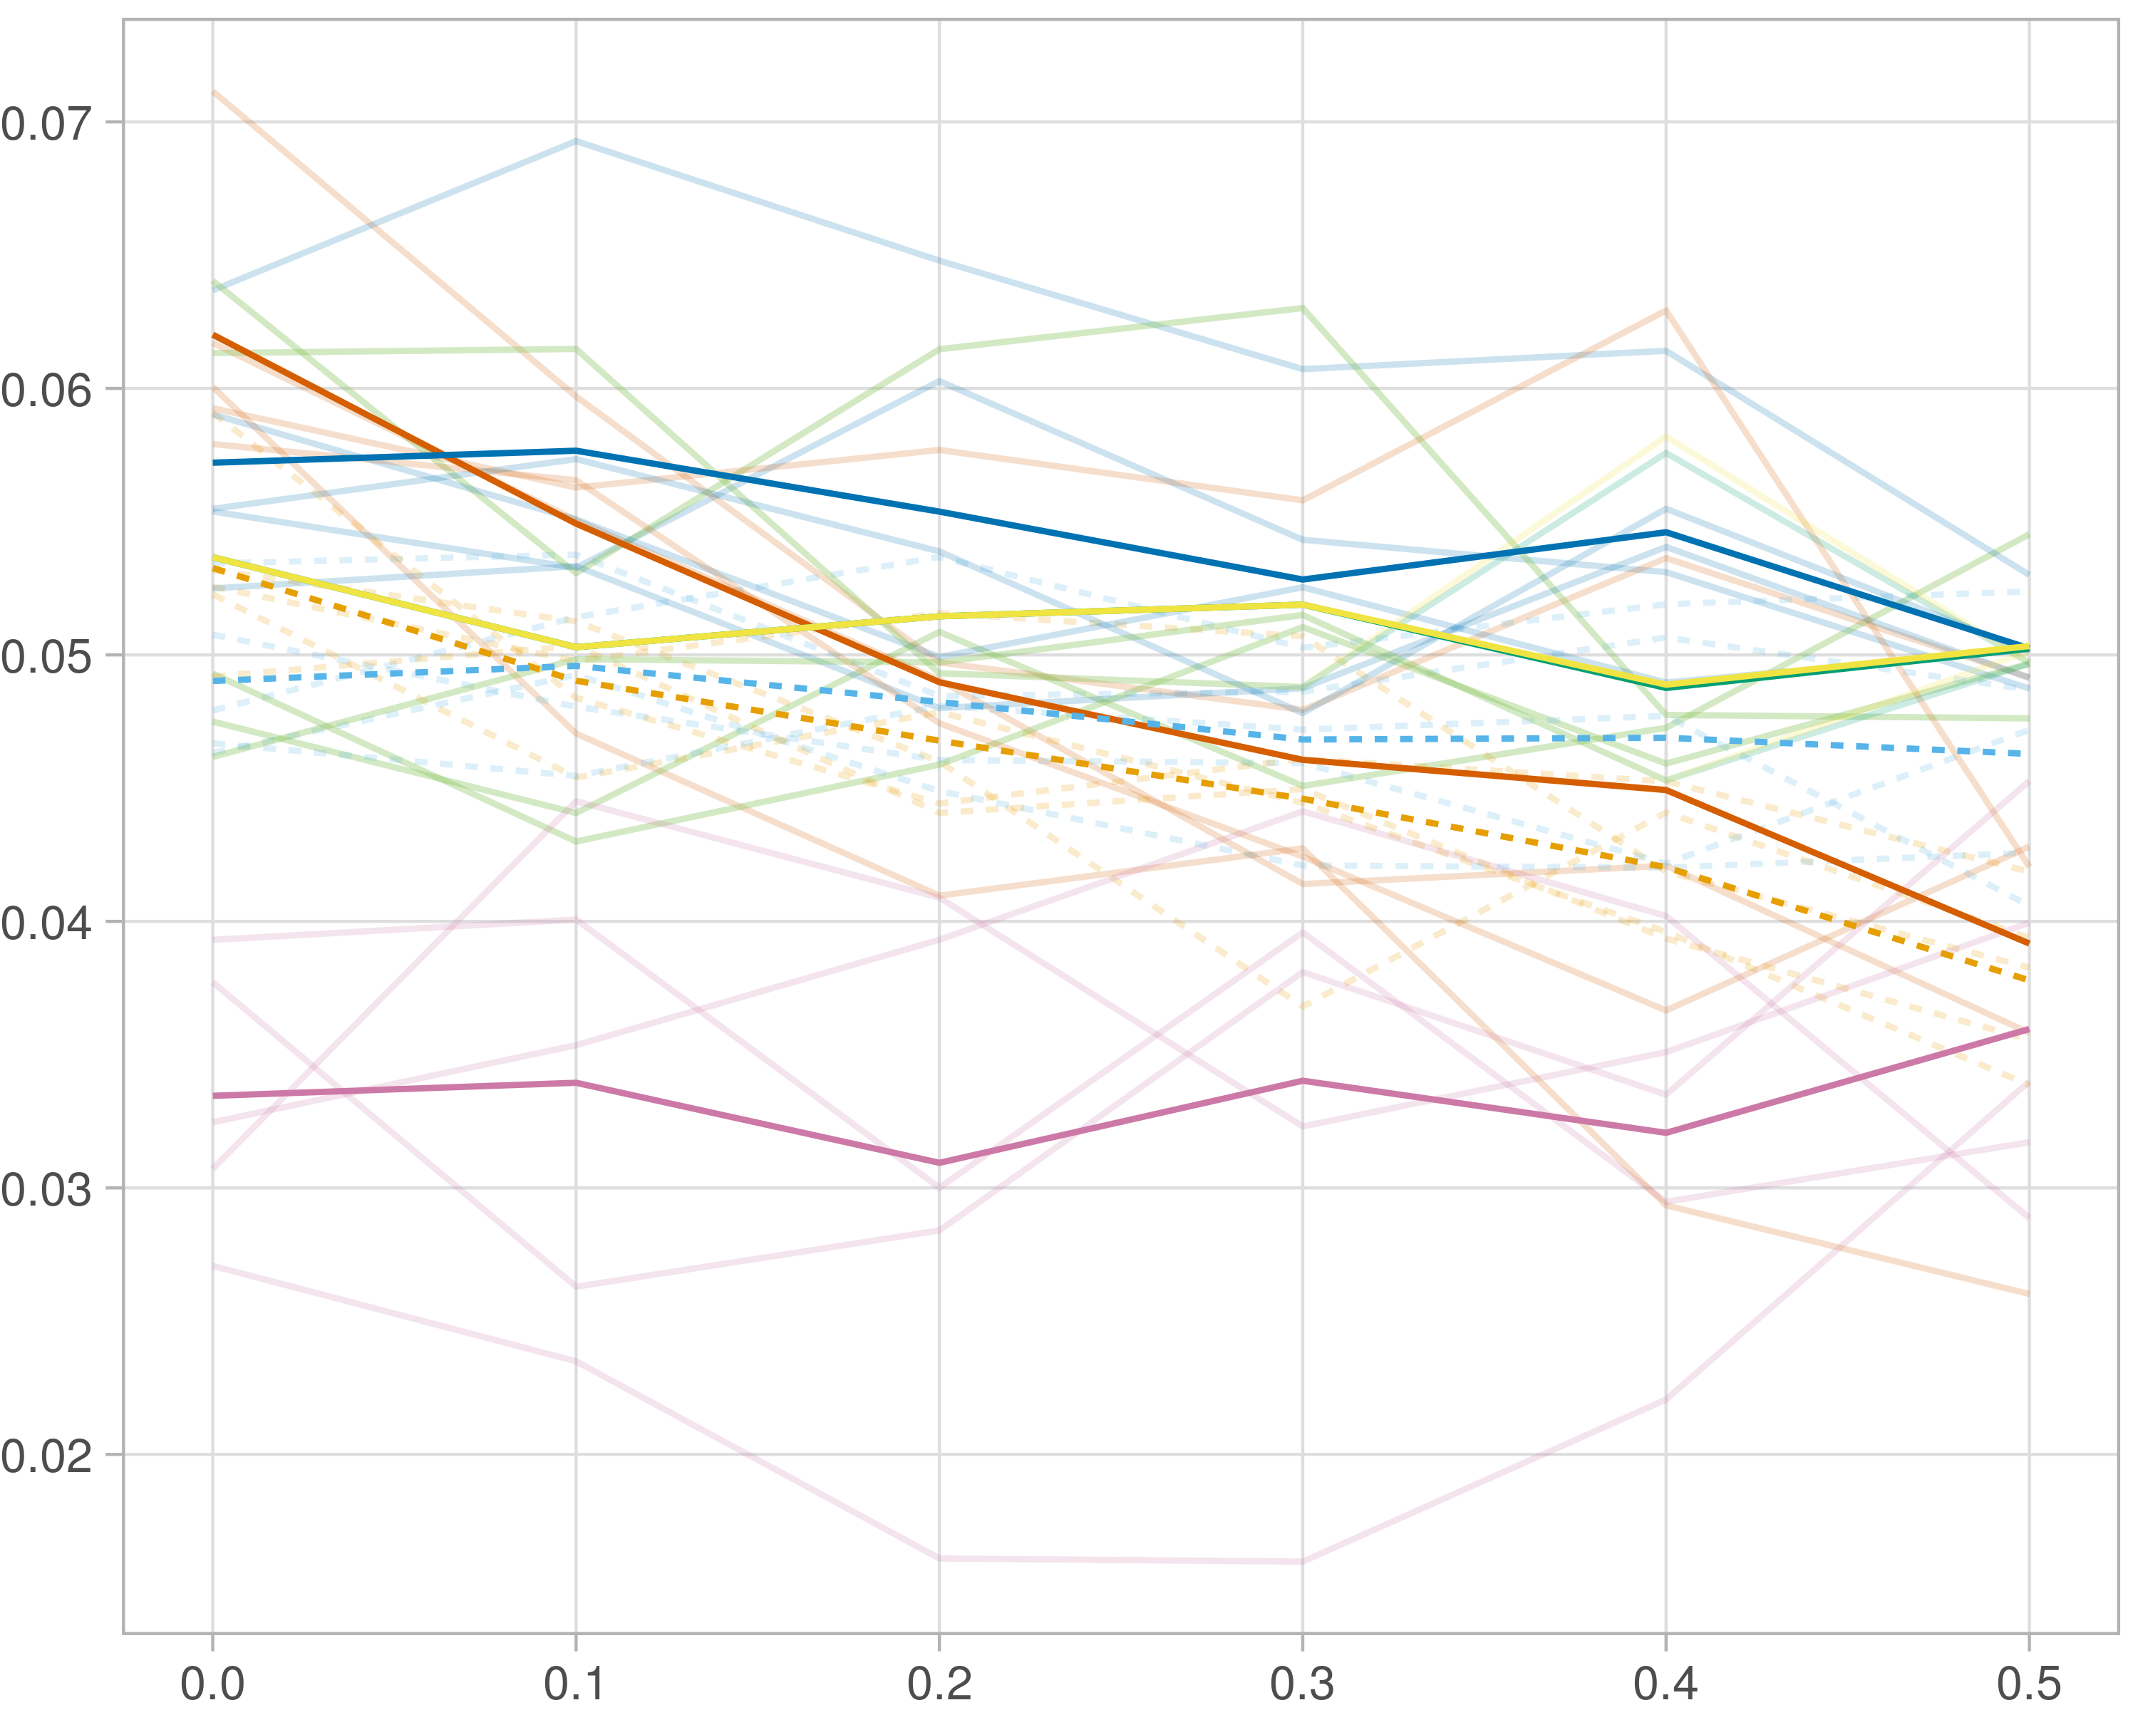

## Median R-squared

### Single-omics

#general setup  
dir <- "/workspaces/phd_dissertation/kimono/analysis/data/derived_data/"  
  
#load library  
setwd(dir)  
  
dat_raw <- fread("221116_all_project_info.csv")  
  
#dat_raw <- cbind(dat_raw[,c(1,2,3,16,18)],nodes=dat_raw$V6+dat_raw$V8+dat_raw$V10)  
#dat_raw <- dat_raw[dat_raw$iteration == 1,]  
  
dat_raw$method <- gsub(pattern = "_moran|_mos|_mor|_so|_sor",replacement = "",x = dat_raw$method)  
  
dat <- dat_raw[tolower(dat_raw$method) %in% c("galasso_false","galasso_true","knnkimono","salasso_false","salasso_true","cocolasso","hmlasso"),]  
  
  
#ggplot(dat, aes(x=clustering, y=n_genes+n_methylation+n_cnv, color=as.factor(method)) )+  
# geom_point(alpha=0.5) + facet_grid(experiment~noise)  
  
#ggplot(dat, aes(y=clustering, x=missingness, color=as.factor(method)) )+  
# geom_point(alpha=0.5) + facet_grid(experiment~noise)  
  
#ggplot(dat, aes(x=missingness, y=clustering,fill=as.factor(method)))+  
# scale_y_continuous(trans='sqrt') + geom_boxplot() + facet_grid(experiment~noise)  
  
  
dat$method <- as.factor(dat$method)   
dat <- dat %>% mutate(method = fct_relevel(method, "knnkimono", "galasso_false" ,"galasso_true" , "salasso_false" , "salasso_true" ,"cocolasso", "hmlasso" ))  
dat$experiment <- as.factor(dat$experiment)  
dat <- dat %>% mutate(experiment = fct_relevel(experiment, "so", "moran" ,"mos" , "sor" , "mor"))  
  
palette_OkabeIto <- c( "#CC79A7", "#D55E00", "#E69F00","#0072B2", "#56B4E9", "#009E73", "#F0E442")  
  
dat <- aggregate(dat[, -c(1:8)], list('noise'=dat$noise,  
 'missingness'=dat$missingness,  
 'method'=dat$method,  
 'experiment'=dat$experiment), function(x){mean(x,na.rm=TRUE)})  
  
dat_raw$method <- as.factor(dat_raw$method)   
dat_raw <- dat_raw %>% mutate(method = fct_relevel(method, "knnkimono", "galasso_false" ,"galasso_true" , "salasso_false" , "salasso_true" ,"cocolasso", "hmlasso" ))  
dat_raw$experiment <- as.factor(dat_raw$experiment)  
dat_raw <- dat_raw %>% mutate(experiment = fct_relevel(experiment, "so", "moran" ,"mos" , "sor" , "mor"))  
  
dat_raw <- dat_raw[ dat_raw$noise==1.5 & dat_raw$experiment %in% 'so' & !dat_raw$method %in% "bdcoco_lasso",]  
dat <- dat[ dat$noise==1.5 & dat$experiment %in% 'so' & !dat$method %in% "bdcoco_lasso",]  
  
dat_raw$adaptive <- grepl(pattern = "true",x = dat_raw$method)  
dat$adaptive <- grepl(pattern = "true",x = dat$method)  
  
p <- ggplot(dat_raw,   
 aes(y= (median_r2), x=missingness,color=as.factor(method)))+  
   
 geom_line(aes( group = interaction(method, iteration),linetype=adaptive),alpha = 0.2)+  
 facet_grid(noise~experiment, scales="free")+  
 scale_color_manual(values = palette_OkabeIto)+  
 scale_fill_manual(values = palette_OkabeIto)+   
 theme_light() +  
 theme(legend.position="bottom",  
 axis.text.x = element_text(size = 8),  
 axis.text.y = element_text(size = 8),  
 strip.background = element_blank(),   
 plot.margin = unit(c(-0.5, -0.5, 0, 0), "cm")  
 ) +  
 ylab("#Nodes")   
  
to.plot3 <- p + geom_line(data = dat,   
 aes(y= (median_r2), x=missingness, color=as.factor(method),linetype=adaptive)) +   
 theme(strip.background = element_blank(), panel.grid.minor = element_blank(),  
 legend.position = "none",  
 axis.title.x=element_blank(),  
 #axis.text.x=element_blank(),  
 #axis.ticks.x=element_blank(),  
 axis.title.y=element_blank(),  
 #axis.text.y=element_blank(),  
 #axis.ticks.y=element_blank(),   
 plot.margin = unit(c(-0.5, -0.5, 0, 0), "cm")  
 )  
  
to.plot3

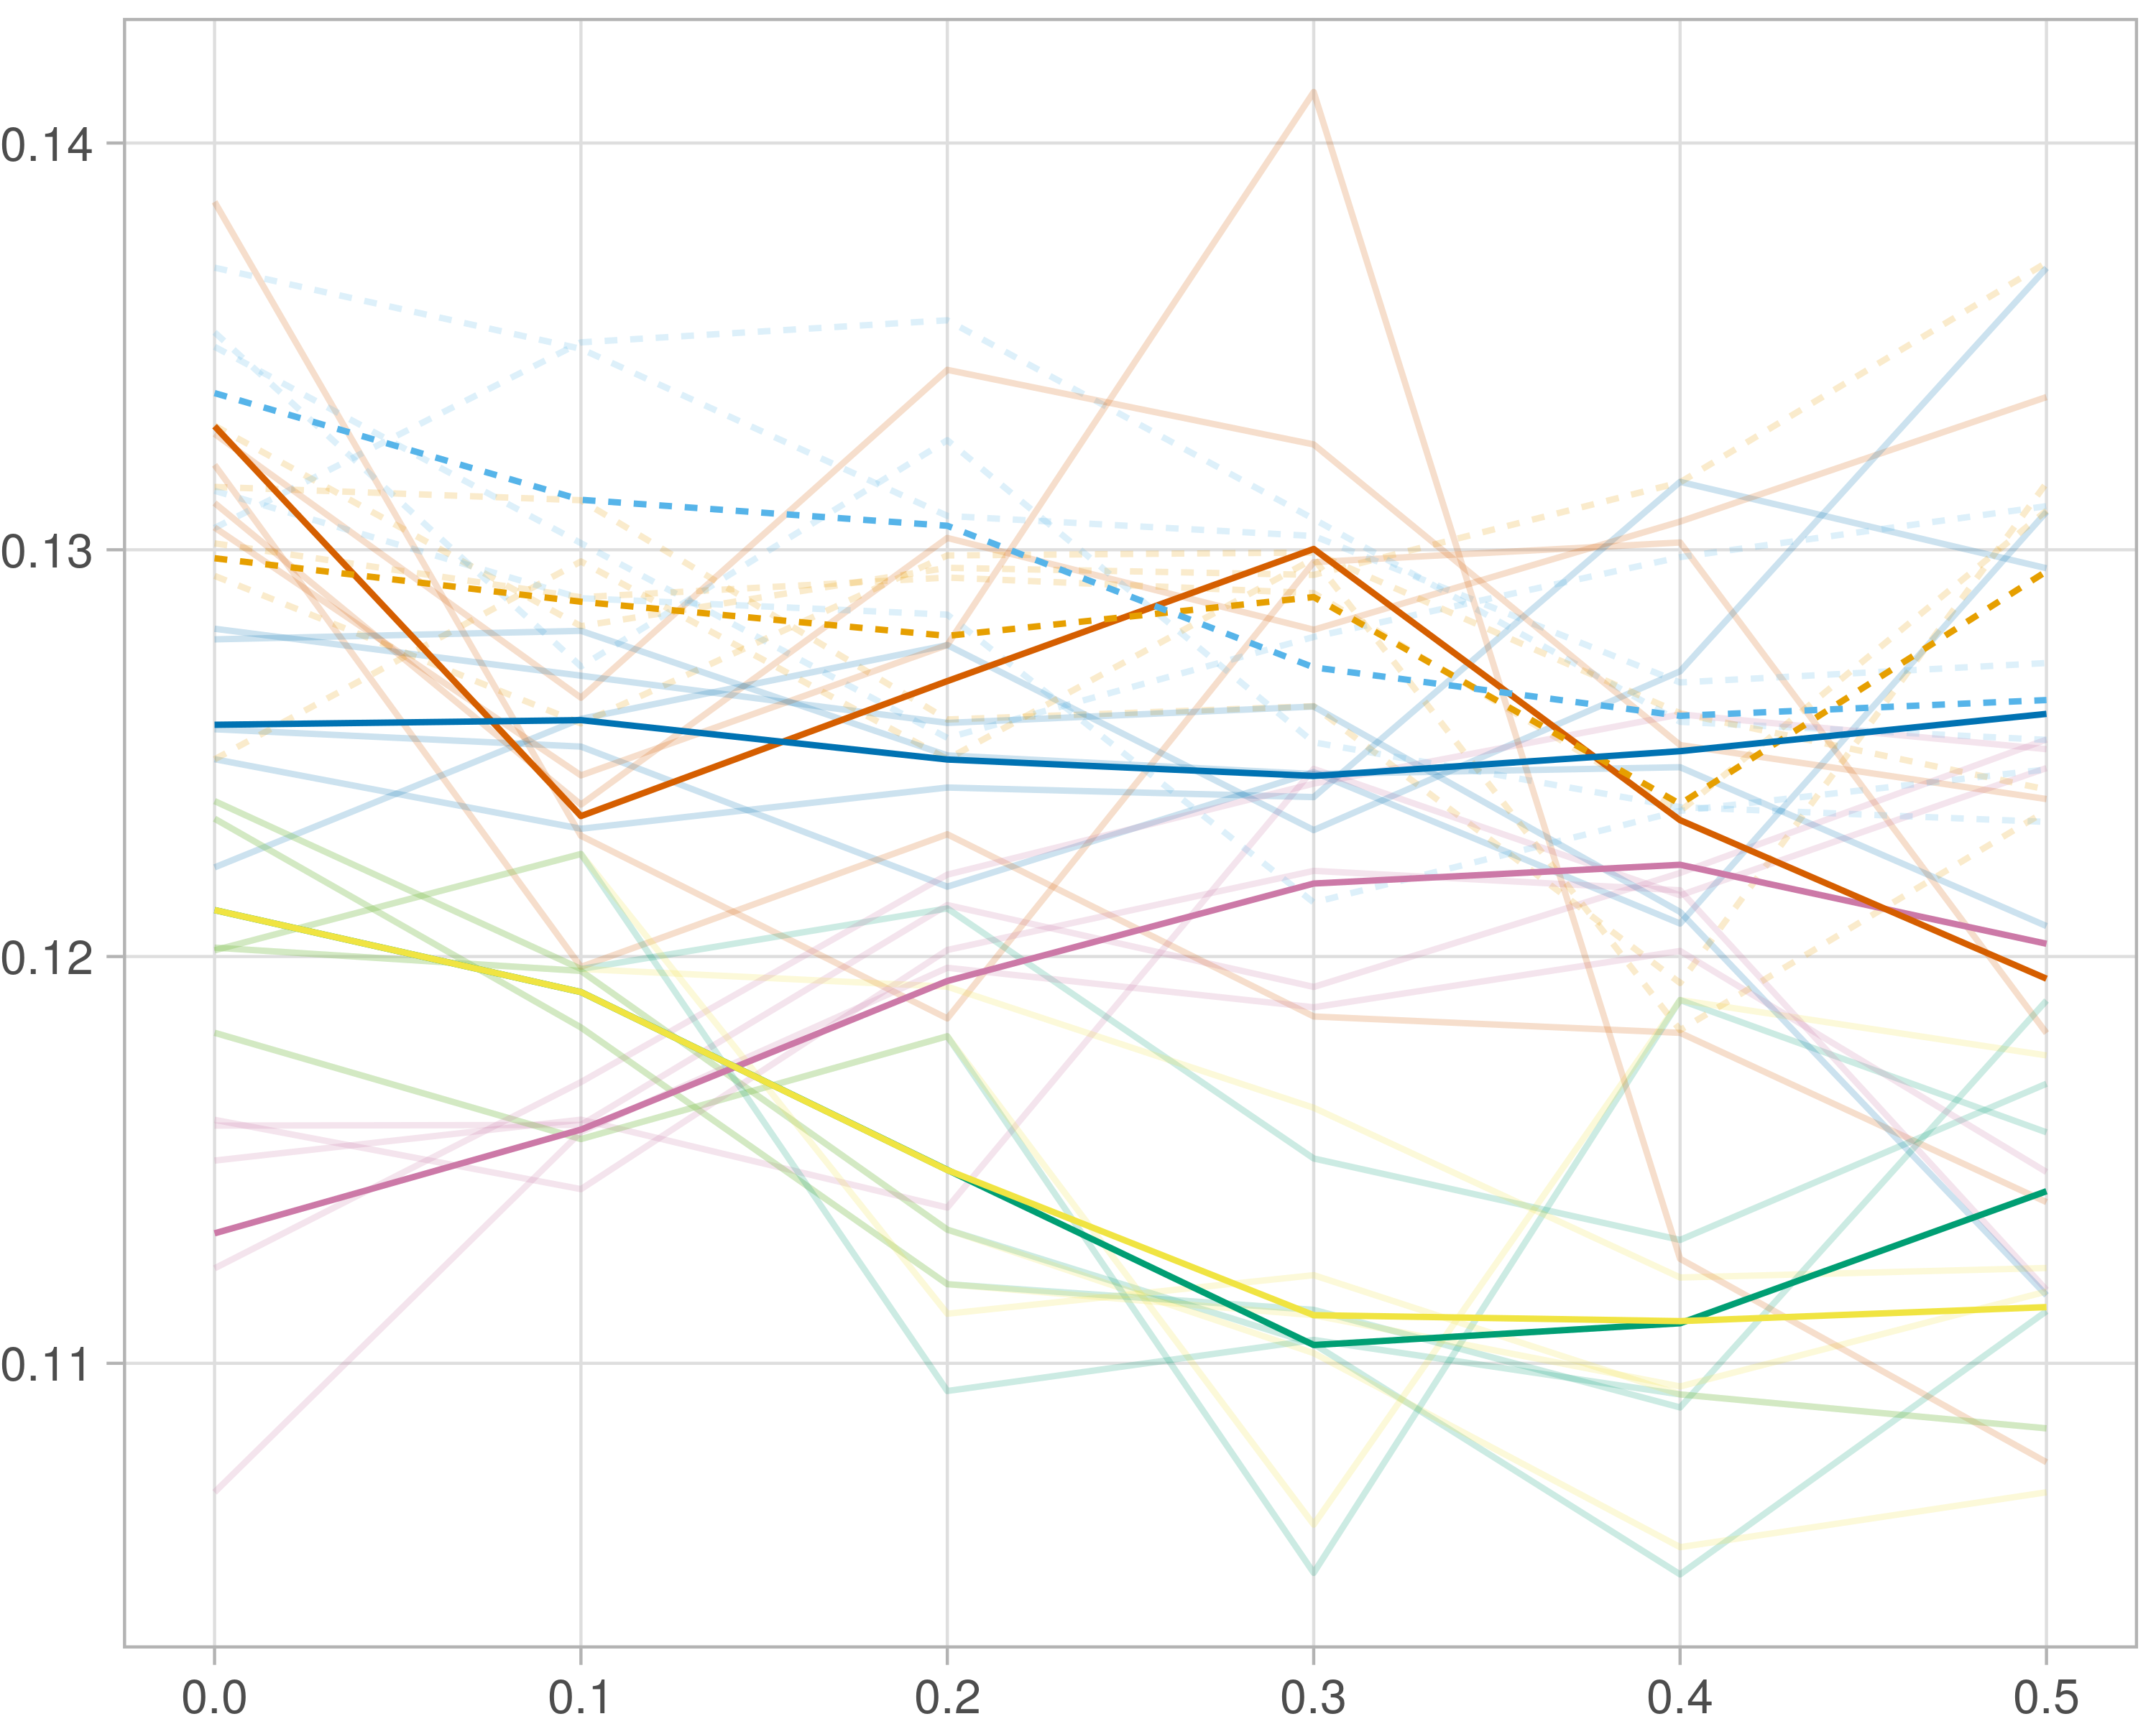

### Multi_omics

#general setup  
dir <- "/workspaces/phd_dissertation/kimono/analysis/data/derived_data/"  
  
#load library  
setwd(dir)  
  
dat_raw <- fread("221116_all_project_info.csv")  
  
#dat_raw <- cbind(dat_raw[,c(1,2,3,16,18)],nodes=dat_raw$V6+dat_raw$V8+dat_raw$V10)  
#dat_raw <- dat_raw[dat_raw$iteration == 1,]  
  
dat_raw$method <- gsub(pattern = "_moran|_mos|_mor|_so|_sor",replacement = "",x = dat_raw$method)  
  
dat <- dat_raw[tolower(dat_raw$method) %in% c("galasso_false","galasso_true","knnkimono","salasso_false","salasso_true","cocolasso","hmlasso"),]  
  
  
#ggplot(dat, aes(x=clustering, y=n_genes+n_methylation+n_cnv, color=as.factor(method)) )+  
# geom_point(alpha=0.5) + facet_grid(experiment~noise)  
  
#ggplot(dat, aes(y=clustering, x=missingness, color=as.factor(method)) )+  
# geom_point(alpha=0.5) + facet_grid(experiment~noise)  
  
#ggplot(dat, aes(x=missingness, y=clustering,fill=as.factor(method)))+  
# scale_y_continuous(trans='sqrt') + geom_boxplot() + facet_grid(experiment~noise)  
  
  
dat$method <- as.factor(dat$method)   
dat <- dat %>% mutate(method = fct_relevel(method, "knnkimono", "galasso_false" ,"galasso_true" , "salasso_false" , "salasso_true" ,"cocolasso", "hmlasso" ))  
dat$experiment <- as.factor(dat$experiment)  
dat <- dat %>% mutate(experiment = fct_relevel(experiment, "so", "moran" ,"mos" , "sor" , "mor"))  
  
palette_OkabeIto <- c( "#CC79A7", "#D55E00", "#E69F00","#0072B2", "#56B4E9", "#009E73", "#F0E442")  
  
dat <- aggregate(dat[, -c(1:8)], list('noise'=dat$noise,  
 'missingness'=dat$missingness,  
 'method'=dat$method,  
 'experiment'=dat$experiment), function(x){mean(x,na.rm=TRUE)})  
  
dat_raw$method <- as.factor(dat_raw$method)   
dat_raw <- dat_raw %>% mutate(method = fct_relevel(method, "knnkimono", "galasso_false" ,"galasso_true" , "salasso_false" , "salasso_true" ,"cocolasso", "hmlasso" ))  
dat_raw$experiment <- as.factor(dat_raw$experiment)  
dat_raw <- dat_raw %>% mutate(experiment = fct_relevel(experiment, "so", "moran" ,"mos" , "sor" , "mor"))  
  
dat_raw <- dat_raw[ dat_raw$noise==1.5 & dat_raw$experiment %in% 'moran' & !dat_raw$method %in% "bdcoco_lasso",]  
dat <- dat[ dat$noise==1.5 & dat$experiment %in% 'moran' & !dat$method %in% "bdcoco_lasso",]  
  
dat_raw$adaptive <- grepl(pattern = "true",x = dat_raw$method)  
dat$adaptive <- grepl(pattern = "true",x = dat$method)  
  
p <- ggplot(dat_raw,   
 aes(y= (median_r2), x=missingness,color=as.factor(method)))+  
   
 geom_line(aes( group = interaction(method, iteration),linetype=adaptive),alpha = 0.2)+  
 facet_grid(noise~experiment, scales="free")+  
 scale_color_manual(values = palette_OkabeIto)+  
 scale_fill_manual(values = palette_OkabeIto)+   
 theme_light() +  
 theme(legend.position="bottom",  
 axis.text.x = element_text(size = 8),  
 axis.text.y = element_text(size = 8),  
 strip.background = element_blank(),   
 plot.margin = unit(c(-0.5, -0.5, 0, 0), "cm")  
 ) +  
 ylab("#Nodes")   
  
to.plot3 <- p + geom_line(data = dat,   
 aes(y= (median_r2), x=missingness, color=as.factor(method),linetype=adaptive)) +   
 theme(strip.background = element_blank(), panel.grid.minor = element_blank(),  
 legend.position = "none",  
 axis.title.x=element_blank(),  
 #axis.text.x=element_blank(),  
 #axis.ticks.x=element_blank(),  
 axis.title.y=element_blank(),  
 #axis.text.y=element_blank(),  
 #axis.ticks.y=element_blank(),   
 plot.margin = unit(c(-0.5, -0.5, 0, 0), "cm")  
 )  
  
to.plot3

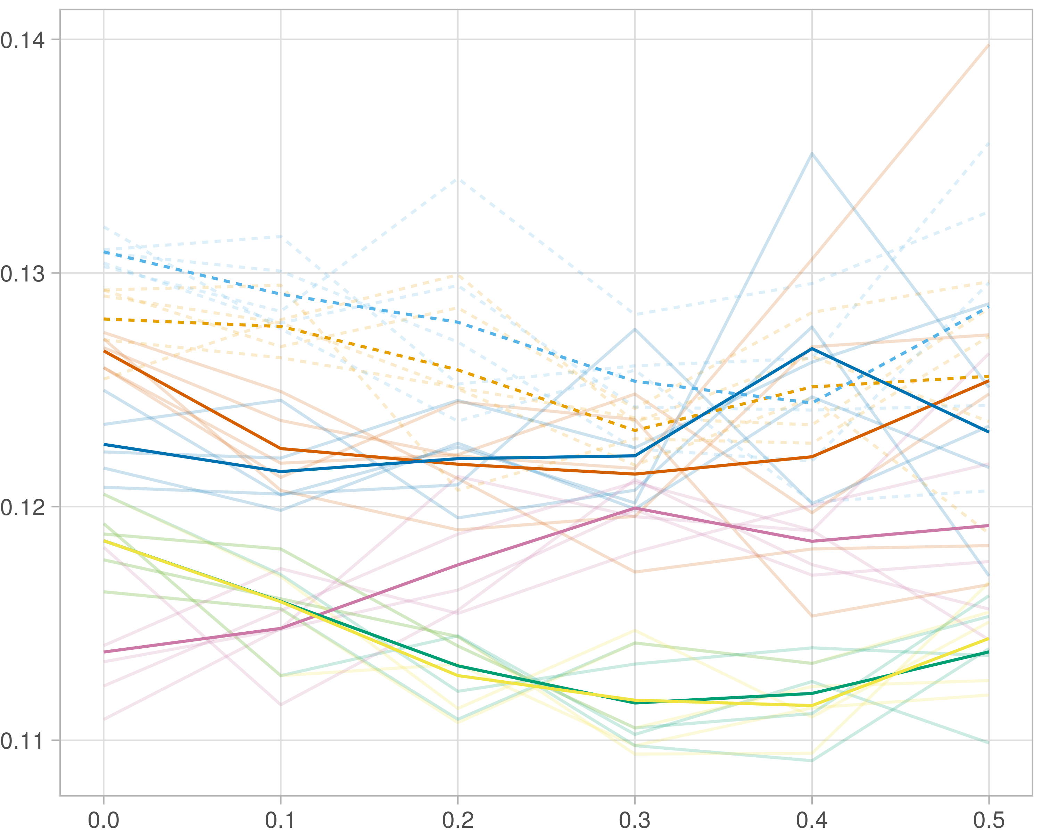

### Block-wise

#general setup  
dir <- "/workspaces/phd_dissertation/kimono/analysis/data/derived_data/"  
  
#load library  
setwd(dir)  
  
dat_raw <- fread("221116_all_project_info.csv")  
  
#dat_raw <- cbind(dat_raw[,c(1,2,3,16,18)],nodes=dat_raw$V6+dat_raw$V8+dat_raw$V10)  
#dat_raw <- dat_raw[dat_raw$iteration == 1,]  
  
dat_raw$method <- gsub(pattern = "_moran|_mos|_mor|_so|_sor",replacement = "",x = dat_raw$method)  
  
dat <- dat_raw[tolower(dat_raw$method) %in% c("galasso_false","galasso_true","knnkimono","salasso_false","salasso_true","cocolasso","hmlasso"),]  
  
  
#ggplot(dat, aes(x=clustering, y=n_genes+n_methylation+n_cnv, color=as.factor(method)) )+  
# geom_point(alpha=0.5) + facet_grid(experiment~noise)  
  
#ggplot(dat, aes(y=clustering, x=missingness, color=as.factor(method)) )+  
# geom_point(alpha=0.5) + facet_grid(experiment~noise)  
  
#ggplot(dat, aes(x=missingness, y=clustering,fill=as.factor(method)))+  
# scale_y_continuous(trans='sqrt') + geom_boxplot() + facet_grid(experiment~noise)  
  
  
dat$method <- as.factor(dat$method)   
dat <- dat %>% mutate(method = fct_relevel(method, "knnkimono", "galasso_false" ,"galasso_true" , "salasso_false" , "salasso_true" ,"cocolasso", "hmlasso" ))  
dat$experiment <- as.factor(dat$experiment)  
dat <- dat %>% mutate(experiment = fct_relevel(experiment, "so", "moran" ,"mos" , "sor" , "mor"))  
  
palette_OkabeIto <- c( "#CC79A7", "#D55E00", "#E69F00","#0072B2", "#56B4E9", "#009E73", "#F0E442")  
  
dat <- aggregate(dat[, -c(1:8)], list('noise'=dat$noise,  
 'missingness'=dat$missingness,  
 'method'=dat$method,  
 'experiment'=dat$experiment), function(x){mean(x,na.rm=TRUE)})  
  
dat_raw$method <- as.factor(dat_raw$method)   
dat_raw <- dat_raw %>% mutate(method = fct_relevel(method, "knnkimono", "galasso_false" ,"galasso_true" , "salasso_false" , "salasso_true" ,"cocolasso", "hmlasso" ))  
dat_raw$experiment <- as.factor(dat_raw$experiment)  
dat_raw <- dat_raw %>% mutate(experiment = fct_relevel(experiment, "so", "moran" ,"mos" , "sor" , "mor"))  
  
dat_raw <- dat_raw[ dat_raw$noise==1.5 & dat_raw$experiment %in% 'mos' & !dat_raw$method %in% "bdcoco_lasso",]  
dat <- dat[ dat$noise==1.5 & dat$experiment %in% 'mos' & !dat$method %in% "bdcoco_lasso",]  
  
dat_raw$adaptive <- grepl(pattern = "true",x = dat_raw$method)  
dat$adaptive <- grepl(pattern = "true",x = dat$method)  
  
p <- ggplot(dat_raw,   
 aes(y= (median_r2), x=missingness,color=as.factor(method)))+  
   
 geom_line(aes( group = interaction(method, iteration),linetype=adaptive),alpha = 0.2)+  
 facet_grid(noise~experiment, scales="free")+  
 scale_color_manual(values = palette_OkabeIto)+  
 scale_fill_manual(values = palette_OkabeIto)+   
 theme_light() +  
 theme(legend.position="bottom",  
 axis.text.x = element_text(size = 8),  
 axis.text.y = element_text(size = 8),  
 strip.background = element_blank(),   
 plot.margin = unit(c(-0.5, -0.5, 0, 0), "cm")  
 ) +  
 ylab("#Nodes")   
  
to.plot3 <- p + geom_line(data = dat,   
 aes(y= (median_r2), x=missingness, color=as.factor(method),linetype=adaptive)) +   
 theme(strip.background = element_blank(), panel.grid.minor = element_blank(),  
 legend.position = "none",  
 axis.title.x=element_blank(),  
 #axis.text.x=element_blank(),  
 #axis.ticks.x=element_blank(),  
 axis.title.y=element_blank(),  
 #axis.text.y=element_blank(),  
 #axis.ticks.y=element_blank(),   
 plot.margin = unit(c(-0.5, -0.5, 0, 0), "cm")  
 )  
  
to.plot3

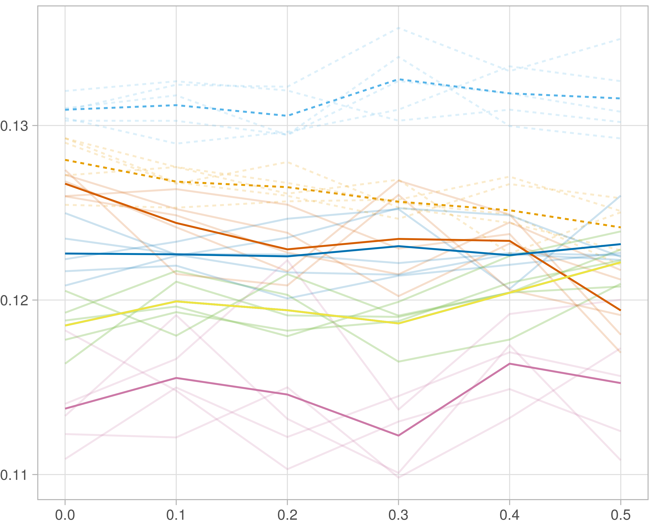

## F1-score (reference)

### Single-omics

#general setup  
dir <- "/workspaces/phd_dissertation/kimono/analysis/data/derived_data/"  
  
#load library  
setwd(dir)  
  
dat_raw <- fread("221116_all_project_info.csv")  
  
#dat_raw <- cbind(dat_raw[,c(1,2,3,16,18)],nodes=dat_raw$V6+dat_raw$V8+dat_raw$V10)  
#dat_raw <- dat_raw[dat_raw$iteration == 1,]  
  
dat_raw$method <- gsub(pattern = "_moran|_mos|_mor|_so|_sor",replacement = "",x = dat_raw$method)  
  
dat <- dat_raw[tolower(dat_raw$method) %in% c("galasso_false","galasso_true","knnkimono","salasso_false","salasso_true","cocolasso","hmlasso"),]  
  
  
#ggplot(dat, aes(x=clustering, y=n_genes+n_methylation+n_cnv, color=as.factor(method)) )+  
# geom_point(alpha=0.5) + facet_grid(experiment~noise)  
  
#ggplot(dat, aes(y=clustering, x=missingness, color=as.factor(method)) )+  
# geom_point(alpha=0.5) + facet_grid(experiment~noise)  
  
#ggplot(dat, aes(x=missingness, y=clustering,fill=as.factor(method)))+  
# scale_y_continuous(trans='sqrt') + geom_boxplot() + facet_grid(experiment~noise)  
  
  
dat$method <- as.factor(dat$method)   
dat <- dat %>% mutate(method = fct_relevel(method, "knnkimono", "galasso_false" ,"galasso_true" , "salasso_false" , "salasso_true" ,"cocolasso", "hmlasso" ))  
dat$experiment <- as.factor(dat$experiment)  
dat <- dat %>% mutate(experiment = fct_relevel(experiment, "so", "moran" ,"mos" , "sor" , "mor"))  
  
palette_OkabeIto <- c( "#CC79A7", "#D55E00", "#E69F00","#0072B2", "#56B4E9", "#009E73", "#F0E442")  
  
dat <- aggregate(dat[, -c(1:8)], list('noise'=dat$noise,  
 'missingness'=dat$missingness,  
 'method'=dat$method,  
 'experiment'=dat$experiment), function(x){mean(x,na.rm=TRUE)})  
  
dat_raw$method <- as.factor(dat_raw$method)   
dat_raw <- dat_raw %>% mutate(method = fct_relevel(method, "knnkimono", "galasso_false" ,"galasso_true" , "salasso_false" , "salasso_true" ,"cocolasso", "hmlasso" ))  
dat_raw$experiment <- as.factor(dat_raw$experiment)  
dat_raw <- dat_raw %>% mutate(experiment = fct_relevel(experiment, "so", "moran" ,"mos" , "sor" , "mor"))  
  
dat_raw <- dat_raw[ dat_raw$noise==1.5 & dat_raw$experiment %in% 'so' & !dat_raw$method %in% "bdcoco_lasso",]  
dat <- dat[ dat$noise==1.5 & dat$experiment %in% 'so' & !dat$method %in% "bdcoco_lasso",]  
  
dat_raw$adaptive <- grepl(pattern = "true",x = dat_raw$method)  
dat$adaptive <- grepl(pattern = "true",x = dat$method)  
  
p <- ggplot(dat_raw,   
 aes(y= (f1_score_reference), x=missingness,color=as.factor(method)))+  
   
 geom_line(aes( group = interaction(method, iteration),linetype=adaptive),alpha = 0.2)+  
 facet_grid(noise~experiment, scales="free")+  
 scale_color_manual(values = palette_OkabeIto)+  
 scale_fill_manual(values = palette_OkabeIto)+   
 theme_light() +  
 theme(legend.position="bottom",  
 axis.text.x = element_text(size = 8),  
 axis.text.y = element_text(size = 8),  
 strip.background = element_blank(),   
 plot.margin = unit(c(-0.5, -0.5, 0, 0), "cm")  
 ) +  
 ylab("#Nodes")   
  
to.plot4 <- p + geom_line(data = dat,   
 aes(y= (f1_score_reference), x=missingness, color=as.factor(method),linetype=adaptive)) +   
 theme(strip.background = element_blank(), panel.grid.minor = element_blank(),  
 legend.position = "none",  
 axis.title.x=element_blank(),  
 #axis.text.x=element_blank(),  
 #axis.ticks.x=element_blank(),  
 axis.title.y=element_blank(),  
 #axis.text.y=element_blank(),  
 #axis.ticks.y=element_blank(),   
 plot.margin = unit(c(-0.5, -0.5, 0, 0), "cm")  
 )  
  
to.plot4

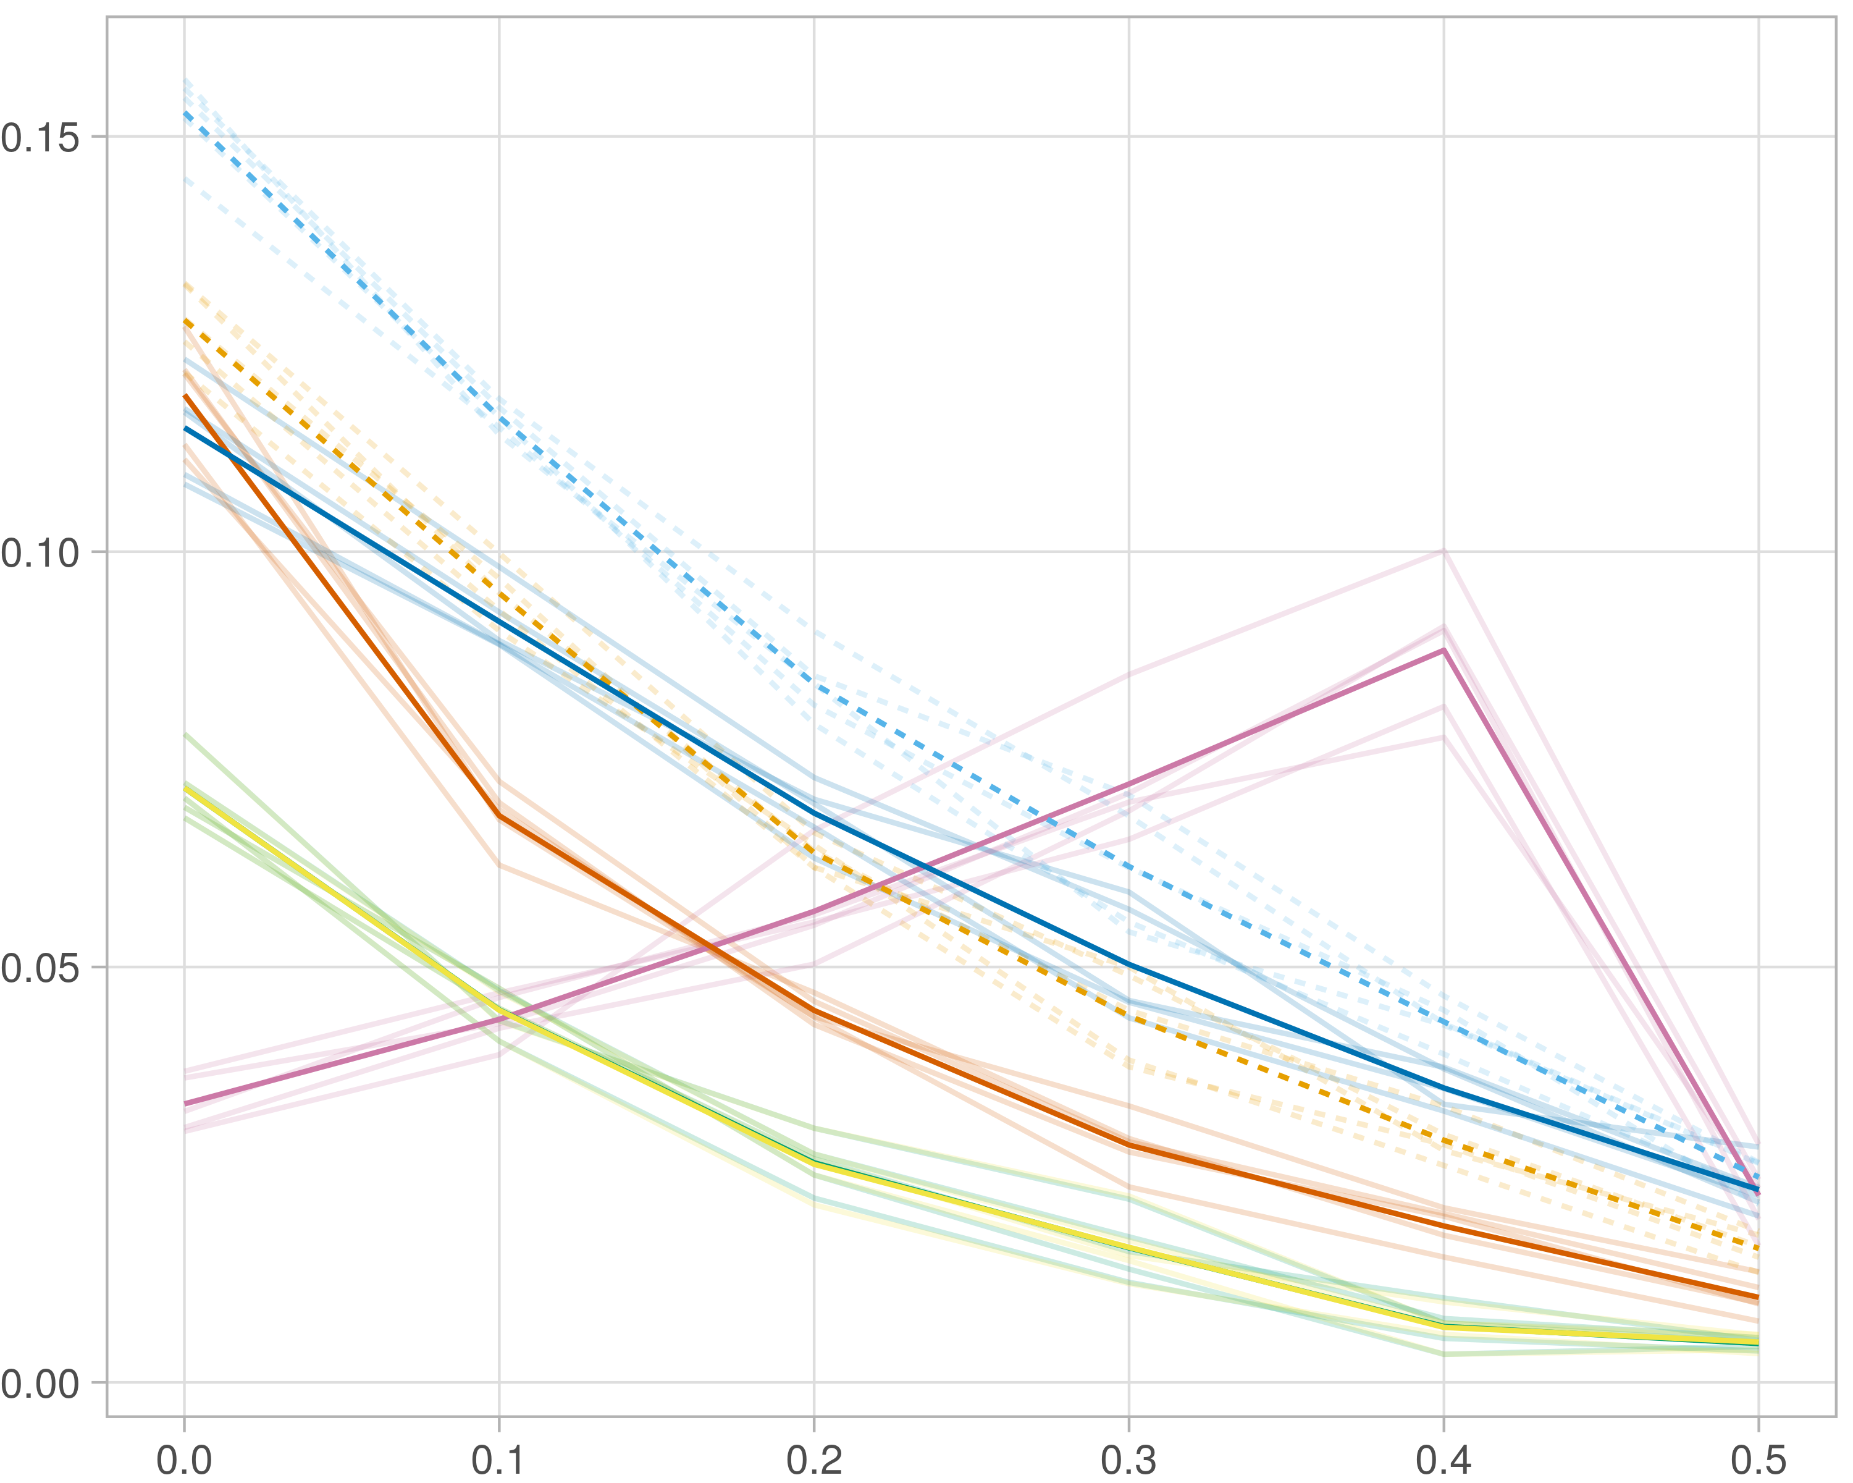

### Multi-omics

#general setup  
dir <- "/workspaces/phd_dissertation/kimono/analysis/data/derived_data/"  
  
#load library  
setwd(dir)  
  
dat_raw <- fread("221116_all_project_info.csv")  
  
#dat_raw <- cbind(dat_raw[,c(1,2,3,16,18)],nodes=dat_raw$V6+dat_raw$V8+dat_raw$V10)  
#dat_raw <- dat_raw[dat_raw$iteration == 1,]  
  
dat_raw$method <- gsub(pattern = "_moran|_mos|_mor|_so|_sor",replacement = "",x = dat_raw$method)  
  
dat <- dat_raw[tolower(dat_raw$method) %in% c("galasso_false","galasso_true","knnkimono","salasso_false","salasso_true","cocolasso","hmlasso"),]  
  
  
#ggplot(dat, aes(x=clustering, y=n_genes+n_methylation+n_cnv, color=as.factor(method)) )+  
# geom_point(alpha=0.5) + facet_grid(experiment~noise)  
  
#ggplot(dat, aes(y=clustering, x=missingness, color=as.factor(method)) )+  
# geom_point(alpha=0.5) + facet_grid(experiment~noise)  
  
#ggplot(dat, aes(x=missingness, y=clustering,fill=as.factor(method)))+  
# scale_y_continuous(trans='sqrt') + geom_boxplot() + facet_grid(experiment~noise)  
  
  
dat$method <- as.factor(dat$method)   
dat <- dat %>% mutate(method = fct_relevel(method, "knnkimono", "galasso_false" ,"galasso_true" , "salasso_false" , "salasso_true" ,"cocolasso", "hmlasso" ))  
dat$experiment <- as.factor(dat$experiment)  
dat <- dat %>% mutate(experiment = fct_relevel(experiment, "so", "moran" ,"mos" , "sor" , "mor"))  
  
palette_OkabeIto <- c( "#CC79A7", "#D55E00", "#E69F00","#0072B2", "#56B4E9", "#009E73", "#F0E442")  
  
dat <- aggregate(dat[, -c(1:8)], list('noise'=dat$noise,  
 'missingness'=dat$missingness,  
 'method'=dat$method,  
 'experiment'=dat$experiment), function(x){mean(x,na.rm=TRUE)})  
  
dat_raw$method <- as.factor(dat_raw$method)   
dat_raw <- dat_raw %>% mutate(method = fct_relevel(method, "knnkimono", "galasso_false" ,"galasso_true" , "salasso_false" , "salasso_true" ,"cocolasso", "hmlasso" ))  
dat_raw$experiment <- as.factor(dat_raw$experiment)  
dat_raw <- dat_raw %>% mutate(experiment = fct_relevel(experiment, "so", "moran" ,"mos" , "sor" , "mor"))  
  
dat_raw <- dat_raw[ dat_raw$noise==1.5 & dat_raw$experiment %in% 'moran' & !dat_raw$method %in% "bdcoco_lasso",]  
dat <- dat[ dat$noise==1.5 & dat$experiment %in% 'moran' & !dat$method %in% "bdcoco_lasso",]  
  
dat_raw$adaptive <- grepl(pattern = "true",x = dat_raw$method)  
dat$adaptive <- grepl(pattern = "true",x = dat$method)  
  
p <- ggplot(dat_raw,   
 aes(y= (f1_score_reference), x=missingness,color=as.factor(method)))+  
   
 geom_line(aes( group = interaction(method, iteration),linetype=adaptive),alpha = 0.2)+  
 facet_grid(noise~experiment, scales="free")+  
 scale_color_manual(values = palette_OkabeIto)+  
 scale_fill_manual(values = palette_OkabeIto)+   
 theme_light() +  
 theme(legend.position="bottom",  
 axis.text.x = element_text(size = 8),  
 axis.text.y = element_text(size = 8),  
 strip.background = element_blank(),   
 plot.margin = unit(c(-0.5, -0.5, 0, 0), "cm")  
 ) +  
 ylab("#Nodes")   
  
to.plot4 <- p + geom_line(data = dat,   
 aes(y= (f1_score_reference), x=missingness, color=as.factor(method),linetype=adaptive)) +   
 theme(strip.background = element_blank(), panel.grid.minor = element_blank(),  
 legend.position = "none",  
 axis.title.x=element_blank(),  
 #axis.text.x=element_blank(),  
 #axis.ticks.x=element_blank(),  
 axis.title.y=element_blank(),  
 #axis.text.y=element_blank(),  
 #axis.ticks.y=element_blank(),   
 plot.margin = unit(c(-0.5, -0.5, 0, 0), "cm")  
 )  
  
to.plot4

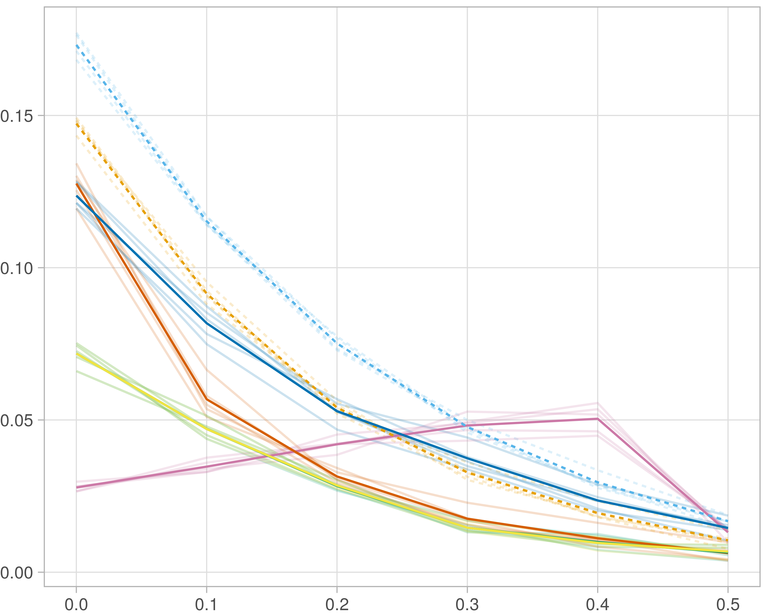

### Block-wise

#general setup  
dir <- "/workspaces/phd_dissertation/kimono/analysis/data/derived_data/"  
  
#load library  
setwd(dir)  
  
dat_raw <- fread("221116_all_project_info.csv")  
  
#dat_raw <- cbind(dat_raw[,c(1,2,3,16,18)],nodes=dat_raw$V6+dat_raw$V8+dat_raw$V10)  
#dat_raw <- dat_raw[dat_raw$iteration == 1,]  
  
dat_raw$method <- gsub(pattern = "_moran|_mos|_mor|_so|_sor",replacement = "",x = dat_raw$method)  
  
dat <- dat_raw[tolower(dat_raw$method) %in% c("galasso_false","galasso_true","knnkimono","salasso_false","salasso_true","cocolasso","hmlasso"),]  
  
  
#ggplot(dat, aes(x=clustering, y=n_genes+n_methylation+n_cnv, color=as.factor(method)) )+  
# geom_point(alpha=0.5) + facet_grid(experiment~noise)  
  
#ggplot(dat, aes(y=clustering, x=missingness, color=as.factor(method)) )+  
# geom_point(alpha=0.5) + facet_grid(experiment~noise)  
  
#ggplot(dat, aes(x=missingness, y=clustering,fill=as.factor(method)))+  
# scale_y_continuous(trans='sqrt') + geom_boxplot() + facet_grid(experiment~noise)  
  
  
dat$method <- as.factor(dat$method)   
dat <- dat %>% mutate(method = fct_relevel(method, "knnkimono", "galasso_false" ,"galasso_true" , "salasso_false" , "salasso_true" ,"cocolasso", "hmlasso" ))  
dat$experiment <- as.factor(dat$experiment)  
dat <- dat %>% mutate(experiment = fct_relevel(experiment, "so", "moran" ,"mos" , "sor" , "mor"))  
  
palette_OkabeIto <- c( "#CC79A7", "#D55E00", "#E69F00","#0072B2", "#56B4E9", "#009E73", "#F0E442")  
  
dat <- aggregate(dat[, -c(1:8)], list('noise'=dat$noise,  
 'missingness'=dat$missingness,  
 'method'=dat$method,  
 'experiment'=dat$experiment), function(x){mean(x,na.rm=TRUE)})  
  
dat_raw$method <- as.factor(dat_raw$method)   
dat_raw <- dat_raw %>% mutate(method = fct_relevel(method, "knnkimono", "galasso_false" ,"galasso_true" , "salasso_false" , "salasso_true" ,"cocolasso", "hmlasso" ))  
dat_raw$experiment <- as.factor(dat_raw$experiment)  
dat_raw <- dat_raw %>% mutate(experiment = fct_relevel(experiment, "so", "moran" ,"mos" , "sor" , "mor"))  
  
dat_raw <- dat_raw[ dat_raw$noise==1.5 & dat_raw$experiment %in% 'mos' & !dat_raw$method %in% "bdcoco_lasso",]  
dat <- dat[ dat$noise==1.5 & dat$experiment %in% 'mos' & !dat$method %in% "bdcoco_lasso",]  
  
dat_raw$adaptive <- grepl(pattern = "true",x = dat_raw$method)  
dat$adaptive <- grepl(pattern = "true",x = dat$method)  
  
p <- ggplot(dat_raw,   
 aes(y= (f1_score_reference), x=missingness,color=as.factor(method)))+  
   
 geom_line(aes( group = interaction(method, iteration),linetype=adaptive),alpha = 0.2)+  
 facet_grid(noise~experiment, scales="free")+  
 scale_color_manual(values = palette_OkabeIto)+  
 scale_fill_manual(values = palette_OkabeIto)+   
 theme_light() +  
 theme(legend.position="bottom",  
 axis.text.x = element_text(size = 8),  
 axis.text.y = element_text(size = 8),  
 strip.background = element_blank(),   
 plot.margin = unit(c(-0.5, -0.5, 0, 0), "cm")  
 ) +  
 ylab("#Nodes")   
  
to.plot4 <- p + geom_line(data = dat,   
 aes(y= (f1_score_reference), x=missingness, color=as.factor(method),linetype=adaptive)) +   
 theme(strip.background = element_blank(), panel.grid.minor = element_blank(),  
 legend.position = "none",  
 axis.title.x=element_blank(),  
 #axis.text.x=element_blank(),  
 #axis.ticks.x=element_blank(),  
 axis.title.y=element_blank(),  
 #axis.text.y=element_blank(),  
 #axis.ticks.y=element_blank(),   
 plot.margin = unit(c(-0.5, -0.5, 0, 0), "cm")  
 )  
  
to.plot4

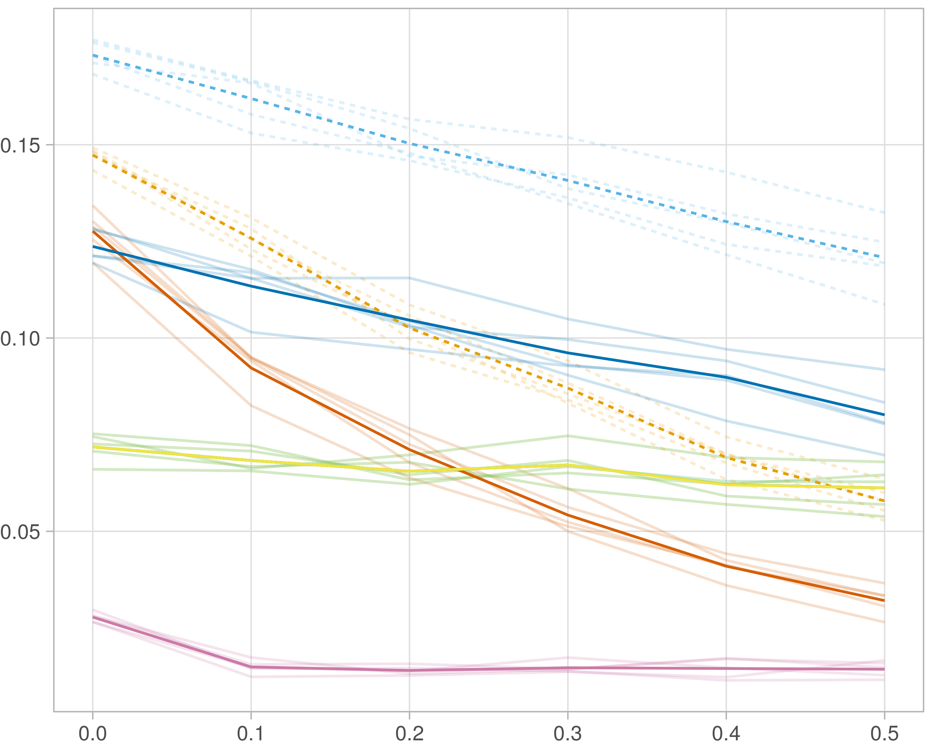

## F1-score (stability selection)

### Single-omics

#general setup  
dir <- "/workspaces/phd_dissertation/kimono/analysis/data/derived_data/"  
  
#load library  
setwd(dir)  
  
dat_raw <- fread("221116_all_project_info.csv")  
  
#dat_raw <- cbind(dat_raw[,c(1,2,3,16,18)],nodes=dat_raw$V6+dat_raw$V8+dat_raw$V10)  
#dat_raw <- dat_raw[dat_raw$iteration == 1,]  
  
dat_raw$method <- gsub(pattern = "_moran|_mos|_mor|_so|_sor",replacement = "",x = dat_raw$method)  
  
dat <- dat_raw[tolower(dat_raw$method) %in% c("galasso_false","galasso_true","knnkimono","salasso_false","salasso_true","cocolasso","hmlasso"),]  
  
  
#ggplot(dat, aes(x=clustering, y=n_genes+n_methylation+n_cnv, color=as.factor(method)) )+  
# geom_point(alpha=0.5) + facet_grid(experiment~noise)  
  
#ggplot(dat, aes(y=clustering, x=missingness, color=as.factor(method)) )+  
# geom_point(alpha=0.5) + facet_grid(experiment~noise)  
  
#ggplot(dat, aes(x=missingness, y=clustering,fill=as.factor(method)))+  
# scale_y_continuous(trans='sqrt') + geom_boxplot() + facet_grid(experiment~noise)  
  
  
dat$method <- as.factor(dat$method)   
dat <- dat %>% mutate(method = fct_relevel(method, "knnkimono", "galasso_false" ,"galasso_true" , "salasso_false" , "salasso_true" ,"cocolasso", "hmlasso" ))  
dat$experiment <- as.factor(dat$experiment)  
dat <- dat %>% mutate(experiment = fct_relevel(experiment, "so", "moran" ,"mos" , "sor" , "mor"))  
  
palette_OkabeIto <- c( "#CC79A7", "#D55E00", "#E69F00","#0072B2", "#56B4E9", "#009E73", "#F0E442")  
  
dat <- aggregate(dat[, -c(1:8)], list('noise'=dat$noise,  
 'missingness'=dat$missingness,  
 'method'=dat$method,  
 'experiment'=dat$experiment), function(x){mean(x,na.rm=TRUE)})  
  
dat_raw$method <- as.factor(dat_raw$method)   
dat_raw <- dat_raw %>% mutate(method = fct_relevel(method, "knnkimono", "galasso_false" ,"galasso_true" , "salasso_false" , "salasso_true" ,"cocolasso", "hmlasso" ))  
dat_raw$experiment <- as.factor(dat_raw$experiment)  
dat_raw <- dat_raw %>% mutate(experiment = fct_relevel(experiment, "so", "moran" ,"mos" , "sor" , "mor"))  
  
dat_raw <- dat_raw[ dat_raw$noise==1.5 & dat_raw$experiment %in% 'so' & !dat_raw$method %in% "bdcoco_lasso",]  
dat <- dat[ dat$noise==1.5 & dat$experiment %in% 'so' & !dat$method %in% "bdcoco_lasso",]  
  
dat_raw$adaptive <- grepl(pattern = "true",x = dat_raw$method)  
dat$adaptive <- grepl(pattern = "true",x = dat$method)  
  
p <- ggplot(dat_raw,   
 aes(y= (f1_score_stability), x=missingness,color=as.factor(method)))+  
   
 geom_line(aes( group = interaction(method, iteration),linetype=adaptive),alpha = 0.2)+  
 facet_grid(noise~experiment, scales="free")+  
 scale_color_manual(values = palette_OkabeIto)+  
 scale_fill_manual(values = palette_OkabeIto)+   
 theme_light() +  
 theme(legend.position="bottom",  
 axis.text.x = element_text(size = 8),  
 axis.text.y = element_text(size = 8),  
 strip.background = element_blank(),   
 plot.margin = unit(c(-0.5, -0.5, 0, 0), "cm")  
 ) +  
 ylab("#Nodes")   
  
to.plot5 <- p + geom_line(data = dat,   
 aes(y= (f1_score_stability), x=missingness, color=as.factor(method),linetype=adaptive)) +   
 theme(strip.background = element_blank(), panel.grid.minor = element_blank(),  
 legend.position = "none",  
 axis.title.x=element_blank(),  
 #axis.text.x=element_blank(),  
 #axis.ticks.x=element_blank(),  
 axis.title.y=element_blank(),  
 #axis.text.y=element_blank(),  
 #axis.ticks.y=element_blank(),   
 plot.margin = unit(c(-0.5, -0.5, 0, 0), "cm")  
 )  
  
to.plot5

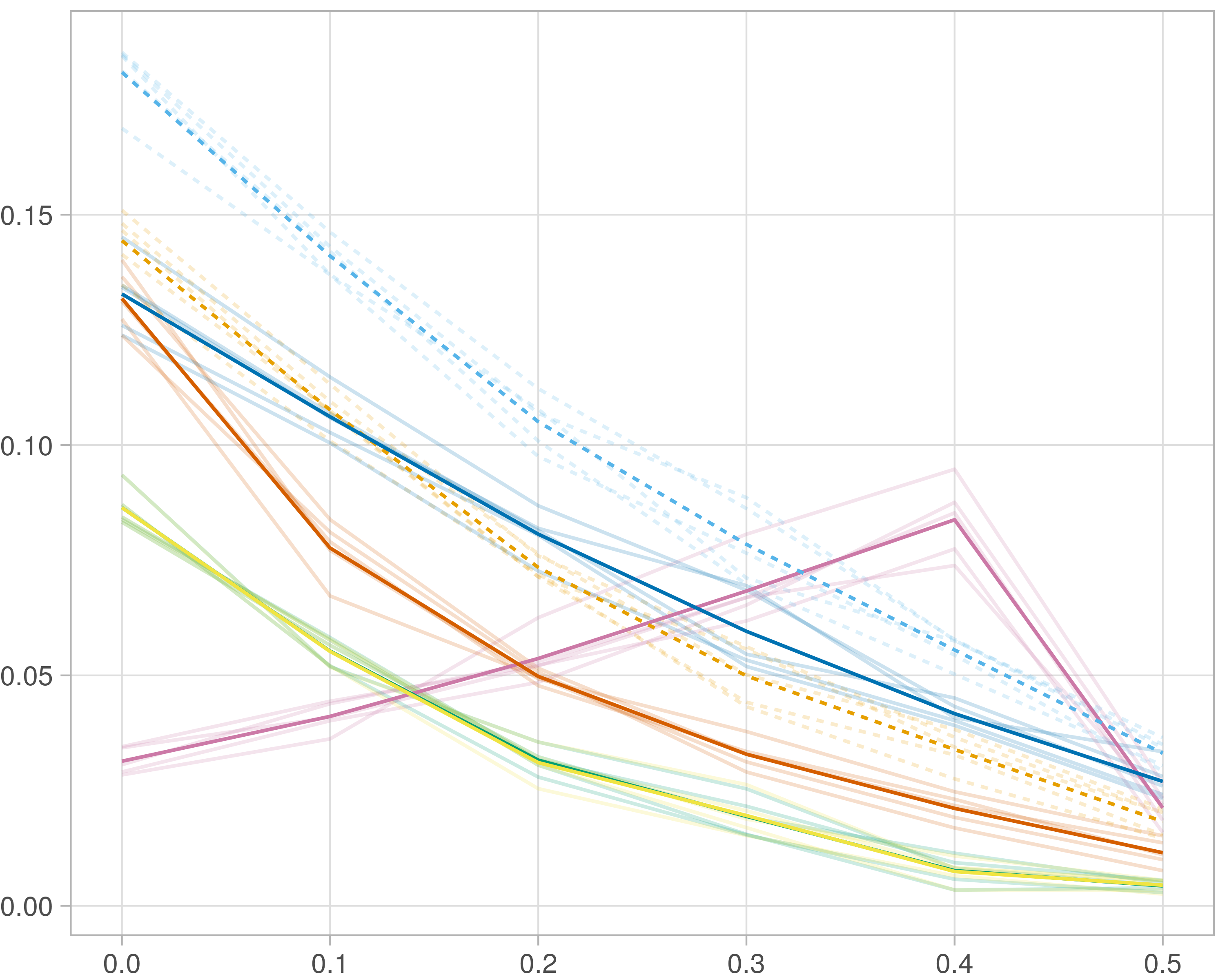

### Multi-omics

#general setup  
dir <- "/workspaces/phd_dissertation/kimono/analysis/data/derived_data/"  
  
#load library  
setwd(dir)  
  
dat_raw <- fread("221116_all_project_info.csv")  
  
#dat_raw <- cbind(dat_raw[,c(1,2,3,16,18)],nodes=dat_raw$V6+dat_raw$V8+dat_raw$V10)  
#dat_raw <- dat_raw[dat_raw$iteration == 1,]  
  
dat_raw$method <- gsub(pattern = "_moran|_mos|_mor|_so|_sor",replacement = "",x = dat_raw$method)  
  
dat <- dat_raw[tolower(dat_raw$method) %in% c("galasso_false","galasso_true","knnkimono","salasso_false","salasso_true","cocolasso","hmlasso"),]  
  
  
#ggplot(dat, aes(x=clustering, y=n_genes+n_methylation+n_cnv, color=as.factor(method)) )+  
# geom_point(alpha=0.5) + facet_grid(experiment~noise)  
  
#ggplot(dat, aes(y=clustering, x=missingness, color=as.factor(method)) )+  
# geom_point(alpha=0.5) + facet_grid(experiment~noise)  
  
#ggplot(dat, aes(x=missingness, y=clustering,fill=as.factor(method)))+  
# scale_y_continuous(trans='sqrt') + geom_boxplot() + facet_grid(experiment~noise)  
  
  
dat$method <- as.factor(dat$method)   
dat <- dat %>% mutate(method = fct_relevel(method, "knnkimono", "galasso_false" ,"galasso_true" , "salasso_false" , "salasso_true" ,"cocolasso", "hmlasso" ))  
dat$experiment <- as.factor(dat$experiment)  
dat <- dat %>% mutate(experiment = fct_relevel(experiment, "so", "moran" ,"mos" , "sor" , "mor"))  
  
palette_OkabeIto <- c( "#CC79A7", "#D55E00", "#E69F00","#0072B2", "#56B4E9", "#009E73", "#F0E442")  
  
dat <- aggregate(dat[, -c(1:8)], list('noise'=dat$noise,  
 'missingness'=dat$missingness,  
 'method'=dat$method,  
 'experiment'=dat$experiment), function(x){mean(x,na.rm=TRUE)})  
  
dat_raw$method <- as.factor(dat_raw$method)   
dat_raw <- dat_raw %>% mutate(method = fct_relevel(method, "knnkimono", "galasso_false" ,"galasso_true" , "salasso_false" , "salasso_true" ,"cocolasso", "hmlasso" ))  
dat_raw$experiment <- as.factor(dat_raw$experiment)  
dat_raw <- dat_raw %>% mutate(experiment = fct_relevel(experiment, "so", "moran" ,"mos" , "sor" , "mor"))  
  
dat_raw <- dat_raw[ dat_raw$noise==1.5 & dat_raw$experiment %in% 'moran' & !dat_raw$method %in% "bdcoco_lasso",]  
dat <- dat[ dat$noise==1.5 & dat$experiment %in% 'moran' & !dat$method %in% "bdcoco_lasso",]  
  
dat_raw$adaptive <- grepl(pattern = "true",x = dat_raw$method)  
dat$adaptive <- grepl(pattern = "true",x = dat$method)  
  
p <- ggplot(dat_raw,   
 aes(y= (f1_score_stability), x=missingness,color=as.factor(method)))+  
   
 geom_line(aes( group = interaction(method, iteration),linetype=adaptive),alpha = 0.2)+  
 facet_grid(noise~experiment, scales="free")+  
 scale_color_manual(values = palette_OkabeIto)+  
 scale_fill_manual(values = palette_OkabeIto)+   
 theme_light() +  
 theme(legend.position="bottom",  
 axis.text.x = element_text(size = 8),  
 axis.text.y = element_text(size = 8),  
 strip.background = element_blank(),   
 plot.margin = unit(c(-0.5, -0.5, 0, 0), "cm")  
 ) +  
 ylab("#Nodes")   
  
to.plot5 <- p + geom_line(data = dat,   
 aes(y= (f1_score_stability), x=missingness, color=as.factor(method),linetype=adaptive)) +   
 theme(strip.background = element_blank(), panel.grid.minor = element_blank(),  
 legend.position = "none",  
 axis.title.x=element_blank(),  
 #axis.text.x=element_blank(),  
 #axis.ticks.x=element_blank(),  
 axis.title.y=element_blank(),  
 #axis.text.y=element_blank(),  
 #axis.ticks.y=element_blank(),   
 plot.margin = unit(c(-0.5, -0.5, 0, 0), "cm")  
 )  
  
to.plot5

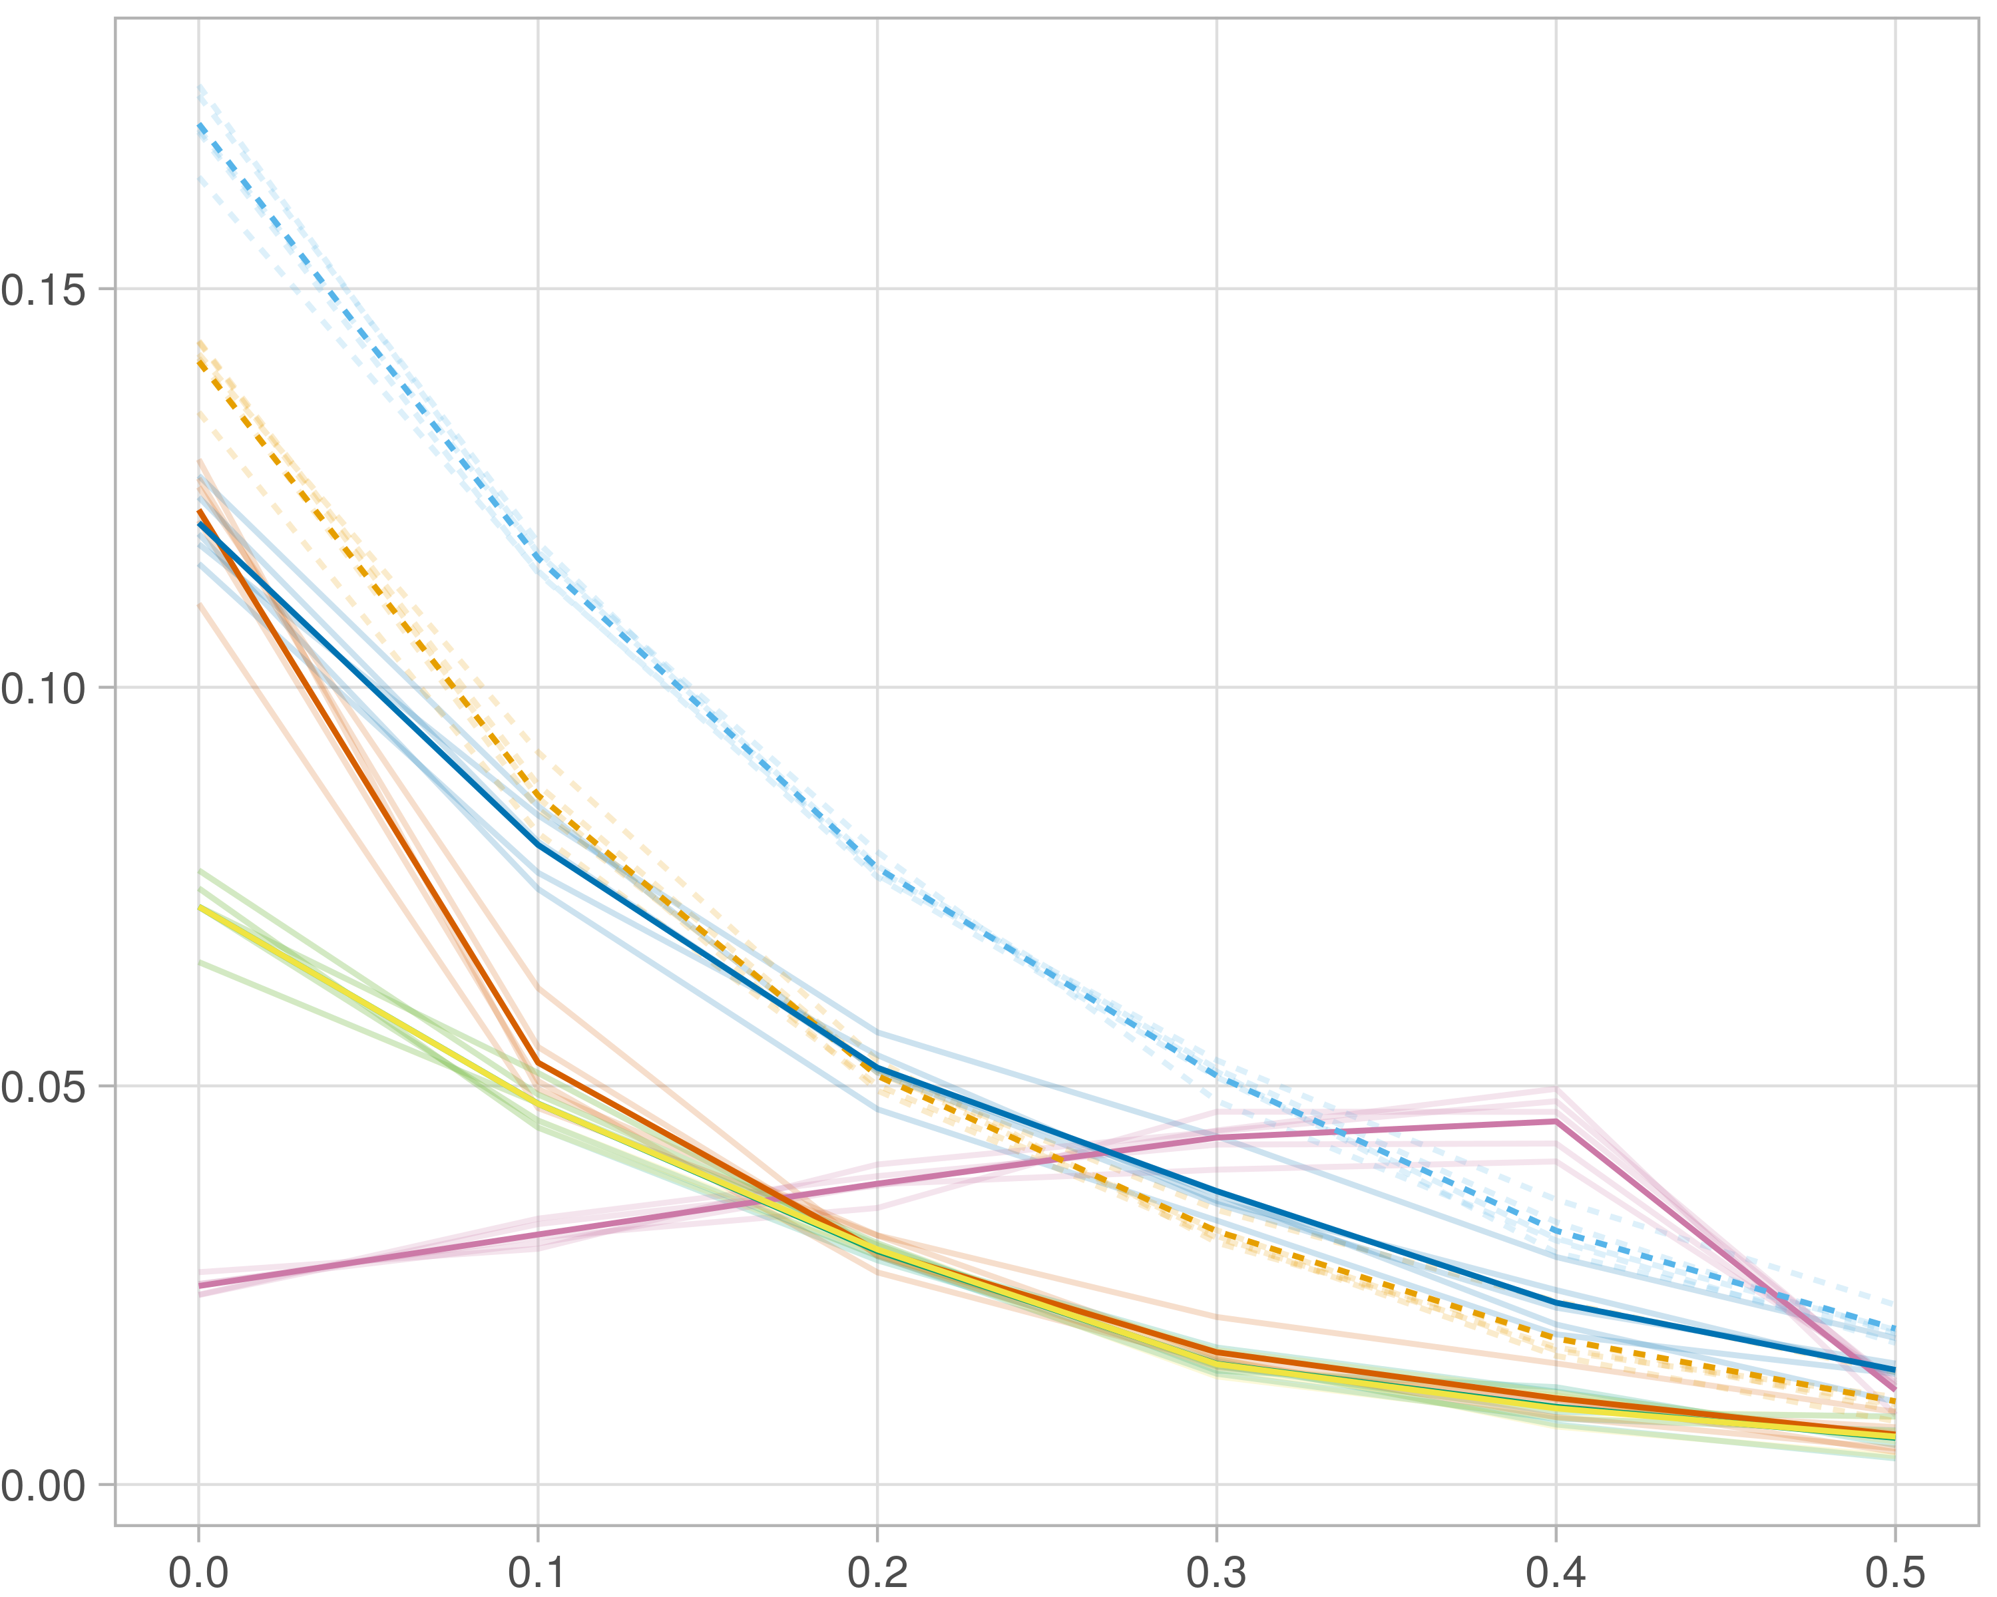

### Block-wise

#general setup  
dir <- "/workspaces/phd_dissertation/kimono/analysis/data/derived_data/"  
  
#load library  
setwd(dir)  
  
dat_raw <- fread("221116_all_project_info.csv")  
  
#dat_raw <- cbind(dat_raw[,c(1,2,3,16,18)],nodes=dat_raw$V6+dat_raw$V8+dat_raw$V10)  
#dat_raw <- dat_raw[dat_raw$iteration == 1,]  
  
dat_raw$method <- gsub(pattern = "_moran|_mos|_mor|_so|_sor",replacement = "",x = dat_raw$method)  
  
dat <- dat_raw[tolower(dat_raw$method) %in% c("galasso_false","galasso_true","knnkimono","salasso_false","salasso_true","cocolasso","hmlasso"),]  
  
  
#ggplot(dat, aes(x=clustering, y=n_genes+n_methylation+n_cnv, color=as.factor(method)) )+  
# geom_point(alpha=0.5) + facet_grid(experiment~noise)  
  
#ggplot(dat, aes(y=clustering, x=missingness, color=as.factor(method)) )+  
# geom_point(alpha=0.5) + facet_grid(experiment~noise)  
  
#ggplot(dat, aes(x=missingness, y=clustering,fill=as.factor(method)))+  
# scale_y_continuous(trans='sqrt') + geom_boxplot() + facet_grid(experiment~noise)  
  
  
dat$method <- as.factor(dat$method)   
dat <- dat %>% mutate(method = fct_relevel(method, "knnkimono", "galasso_false" ,"galasso_true" , "salasso_false" , "salasso_true" ,"cocolasso", "hmlasso" ))  
dat$experiment <- as.factor(dat$experiment)  
dat <- dat %>% mutate(experiment = fct_relevel(experiment, "so", "moran" ,"mos" , "sor" , "mor"))  
  
palette_OkabeIto <- c( "#CC79A7", "#D55E00", "#E69F00","#0072B2", "#56B4E9", "#009E73", "#F0E442")  
  
dat <- aggregate(dat[, -c(1:8)], list('noise'=dat$noise,  
 'missingness'=dat$missingness,  
 'method'=dat$method,  
 'experiment'=dat$experiment), function(x){mean(x,na.rm=TRUE)})  
  
dat_raw$method <- as.factor(dat_raw$method)   
dat_raw <- dat_raw %>% mutate(method = fct_relevel(method, "knnkimono", "galasso_false" ,"galasso_true" , "salasso_false" , "salasso_true" ,"cocolasso", "hmlasso" ))  
dat_raw$experiment <- as.factor(dat_raw$experiment)  
dat_raw <- dat_raw %>% mutate(experiment = fct_relevel(experiment, "so", "moran" ,"mos" , "sor" , "mor"))  
  
dat_raw <- dat_raw[ dat_raw$noise==1.5 & dat_raw$experiment %in% 'mos' & !dat_raw$method %in% "bdcoco_lasso",]  
dat <- dat[ dat$noise==1.5 & dat$experiment %in% 'mos' & !dat$method %in% "bdcoco_lasso",]  
  
dat_raw$adaptive <- grepl(pattern = "true",x = dat_raw$method)  
dat$adaptive <- grepl(pattern = "true",x = dat$method)  
  
p <- ggplot(dat_raw,   
 aes(y= (f1_score_stability), x=missingness,color=as.factor(method)))+  
   
 geom_line(aes( group = interaction(method, iteration),linetype=adaptive),alpha = 0.2)+  
 facet_grid(noise~experiment, scales="free")+  
 scale_color_manual(values = palette_OkabeIto)+  
 scale_fill_manual(values = palette_OkabeIto)+   
 theme_light() +  
 theme(legend.position="bottom",  
 axis.text.x = element_text(size = 8),  
 axis.text.y = element_text(size = 8),  
 strip.background = element_blank(),   
 plot.margin = unit(c(-0.5, -0.5, 0, 0), "cm")  
 ) +  
 ylab("#Nodes")   
  
to.plot5 <- p + geom_line(data = dat,   
 aes(y= (f1_score_stability), x=missingness, color=as.factor(method),linetype=adaptive)) +   
 theme(strip.background = element_blank(), panel.grid.minor = element_blank(),  
 legend.position = "none",  
 axis.title.x=element_blank(),  
 #axis.text.x=element_blank(),  
 #axis.ticks.x=element_blank(),  
 axis.title.y=element_blank(),  
 #axis.text.y=element_blank(),  
 #axis.ticks.y=element_blank(),   
 plot.margin = unit(c(-0.5, -0.5, 0, 0), "cm")  
 )  
  
to.plot5

